Training of the

Time, Attendance & Leave (TAL) System for Privileged User Roles

Last Updated 1/27/16

Table of Contents

1. TAL System Overview for Privileged Users 3

1.1 TAL Users and Their Privileges 3

1.2 Benefits to Agencies 6

1.3 Responsibilities for Agency HR Team while in the HR User role (HR only) 7

1.4 Responsibilities for Payroll Users (Payroll Only) 7

1.5 Accessing TAL as a Privileged User 8

Special Section: Accessing TAL as a Timekeeper 10

2. Understanding the Agency Config Tab and Screens 12

2.1 Holiday Calendars 13

2.2 Notification Configurations 14

2.3 Pay Groups 16

2.4 Timesheet Categories 17

2.5 Timesheet Choices 18

2.6 Work Cycles 19

3. Understanding the Employee Tab and Screens 20

3.1 Employee Tab filter 20

3.2 Notification Screen 24

3.3 Employee Position Information Screen 26

3.4 Leave / Balance History Screen 37

3.5 Adjusting Leave (HR only) 45

3.6 Leave Request Screen 48

3.7 Approving and Creating Leave Requests (HR only) 50

3.8 Timesheet Screen 54

3.9 Approving and/or Adjusting Employee Timesheets (HR only) 59

4. Understanding the HR Review Tab and Screens 61

4.1 TAL Query (and other reporting) 62

4.2 Pay Groups 67

4.2.1 Creating, Reviewing, and Transmitting a Batch of CIPPS Transactions 69

4.3 Agency Exceptions and Reportable Events 78

# TAL System Overview for Privileged Users

## TAL Users and Their Privileges

An employee can have a number of different roles in TAL. Most employees will just be entering time and / or leave requests. Some others will function in an additional role of supervisor and have the ability to approve leave requests and timesheets. A select handful will have special additional privileges to view and / or update data across the system for their agency and for their agency’s employees.

The following diagram depicts the roles that employees can have and which of the two DHRM portals they would use to access TAL and function in those roles:

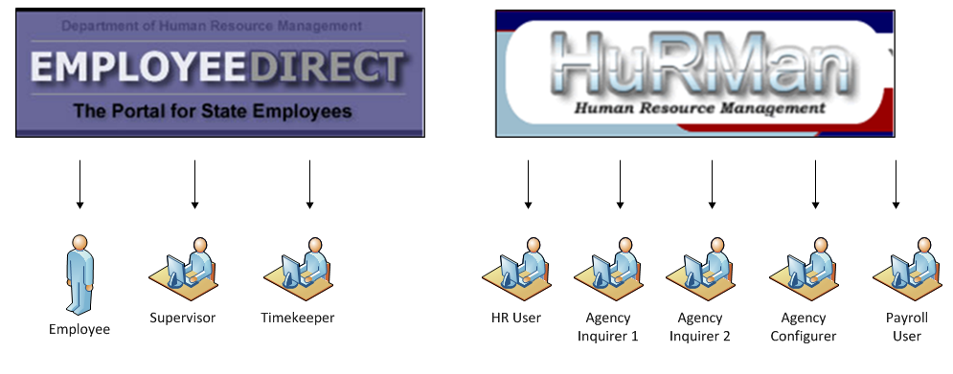

The above roles have the following privileges:

|  |  |  |
| --- | --- | --- |
| TAL User Roles | Description | Must Request Access using DHRM’s System Access Request Form?[1] |
| Employee | A user assigned this role will be able to:  1) Create, update, save, revise, submit and withdraw his/her leave requests  2) Make entries to, update and submit his/her timesheets  3) View leave balances, leave transactions and leave accrual rates  4) View his/her employee and position data  5) View status of leave requests and timesheets | N |
| Supervisor / Supervisor Alternate | In addition to the Employee Role, a user assigned to this role will be able to perform the following for subordinates in his/her PMIS defined reporting hierarchy (not just direct reports):  1) Approve, cancel, request revisions or deny an employee's leave request (not his/her own)  2) Approve, request revisions or deny an employee's timesheet submission (not his/her own)  3) View an employee's leave balances, leave transactions and leave accrual rates (including his/her own) prior to approving requested leave.  4) View an employee's employee and position data residing in TAL (including his/her own)  5) Initiate leave requests and timesheets (in certain situations) for an employee, such as VSDP and LWOP.  A user defined as an alternate can perform the above functions on the same employees as the supervisor for whom he/she is an alternate. | N |
| Timekeeper | In addition to the Employee role, a user assigned to this role will update the timesheet and leave requests for employees for whom he/she is designated as the Timekeeper.  It is envisioned that this role would be used at agencies where certain employees do not have routine access to a computer at work. | N |
| Agency Inquirer Type 1 | This user role can:   1. view the following employee data in TAL: - leave requests - leave balances - leave history - timesheets 2. view position data in TAL 3. view agency configuration data 4. Run queries from the TAL data for ad hoc reporting needs   This User Role is not authorized to change data or configurations. | Y |
| Agency Inquirer Type 2 | This user role can:   1. view the following employee data in TAL:    1. timesheet data 2. view position data in TAL   This User Role is not authorized to change data or configurations. | Y |
| Agency Configurer | A user in this role will be able to enter agency-wide configurations necessary for the TAL system to work properly for an agency.  If an employee needs this role across multiple agencies, he / she must be established in this role for each agency. | Y |
| HR User | This user role can:  1) View, and update employee-level and position-level configuration data for employees and positions in the agency  2) View, add and update the following information for an employee at the agency:          - leave requests (including reviewing, revising & approving)          - leave balances (including adjusting entries)          - timesheets (including reviewing, revising & approving)  3) Create and review batches of transactions on the HR Review tab prior to this data being transmitted to CIPPS  4)Run queries from the TAL data for ad hoc reporting needs  5) Perform privileges associated with Agency Configurer role | Y |
| Payroll User | This user role can:   1. Create and review batches of transactions on the HR Review tab prior to this data being transmitted to CIPPS 2. Run queries from the TAL data for ad hoc reporting needs | Y |

## Benefits to Agencies

The TAL Project Team is excited about the many benefits this system:

* Web-enabled System
* Built-in Management/Supervisor Accountability
  + Timesheet Approvals and Timesheet Management
  + Leave Management and Leave Approvals
  + Capturing of information related to Pay Dockings for Intermittent Leave without Pay (less than 14 consecutive days)
* Absence Management Metrics Reports
  + Ability to assess peak leave usage periods (fact vs. fiction)
  + Critical factual data for disciplinary/performance improvement needs
* Ability to provide data to support Leave Liability Reporting
* Accurate, current PMIS data available in TAL on a daily basis
* Employee leave balances and history that is closer to real time

## Responsibilities for Agency HR Team while in the HR User role (HR only)

* Review internal processes with stakeholders and incorporate TAL automation into those processes.
  + Communicate changes to users.
* Ensure that all TAL users are familiar with their roles and responsibilities and trained in TAL operations.
  + TAL brings a greater degree of accountability for accuracy and timeliness of leave and timekeeping management .
* Ensure that **PMIS data** is current, accurate, and updated timely on an on-going basis.
  + TAL updates from PMIS data nightly. New hires or transferred employees may not access TAL timesheets/leave balances/requests until the day after PMIS data has been entered.
* Ensure that **TAL agency configurations** are current and appropriate for agency employees and operations.
* Ensure that **TAL settings for individual employees** are accurate and updated as position/employee/status changes occur and facilitate TAL user access.
* Make timely, accurate leave adjustments as needed.
* Coordinate with Payroll to
  + Ensure that employees are set up properly in TAL so that CIPPS transmissions are accurate and timely.
  + Review exceptions and reportable events in TAL to ensure that appropriate documentation regarding exceptional pay is sent to Payroll.
  + Create/review/transmit batches of transactions to CIPPS based on established calendars.
* Run queries and reports to meet management information needs and to identify maintenance needed for data integrity or to clarify information.
* Report issues and suggestions to the agency TAL contact so that the DHRM TAL team can provide assistance and identify system enhancements or user training needed.
* Direct new agency TAL users to on-line training modules and assist privileged users in becoming familiar with their responsibilities.

## Responsibilities for Payroll Users (Payroll Only)

* Some agencies may assign a subset of the above HR responsibilities to Payroll Users. Check with your agency to determine which of the above are reassigned to the Payroll User.

## Accessing TAL as a Privileged User

In order to access TAL in any of the privileged user roles (in Figure 1.1 above), the user must first submit an Access Request form[2] for designated employees to DHRM. All employees entered in PMIS are automatically granted employee or supervisor user roles based on their place in the organizational hierarchy. Employees who are assigned Privileged User roles also have access to employee user and/or supervisor User role functions.

Following are valid combinations that agencies should use when requesting access: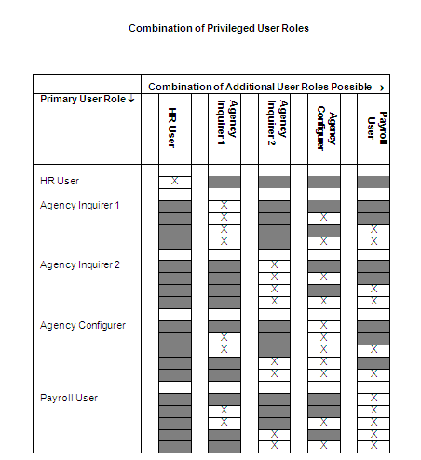

After the request is submitted to DHRM and approved, DHRM will either

1) issue a new HuRMan account with the appropriate privileges or   
2) update the privileges on the employee’s existing account.

Once a user has HuRMan credentials and DHRM has granted TAL access, (s)he may access the HuRMan portal at secure.dhrm.virginia.gov. The following login screen will appear:

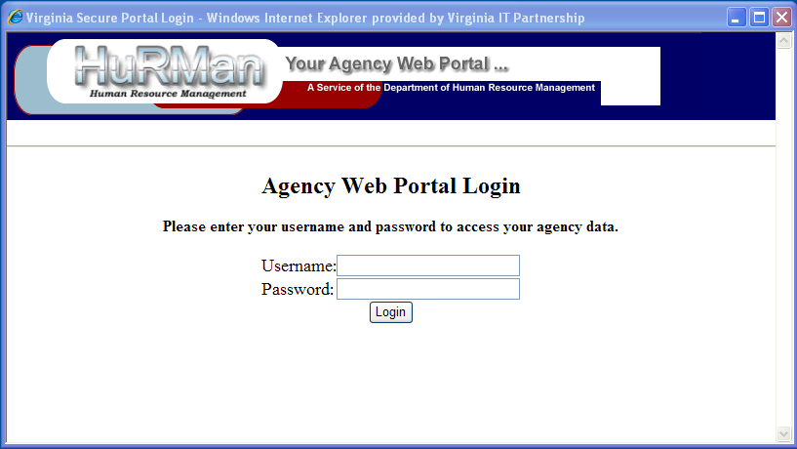Figure 1.3

Use the HuRMan user name and password. The designated user roles will be authenticated through HuRMan and permit the designated access and privileges.

If a privileged user has access to multiple agencies in TAL, it is possible to switch between agency data without logging out of HuRMan/TAL. To do so, select the arrow highlighted in green, which is located to the right of the dropdown used to select the TAL application. A message box will appear asking for confirmation that you want to continue. Select “OK” to continue. You can then select the agency number from the dropdown list that appears.

### Special Section: Accessing TAL as a Timekeeper

While the Timekeeper is not considered a “Privileged User”, (s)he does have special privileges: (s)he may create and update leave requests and timesheets for specified employees. Employees assigned to timekeeper roles must be designated as agency timekeepers in their TAL settings. Such employees access TAL via **E-Direct** just as other employees or supervisors do.

In the TAL screenshot below, George Schenck has been designated by the HR User as an Agency Timekeeper. George’s name will now appear in a “drop-down” option for any employee in the agency whose time will be maintained by him in TAL.

The timekeeper role may be assigned or removed by changing the “Designated as Agency Timekeeper” <Yes> to <No> or vice versa. Only the HR User has permissions to assign the timekeeper role to an employee.

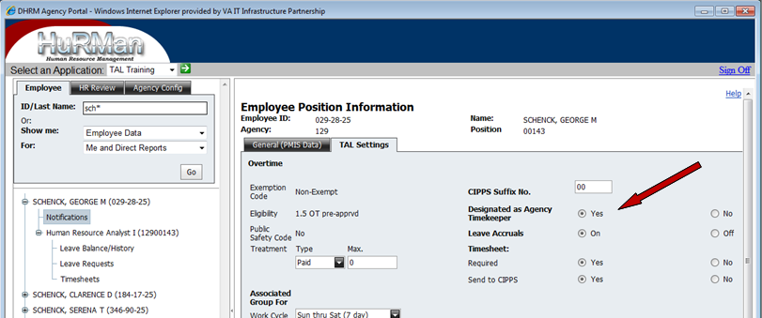

HR Users must also designate a timekeeper in TAL settings for each employee whose time is maintained by a timekeeper. In addition to designating one or more timekeepers, the period of time during which the time will be maintained must be recorded. The Start Date for the timekeeper designation must be the current or future date. (The End Date must be later than the Start Date.) Dates may be entered by using the calendar that appears or by typing the date.

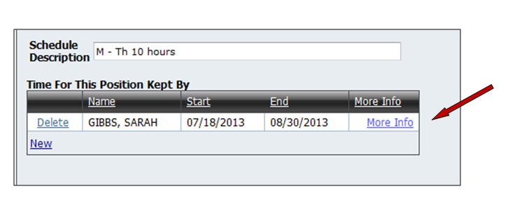

# Understanding the Agency Config Tab and Screens

The Agency configuration data tables are used to establish consistent operating criteria within TAL for all agency employees. This operational strategy within the system greatly improves internal controls regarding timesheets and leave processing.

All privileged user roles can view the Agency Configuration tab, however only the HR User and the Agency Configurer roles will see the Edit button and will have the ability to modify data.

For example, the Agency Configurer wants to review the agency’s Holiday Calendar tables. Using the treeview, select ‘Go’. Select any one of the areas listed in the tree view to review and/or revise.

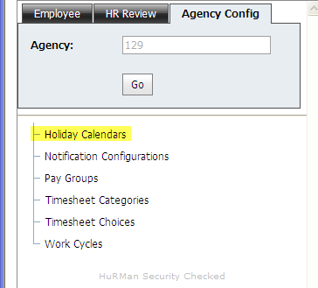

## Holiday Calendars

Privileged users can view the agency’s Holiday Calendar table within TAL on the Holiday Calendar screen (see below) Based upon certain agency criteria, some agencies may elect to establish an alternative holiday calendar.

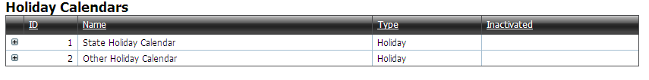

By pointing and clicking the symbol located to the left of Other Holiday Calendar the following illustrates examples of alternative holiday dates for 2012.

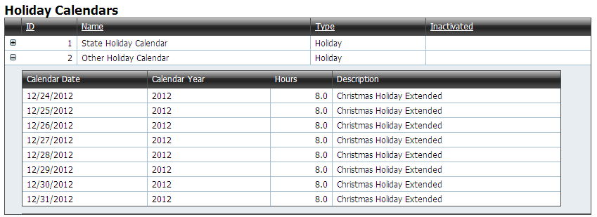

Note: Each year the agency will need to coordinate with the TAL support team to have any alternate holiday calendar loaded into TAL.

## Notification Configurations

TAL has a pre-established table of notifications designed specifically for various user communication needs on critical TAL functions.

Privileged users may view notification configurations for their agency on the Notifications Configuration Screen:

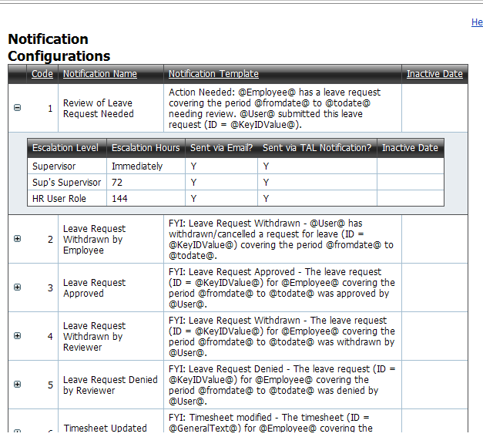

Notes:

* The Escalation Hours indicates the specific time period in hourly increments the notification will occur following the relevant transaction
* Notifications can be configured to be delivered through the agency’s email and/or internally through TAL
* To update settings for an agency’s notification configurations, the HR agency team should contact the TAL Support Team
* If a notification is configured to go to a supervisor, and that supervisor position is vacant, the notification will be sent instead to the supervisor of the vacant position.
* If a timesheet is submitted prior to the last day on the timesheet, the notification will not be sent to the supervisor until the last day on the timesheet. This is because a timesheet for an employee in an active position cannot be approved prior to the last day on the timesheet.
* TAL handles notification type code 7 (“Timesheet needs to be submitted”) and 17 (“Timesheet needs Supervisor Review”) different from other notifications.  For notification 7, TAL checks for timesheets that need to be submitted or have the supervisor review completed five days from the current date.  If TAL finds any timesheets that meet these criteria, then it sets up a notification to the appropriate employee / supervisor to appear in the number of hours specified in the notification setting.  So, in the following case, if TAL detects that an employee’s timesheet is due in 5 days, TAL will set up a notification that will appear 72 hours later (still two days before the timesheet is due) on the employee’s list of notifications.

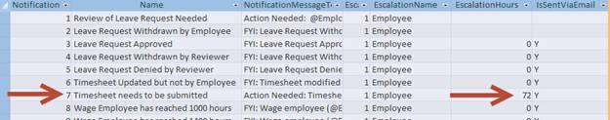

* Notification type code 17 (“Timesheet needs Supervisor Review”). TAL will check to see which supervisors have direct reports that are required to submit timesheets for each Pay Group. Five days prior to the timesheet review due date, TAL will create the notification. The notification will be sent/displayed to supervisors xx hours after the notification was created (where xx is defined by the Escalation Hours configuration). TAL does not check first to see if the timesheets have already been created/submitted/approved. It is meant as a reminder to supervisors. As noted in the following screenshot, the notification is set to go to “Employee” instead of “Supervisor”; In this case the supervisor is the “employee” who should and will get the notification.  The employee of the supervisor will not get this notification.
* Notification #8 will be sent once when the total number of hours worked on approved timesheets for wage employees reaches 1000 hours.
* Notification #9 will be sent every time the total number of hours worked on approved timesheets for wage employees is greater than 1400 hours.

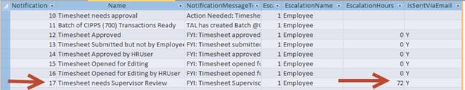

## Pay Groups

The Pay Group configuration screen shows the pay groups and pay periods set up for an agency.

Privileged users can see the following Pay Group information:

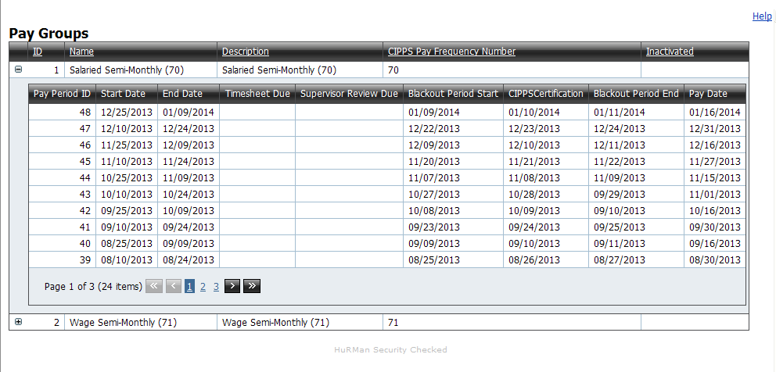

Note: An agency must work with the TAL Support Team to add or change pay group information. An agency should plan to provide this information annually to the TAL Support Team.

## Timesheet Categories

The Timesheet Category screen provides a way for privileged users to view, create and update the categories to which hours on timesheets can be allocated. The Timesheet Category screen has the following look:

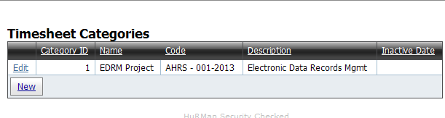

Once a timesheet category has been inactivated, it can no longer be used on a timesheet (unless the Inactive Date is removed).

## Timesheet Choices

The Timesheet Choices screen provides a way for privileged users to view, create and update the options available for employee to select on his/her timesheet.

The Timesheet Choices screen has the following look:

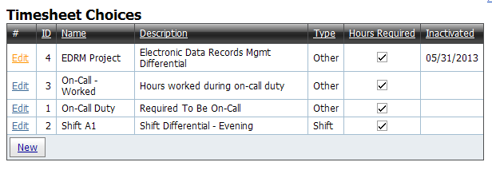

|  |  |
| --- | --- |
| **Grid / Field** | **Definition and Key Notes** |
| **ID** | A unique number that TAL assigns to each Timesheet Choice |
| **Name** | A brief description that will show on a timesheet |
| **Description** | A fuller description than the Name field |
| **Type** | Either “Shift” or “Other” |
| **Hours Required** | A checkbox that indicates whether hours must be specified when a particular Timesheet Choice is selected on a timesheet |
| **Inactivated** | If a Timesheet Choice is inactivated it is no longer able to be selected on a timesheet (unless the Inactivated date is removed) |

Unlike Timesheet Categories, Timesheet Choices…

* relate to supplements/differential pay and may directly impact an employee’s pay
* must be associated with an employee’s profile on the Position Screen in order for the employee to be able to select it on his/her timesheet.

## Work Cycles

The Work Cycles configuration screen defines each work cycle and associated start and end dates used by the agency. Privileged users may view the calendars for each work cycle. The TAL Support Team must assist the agency with any changes to work cycle configurations.

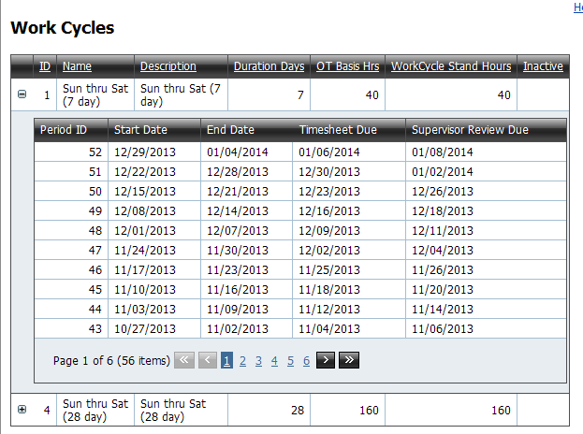

|  |  |
| --- | --- |
| **Grid / Field** | **Definition and Key Notes** |
| **ID** | A unique number that TAL assigns to each Work Cycle within the agency |
| **Name** | A brief description that will show on a timesheet |
| **Description** | A fuller description than the Name field |
| **Duration Days** | The number of calendar days assigned to the work cycle |
| **OT Basis Hrs** | The total hours worked before overtime may be paid |
| **Work Cycle Stand Hours** | The standard work hours assigned to the work cycle |
| **Inactivated** | If a Work Cycle is inactivated it is no longer able to be selected on a timesheet (unless the Inactivated date is removed) |

# Understanding the Employee Tab and Screens

## Employee Tab filter

There are three tabs in TAL for employee/position/agency data. These are the Employee Tab, the HR Review Tab, and the Agency Configuration Tab.

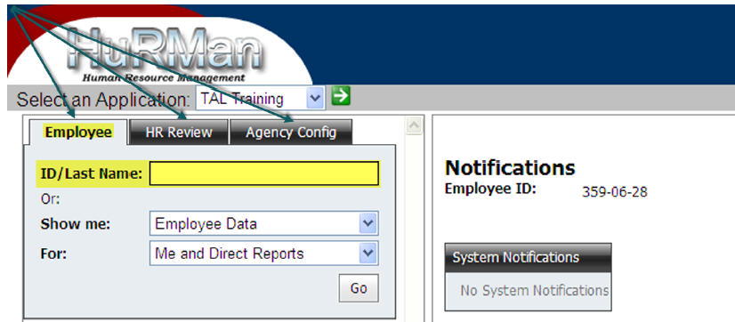

Remember that, after making a selection, one must click the  button.

***Finding the Employee***

Using the **Employee Tab** on the left, the HR User may access an employee’s data in several ways.

In the **ID/Last Name** box, enter the employee’s ID number. The number must contain a minimum of 7 digits so leading zeroes must be included. Example: The EID is 0000123. You must enter the four leading zeroes.

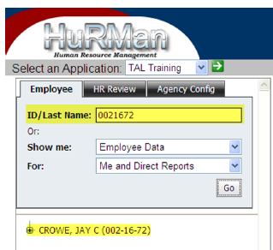

OR

In the **ID/Last Name** box, enter the employee’s full last name.

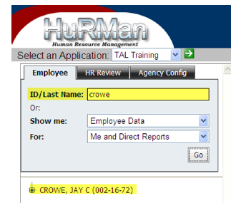

OR

In the **ID/Last Name** box, enter a portion of a last name followed by an asterisk.

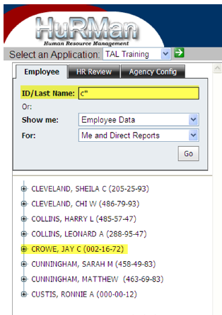

**Show Me** box on the Employee Tab filter the HR User can access any of the 3 options below. Other privileged users can only access the Employee Data option in the dropdown

* Employee Data
* Unapproved Timesheets
* Unapproved Leave Requests

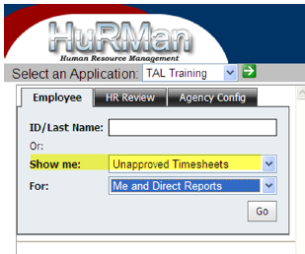

Using the **For** box on the Employee Tab filter, the HR User can access either of the options below; however other privileged users can only access the Direct Reports option:

* Me and Direct Reports
* Direct Reports

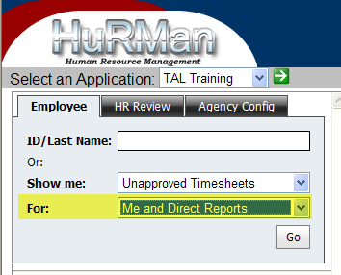

## Notification Screen

Appears automatically and shows system notifications and timesheet/leave request (action and status) notifications. Users may proceed with other actions and return to notifications later. System notifications will alert the user to times when the system will be unavailable due to maintenance.

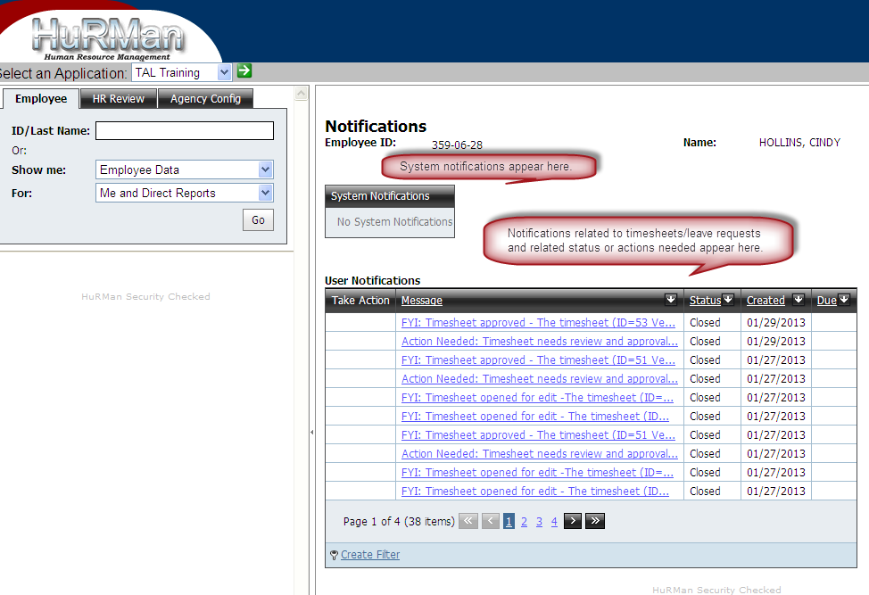

Notifications show 30 days worth of information.

HR Users may have many notifications because they are in “need to know” users in TAL. The notifications may be their own, those of subordinate employees, and those of other agency employees.

***Employee Information Screen***

When the employee’s name appears in the tree view, click on it and the Employee Information screen will appear.

All data highlighted on the screen is transferred from PMIS to TAL.

If the data displayed is incorrect, it must be corrected in PMIS. Once corrected in PMIS, it will be updated in TAL by 11 PM the night of the change (including weekends/holidays).

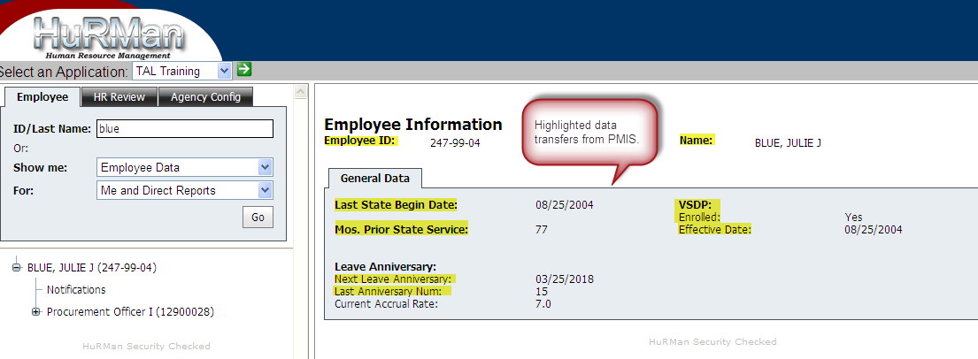

The General Data recorded includes information needed for leave accruals/year-end adjustments. It also includes indicators needed to provide appropriate sick leave categories on timesheets and leave records to employees.

* Employees’ sick leave category choices differ depending upon their participation in either the VSDP or the Traditional sick leave programs… as recorded in PMIS/TAL.

## Employee Position Information Screen

The **Employee Position Information** Screen is comprised of two tabs: one that captures General (PMIS Data) and one that establishes TAL Settings. The HR User role will have edit permissions on the TAL Settings tab; all other privileged user roles will have view only permissions.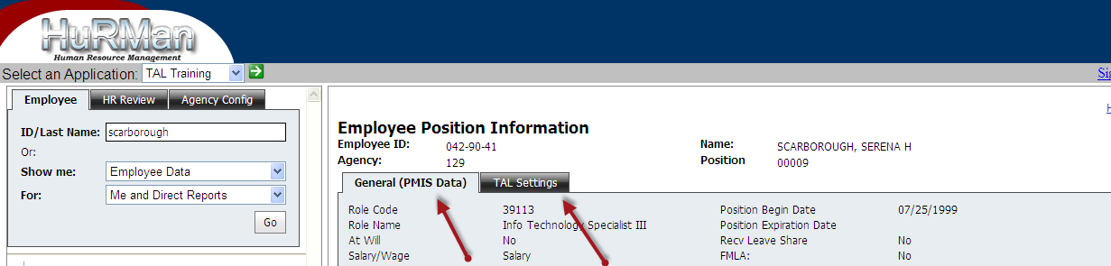

All information on the General (PMIS Data) tab is transferred into TAL directly from PMIS data. The recorded fields should be very familiar to HR Users who are familiar with PMIS. If information displayed on this tab is incorrect, it must be changed in PMIS before it will display correctly in TAL.

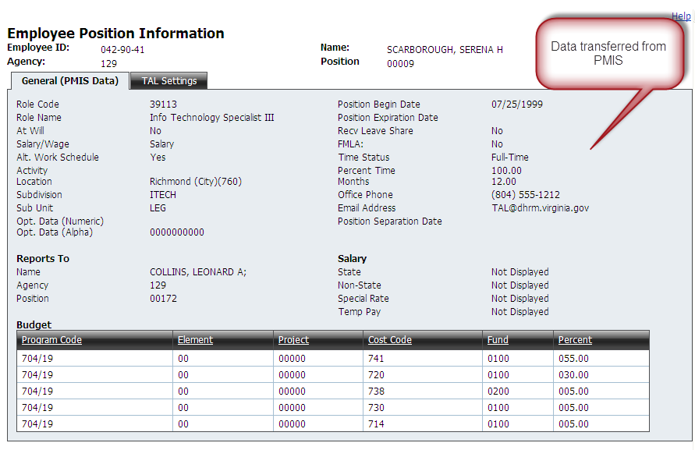

The TAL Settings tab contains information essential for TAL to provide appropriate timesheets and leave requests/balances to individual employees and to correctly transmit information to CIPPS Payroll. HR Users must exercise close attention to accurately recording information in this tab. The highlighted data is transferred from PMIS. All other data must be recorded by the HR User.

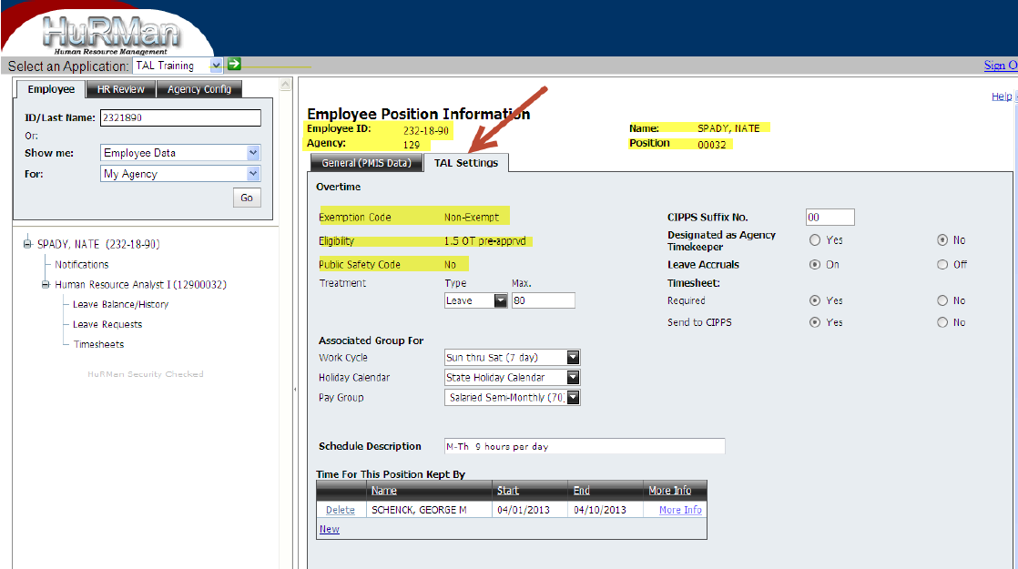

***TAL Settings*** – ***Field definitions and implications***   
**Overtime**

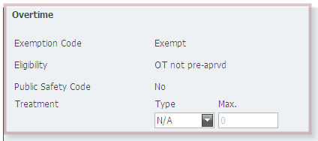

|  |  |
| --- | --- |
| **Grid / Field** | **Definition and Key Notes** |
| **Overtime** | The upper left corner of the screen addresses how overtime is treated for the employee. Exemption Code, Eligibility, and Public Safety Code are read/transferred from PMIS. |
| Treatment | There are three ways in which overtime may be treated: It may be **Paid**, it may be earned as Overtime **Leave**, or it may be **N**ot **A**pplicable. |
| Type and Max. | If overtime is to be paid, the Type should be set to **Paid** and the **Max.** should be 0. |
|  | If overtime leave is to be earned, the Type should be set to **Leave** and the maximum threshold for OT leave that can be awarded before it must be paid should be set in the Max. box. (240 hours for non-exempts, 480 hours for FLSA law enforcement **or** agency established maximums.) This field requires a value between 0 and 480. Once the maximum number of hours awarded have been reached, TAL will treat the overtime as Pay by default. |
|  | If the employee is exempt and does not earn overtime, the Type should be **N/A** and the **Max.** should be 0. |

**Associated Group For**

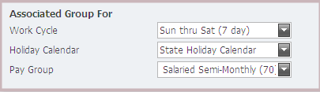

|  |  |
| --- | --- |
| **Grid / Field** | **Definition and Key Notes** |
| **Work Cycle** | Work Cycle refers to the cycle used for scheduling employees’ work and, for those covered by FLSA, the length of time used to assess the overtime threshold. Work cycles for the agency are set up in TAL by the Agency Configurer/HR User. The HR User must record the appropriate work cycle on each employee’s TAL Setting. Work Cycles are *typically* 7 day cycles or 28 day cycles  The setting of the work cycle in TAL generates the appropriate timesheet dates for the employee (except in the case of wage employees who are paid on a semi-monthly basis). |
| **Holiday Calendar** | Most state agencies use the standard state holiday calendar including the specific holiday dates noted in code and any additional holidays awarded by the Governor. Some agencies observe different holiday dates based on business needs. The holiday calendar (s) used by each agency are entered in TAL by the Agency Configurer/HR User.  The setting of the holiday calendar in TAL generates notations on the employee’s timesheets regarding the holiday dates. |
| **Pay Group** | Pay groups typically correlate to the pay frequencies used in CIPPS. Those often used are Salaried Semi-Monthly (70) and Wage Semi-Monthly (71). The pay groups used by the agency are entered in TAL by the Agency Configurer/HR User. HR Users should consult with their Payroll offices to ensure appropriate assignment of Pay Groups.  The setting of the Pay Group for each employee ensures that pay information is processed from TAL to CIPPS timely and appropriately. |

**Schedule Description**



The employee’s work schedule description is not a required field in TAL. However, agencies may wish to use a standardize format to capture the actual schedules of their employees. This field permits alpha-numeric notations. [Options may range from <Monday through Friday, 8 hours> to <Monday through Friday 8:30 – 5:00> to <M-Th, 10 hours> to <28 day cycle – B Break Day Shift>, etc.] HR Users may record employee’s schedule descriptions.

***Additional TAL Settings***

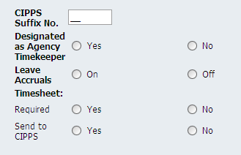

|  |  |
| --- | --- |
| **Grid / Field** | **Definition and Key Notes** |
| **CIPPS Suffix No.** | The CIPPS Suffix No. is a two-digit number added to the Employee Identification number in CIPPS. The agency’s Payroll office can provide the suffix numbers used within your agency. The HR User must enter two digits having a value of 00 – 99 in this field. Typically this number is 00.  This designation correlates to CIPPS payroll processing. |
| **Designated as Agency Timekeeper** | Those employees who are responsible for timekeeping for other employees must be designated in TAL via the TAL settings. Once they are identified, their names are included in “drop-down” boxes that may be used to specify timekeepers for individual employees in the agency. Some agencies may not use the Timekeeper role. This role is typically used by agencies where groups of employees may not have routine access to computers during their work schedules. Most employees will not be designated as Agency Timekeepers.  It is important to remember that HR User must designate timekeepers on their TAL Setting tabs and must also set up the timekeeping relationship in the “Time for This Position Kept By” field for the individual employees for whom the time is kept. |
| **Leave Accruals** | Leave accruals must be set to “On” or “Off” for each individual employee in the TAL Settings tab. When employees enter LWOP status, when they leave state government, etc., the HR User must turn off leave accruals in TAL or turn accruals on as warranted by the circumstances. If an employee begins employment in the middle of a pay period and the accrual switch is on, TAL will apply the leave accrual. We recommend that the accrual switch be set to “Off” for new employees until the employee reaches the first eligible accrual period.  The TAL Leave system continues to accrue leave for employees whose accrual is set to “On” in the TAL Settings tab unless TAL detects a scenario (e.g., unpaid leave on a timesheet or on a leave request) that warrants not giving the accrual for a specific period. |
| **Timesheet** | Timesheets are available to exempt and non-exempt employees.  Timesheets completed by exempt employees are not used for pay purposes but may be used to account for time worked on specific projects, charged to specific funding sources, or related to specific events. Agencies may determine if such timesheets are to be used for exempt employees and the categories to which time will be charged.  Timesheets are required for all non-exempt employees (salaried or wage). |
| **Required** | HR Users should record that timesheets are required for all non-exempt employees and must check with management or their fiscal departments to determine if timesheets will be used for exempt employees.  When the Timesheet Required “Yes” button is checked for an employee, TAL will allow employees to create timesheets. If the “No” button is checked, timesheets will not be available in TAL for that employee. |
| **Send to CIPPS** | HR Users should record whether timesheets must be sent to CIPPS Payroll. Again, timesheets must be sent to CIPPS Payroll for all non-exempt employees but must not be sent to CIPPS Payroll for exempt employees.  HR Users may also change this status if a timesheet must be processed manually due to exceptional circumstances. TAL will send hours from approved timesheets (except for salaried exempts) marked “Yes” to CIPPS Payroll. |

**Wage Hours Tracking (applicable only to wage employees)**

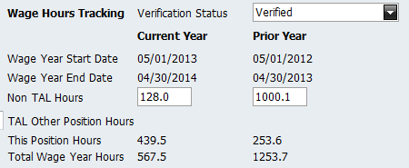

|  |  |
| --- | --- |
| **Field** | **Description** |
| Verification Status | The status of the Non-TAL Hours that show on the screen (see below for an explanation of “Non-TAL Hours”.  Possible Status values are:   * Verified – the agency has confirmed the values in the “Non-TAL Hours” field. * Verification in Progress – the agency is currently in the process of reviewing / confirming the amount of “Non-TAL Hours” * Verification Not Started – the agency has not reviewed/confirmed the amount of the “Non-TAL Hours”. TAL will not allow the setup of an employee to be completed when this is the status showing on the screen. This is the default status that will appear when setting up a new employee. |
| Wage Year Start Date | 5/1 of a particular wage hour year |
| Wage Year End Date | 4/30 of a particular wage hour year (12 months after the wage year start) |
| Non-TAL Hours | Hours for a wage year that TAL does not have on a TAL timesheet; e.g., if your agency went live with TAL on 9/25, then TAL would not have hours for wage employees from 5/1 to the start of the employee’s first TAL Timesheet (likely 10/1). These hours need to be entered into TAL in the appropriate non-TAL field. If you would prefer to provide a spreadsheet of non-TAL hours uploaded into TAL for your agency, send that request to [TAL@dhrm.virginia.gov](mailto:TAL@dhrm.virginia.gov).  Also if your agency, after adopting TAL had an employee complete a paper timesheet that was not entered into TAL, HR Users should add these hours into the non TAL hours field.  The “Verification Status” field (see above) applies to the status of the Non-TAL Hours.  Only TAL HR Users can update the “Non-TAL Hours” fields |
| TAL Other Position Hours | If an employee at your agency had more than one wage position at your agency, the hours from approved timesheets from the other position(s) for the wage year would display here. |
| This Position Hours | TAL shows the hours worked from approved TAL Timesheets for the currently displayed wage position. If multiple versions of a timesheet exist, only hours from the last approved timesheet will be included. |
| Total Wage Hours | The sum of Non-TAL Hours + TAL Other Position Hours + This Position Hours. |

Note: Additional information on tracking Wage Hours in TAL can be found in Appendix F – Tracking Wage Employees in TAL

**Time for This Position Kept By**

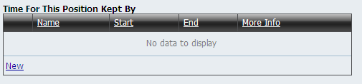

|  |  |
| --- | --- |
| **Grid / Field** | **Definition and Key Notes** |
| **Time for This Position Kept By** | HR Users must complete this field for all employees whose time will be kept and recorded in TAL by an agency Timekeeper. |
| **Name** | Clicking on New displays a selection of agency Timekeepers’ names from which the HR User may select. More than one Timekeeper may be recorded for an employee. |
| **Start and End Dates** | Both a Start and an End Date must be selected. One may select from the calendar or record dates in mm/dd/yy format. The Start Date must be the current date or a date in the future. The End Date must be later than the Start Date. |
| **More Info** | This field displays TAL generated notes regarding who makes these entries in TAL and when. |

**Supervisor Alternate**

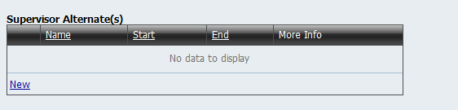

|  |  |
| --- | --- |
| **Grid / Field** | **Definition and Key Notes** |
| **Supervisor Alternate** | This grid appears only for employees designated as a supervisor. The HR user can set an alternate for any supervisor using HuRMan. A supervisor can designate an alternate supervisor for his/herself in Employee Direct. |
| **Name** | Clicking on New will display a dropdown of names which can be selected as an alternate. Names in the dropdown will include the Supervisor’s Supervisor, Supervisor’s peers, and all of the Supervisor’s direct reports. More than one alternate may be recorded for a supervisor. |
| **Start and End Dates** | Both a Start and an End Date must be selected. One may select from the calendar or record dates in mm/dd/yy format. The Start Date must be the current date or a date in the future. The End Date must be later than the Start Date. |
| **More Info** | This field displays TAL generated notes regarding who makes these entries in TAL and when. |

**Additional Timesheet Choices**

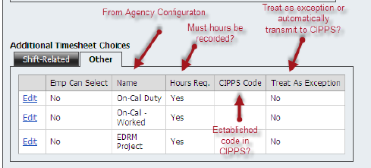

|  |  |
| --- | --- |
| **Grid / Field** | **Definition and Key Notes** |
| **Additional Timesheet Choices** | HR Users must complete this field for all employees for whom additional choices must be added to timesheets. |
| **Shift-Related or Other** | Timesheet choices are typically related to shift differentials or other (non-shift related) work practices such as pay supplements, on-call duty pay, etc. Agencies must define the additional practices that will be incorporated in TAL and the Agency Configurer/HR User must record them in TAL.  The HR User must set parameters for the use of these choices on each individual employee’s TAL Settings tab. |
| **Employee Can Select** | The HR User sets whether the employee can select the option or not. |
| **Name** | The possible options are listed in a “drop down” box. |
| **Hours Req.** | The HR User notes whether a specific number of hours must be recorded for the type of choice being included. For example, an employee may be eligible for a minimum “Call-Back” pay rate if (s)he is assigned call duty for an 8 hour shift. |
| **CIPPS Code** | If there is an established pay rate in CIPPS that corresponds to the timesheet choice, it may be recorded here. If so, TAL will report the number of hours corresponding to that rate to CIPPS. |
| **Treat as Exception** | For some pay practices, the agency may wish to have additional documentation/authorization before payment is made for hours on a timesheet choice. The HR User may note that such choices selected must be treated as exceptions. TAL will then report entries as exceptions so that the HR User may further scrutinize the entry and obtain appropriate authorization. |

***TAL Settings – Required Fields***

The shaded boxes contain fields that **must** be completed in TAL before a Set-Up is complete. Other fields are optional.

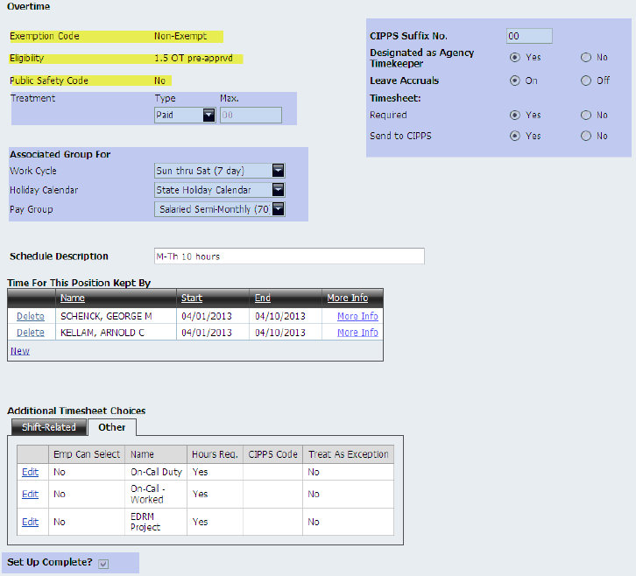

Note: Please see Appendix E which describes the importance of the Timesheet Required Setting.

After the required fields have been completed, the HR User must check the Set Up Complete box and then save the information. Once the Set Up Complete is checked and saved, several things happen in TAL for the Employee:

1. Employee leave categories are set up
2. The employee is able to access his / her leave and timesheet information in TAL

TAL will alert the user if required information has been mis-keyed or omitted (see following screenshot).

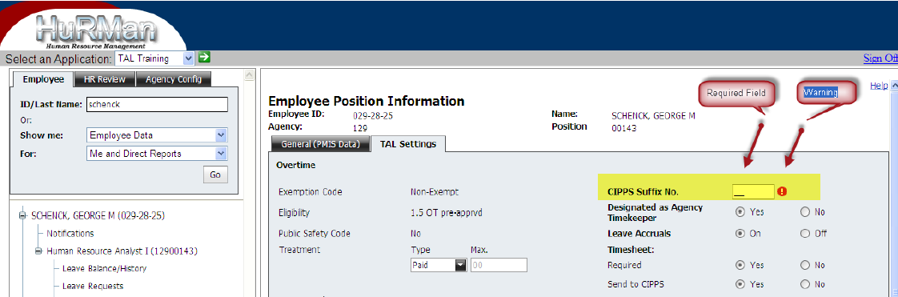

## Leave / Balance History Screen

The Leave Balance screen is accessed by clicking on “Leave Balance/History” in the Treeview.

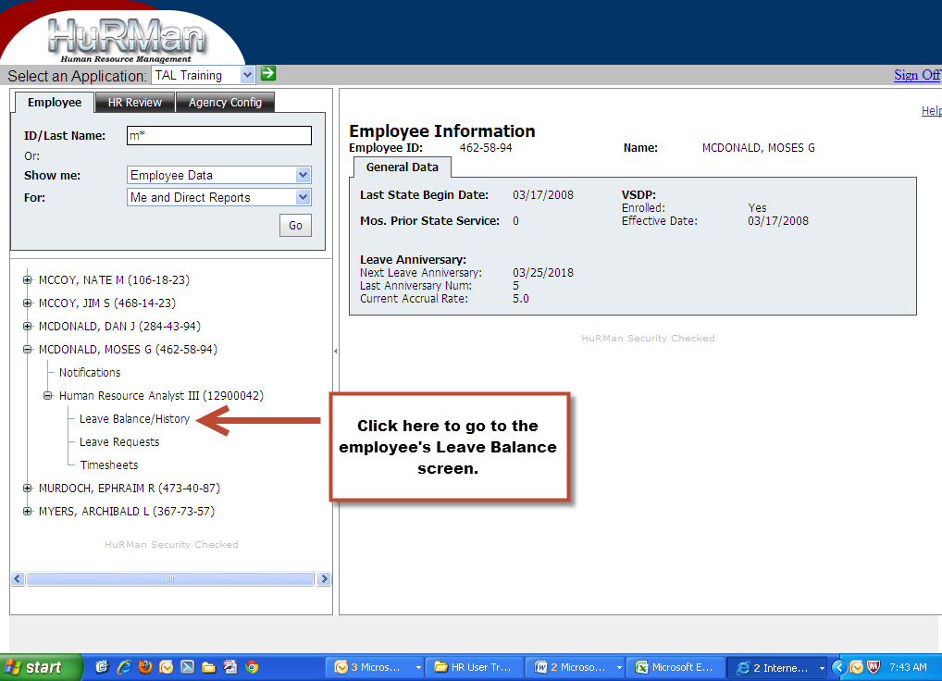

The Leave/History/Balance Screen provides information regarding an employee’s:

* leave balances
* eligible leave types (VSDP vs. Traditional Sick Leave)
* accrual rate
* anniversary date
* a history of leave accruals, usage, and other transactions
* maximum annual leave balance carryover
* estimated hours of annual leave lost

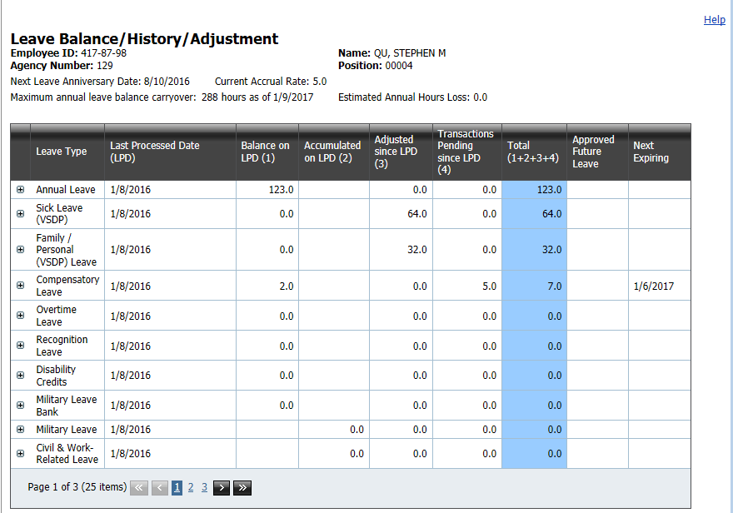

On the Leave Balance/History/Adjustment screen a user will find close to real time information regarding:

* the date leave was last processed (LPD)
* the employee’s leave balances on the LPD,
* any leave that was accrued on the LPD
* adjustments made since the LPD
* transactions that have been created but not yet processed since LPD
* the total amount of each leave type available, or used
* approved future leave requests
* dates of next expiring leave

Notes on the Balance screen:

* For a given leave type, there will be either an amount in the Balance on LPD (1) or the Accumulated on LPD (2) column, but never in both.
* For employees who are required to complete a timesheet, TAL will update leave balances based upon the information on an approved timesheet.
* For all other employees, TAL will update balances based upon the information on an approved leave request.
* When TAL calculates an employee’s estimated annual leave that would be lost at leave year end, it multiplies the number of annual leave accrual periods remaining in the leave year by the employee’s accrual rate. TAL also takes into account the fact that an employee may move to a higher accrual rate before leave year end. In computing the estimated annual leave lost, TAL does not consider any future-dated leave requests.

**Year End Leave Processing**

The TAL Year End Leave Process will run early in the morning on 1/10/ of each year. The process:

* will reduce the annual leave balance for employees whose balances exceed the carryover limit as defined in policy.
* will add annual leave accruals for the 12/25 through 1/9 pay period to be available on 1/10/.
* will reduce employee balances to 0 for Sick Leave and Family Personal Leave as of the end of day 1/9 for employees who participate in the Virginia Sickness & Disability Program (VSDP) .
* will give annual allotments for Sick Leave and Family Personal Leave as per policy to employees who participate in the [Virginia Sickness & Disability Program](http://www.dhrm.virginia.gov/hrpolicy/policy/pol457VSDP.pdf) (VSDP). **\*\*Note:** According to policy, employees receiving a STD or LTD disability benefit on January 10 will not receive SL or F/P leave credits until they are released by their LTP and return to "active employment”. TAL currently does not know whether an employee is currently receiving a STD or LTD benefit and will give the employee an allotment. Agency HR will need to make manual leave adjustments to remove the allotments that TAL will give and then later grant them upon return to active employment.
* will reset all accumulator leave types (i.e., the leave types that show values in the “Accumulated on LPD (2)” column) to 0. Military Leave is the exception. It will be reset to 0 on 10/31.

TAL will process leave from timesheets and leave requests submitted after the beginning of the new leave year for dates in the prior leave year. Supervisors should be reminded that retroactive leave requests/usage may be approved only if employees had sufficient leave balances to cover the time requested on the dates when the leave was used.

Additional information on the TAL Year End Leave process can be found in Appendiix I - Understanding how TAL processes leave lost, resets, and credits.

From the Leave Balance/History/Adjustment screen a user is also able to retrieve more detailed information regarding a specific leave type.

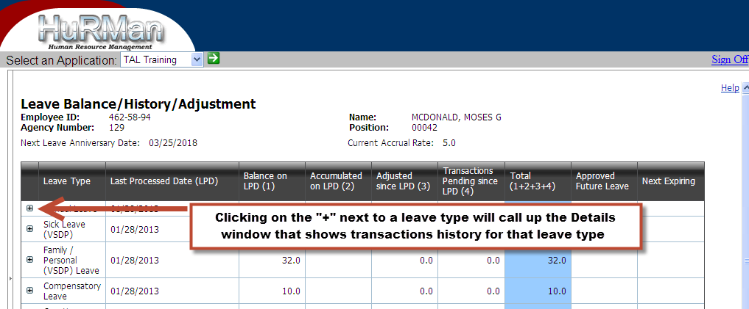

In the Details window the user can find information on transactions such as:

* beginning balances
* accrued leave transactions and dates they occurred
* used leave transactions and dates they occurred
* amount of leave that was lost during year end processing (if any)
* leave that was awarded, or given as a bonus
* expiration dates
* leave that was paid out

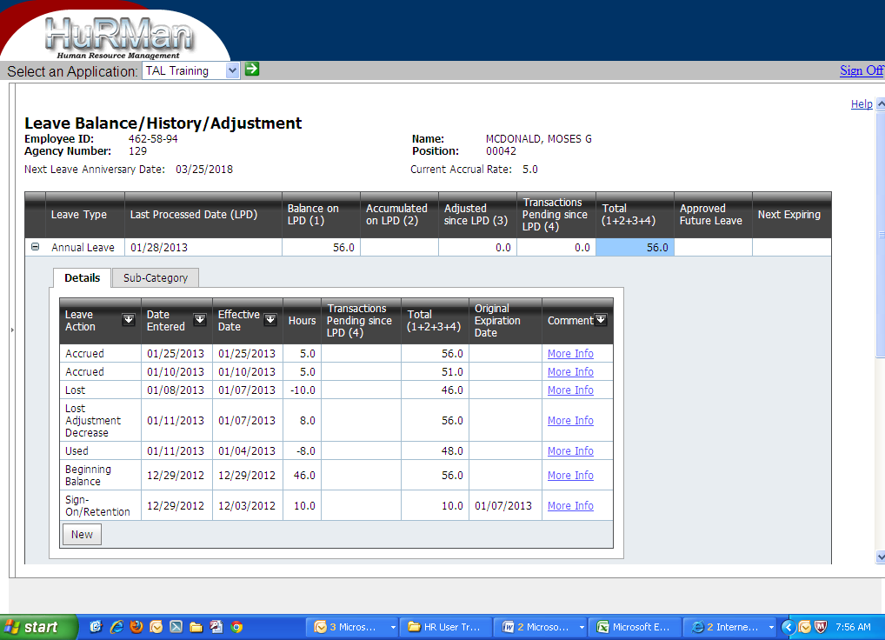

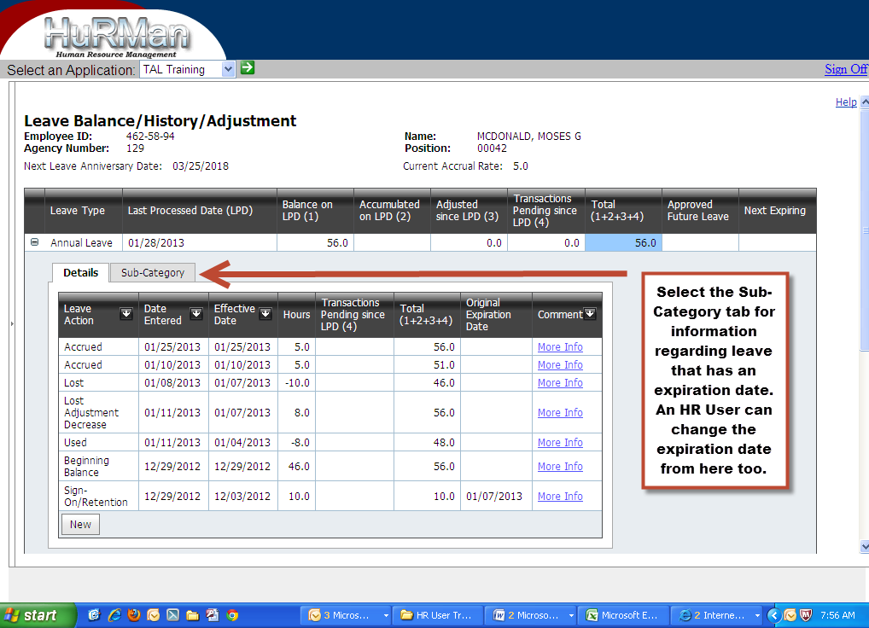

In the Sub-Category window the HR user can find information regarding other leave types that need special tracking, and also view or modify leave expiration dates. These leave types are:

* Annual Leave for carryover extensions, sign-on/retention bonuses, and donations for leave sharing purposes
* Compensatory Leave expiration dates
* Recognition Leave expiration dates

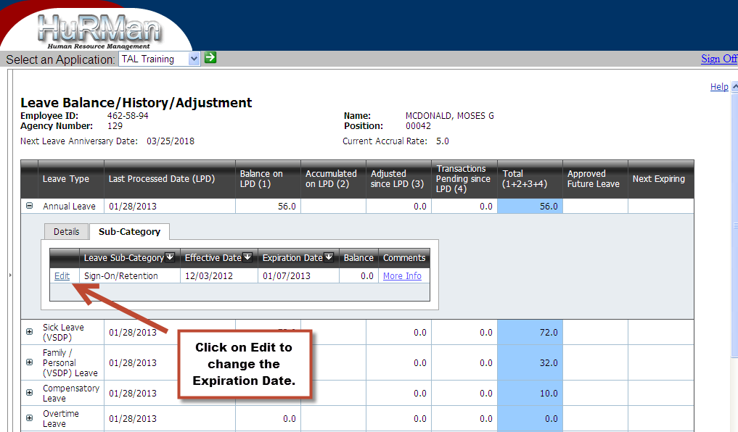

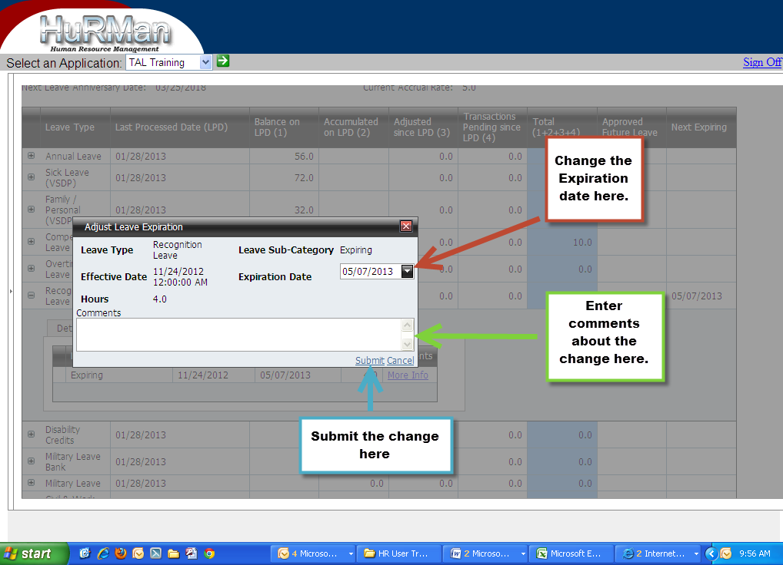

## Adjusting Leave (HR only)

An HR User is **the only role** that has the authority in TAL to make adjustments to an employee’s leave balances. These adjustments are made from the Adjust Leave screen. The Adjust Leave screen is accessed by clicking on the New button at the bottom of the Leave Details window.

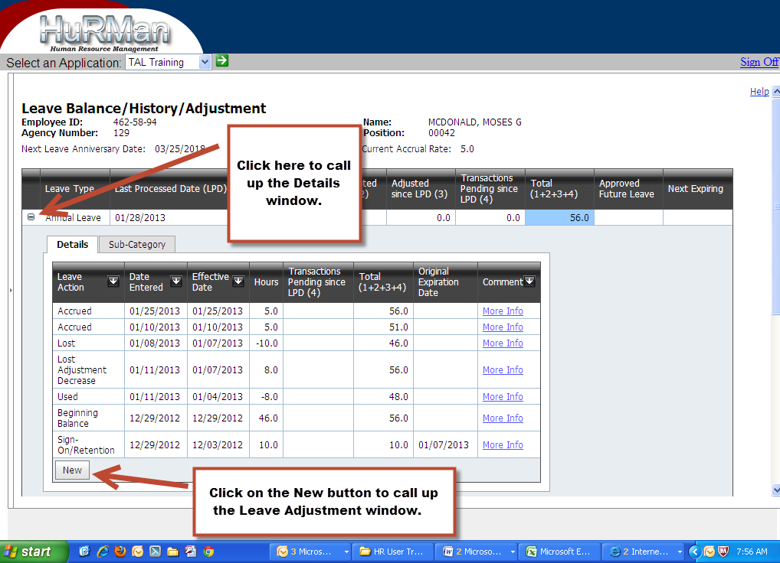

Once on the Adjust Leave screen, an HR User can take actions such as:

* correct a leave balance
* credit an employee with Compensatory leave earned
* award Recognition leave and assign an expiration date
* create transactions for leave donated, received or returned for leave sharing purposes
* award sign-on/retention leave bonuses
* change expiration dates
* record leave used
* process leave balances for separated employees – for additional details and examples, see Appendix J - Processing Leave Balances for Separated Employees.
* verify leave liability data - for additional details see Appendix K - Certifying Leave Liability Data.

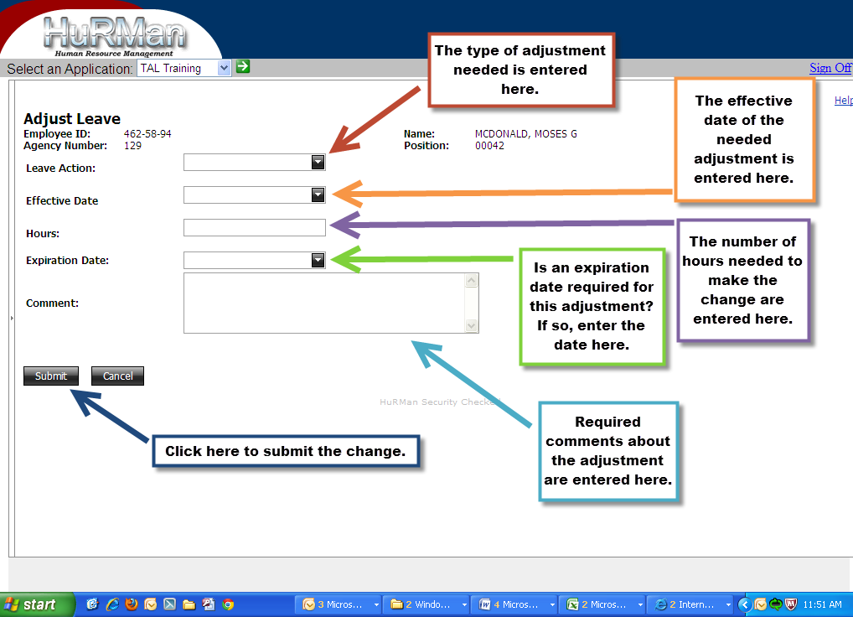

The choices available in the Leave Action drop down menu will depend on which leave type the HR user is trying to adjust. Here is a list of which actions can be taken on a specific leave type:

|  |  |
| --- | --- |
| **Leave Type** | **Valid Actions for Leave Type** |
| Annual | Beginning Balance, Corrected-Increase, Corrected-Reduction, Donation Made, Donation Received, Donation Returned, Extended, Income Replacement, Paid Out, Sign-On/Retention, Used |
| Family/ Personal | Beginning Balance, Corrected-Increase, Corrected-Reduction, Used |
| Sick Leave (VSDP) | Beginning Balance, Corrected-Increase, Corrected-Reduction, Used |
| Sick Leave (Traditional)* | Beginning Balance, Corrected-Increase, Corrected-Increase (Family), Corrected-Reduction, Corrected-Reduction (Family, Family-Used, Paid Out, Used |
| Compensatory | Beginning Balance, Corrected-Increase, Corrected-Reduction, Extended, Earned, Income Replacement, Paid Out, Used |
| Overtime | Beginning Balance, Corrected-Increase, Corrected-Reduction, Earned, Income Replacement, Paid Out, Used |
| Recognition | Awarded, Beginning Balance, Corrected-Increase, Corrected-Reduction, Extended, Income Replacement, Paid Out, Used |
| Disability Credits | Beginning Balance, Corrected-Increase, Corrected-Reduction, Income Replacement, Paid Out, Used |
| Military Leave Bank | Beginning Balance, Corrected-Increase, Corrected-Reduction, Credited, Income Replacement, Paid Out, Used |
| Military Leave | Beginning Balance, Corrected-Increase, Corrected-Reduction, Used |
| Civil & Work Related | Beginning Balance, Corrected-Increase, Corrected-Reduction, Used |
| School Assistance & Volunteer Service | Beginning Balance, Corrected-Increase, Corrected-Reduction, Used |
| Bone Marrow/Organ Donation | Beginning Balance, Corrected-Increase, Corrected-Reduction, Used |
| Educational | Beginning Balance, Corrected-Increase, Corrected-Reduction, Used |
| Emergency/Disaster | Beginning Balance, Corrected-Increase, Corrected-Reduction, Used |
| Public Health Emergency | Beginning Balance, Corrected-Increase, Corrected-Reduction, Used |
| Pre-Layoff | Beginning Balance, Corrected-Increase, Corrected-Reduction, Used |
| Pre-Disciplinary | Beginning Balance, Corrected-Increase, Corrected-Reduction, Used |
| Leave Without Pay | Beginning Balance, Corrected-Increase, Corrected-Reduction, Used |
| Short-term Disability | Beginning Balance, Corrected-Increase, Corrected-Reduction, Used |
| Long-term Disability | Beginning Balance, Corrected-Increase, Corrected-Reduction, Used |
| Workers Comp | Beginning Balance, Corrected-Increase, Corrected-Reduction, Used |
| Family Medical Leave | Beginning Balance, Corrected-Increase, Corrected-Reduction, Used |
| Pay Docking | Beginning Balance, Corrected-Increase, Corrected-Reduction, Used |

\***Notes:**

This table contains only those types of leave that can be adjusted using the Adjust Leave screen. Other types of leave can be selected by the employee on the Timesheet screen and/or the Leave Request. (Example: Emergency Closing/Delayed Opening, Holidays)

* If the HR User enters Pay Dock or LWOP using the Leave Adjustment screen, TAL will still apply the leave accrual for the associated pay cycle.  The HR user would also need to manually adjust the leave to remove the accrual.
* While Sick Leave (Traditional) – Family is a leave type on the Balance/History/Adjustment Screen, no adjustment can be made to this leave type. Any adjustments for this leave type must be made from the Sick Leave (Traditional) Adjust Leave screen.
* When making an adjustment that spans multiple days, rather than lumping the hours into a single adjustment, individual adjustments should be made on specific days and for the hours used.  Although this technique will take additional time compared to the lump sum approach, it will accurately reflect the usage of the leave.  In addition, if TAL needs to determine if an employee had sufficient leave on a certain date, it can only do this if the leave is entered as it was actually used

## Leave Request Screen

The Leave Request screen is accessed by clicking on “Leave Requests” in the Treeview.

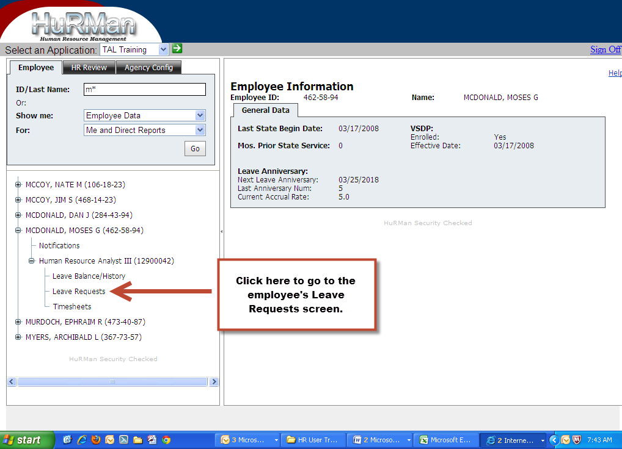

This will bring the privileged user to the same Leave Request screen that the employee can access. The HR User will have all of the same functionality as the employee.

## Approving and Creating Leave Requests (HR only)

From the Leave Request Screen, an HR User may review an employee’s old leave requests or create a new leave request on behalf of an employee. This is done the same way an employee would create a leave request for themselves.

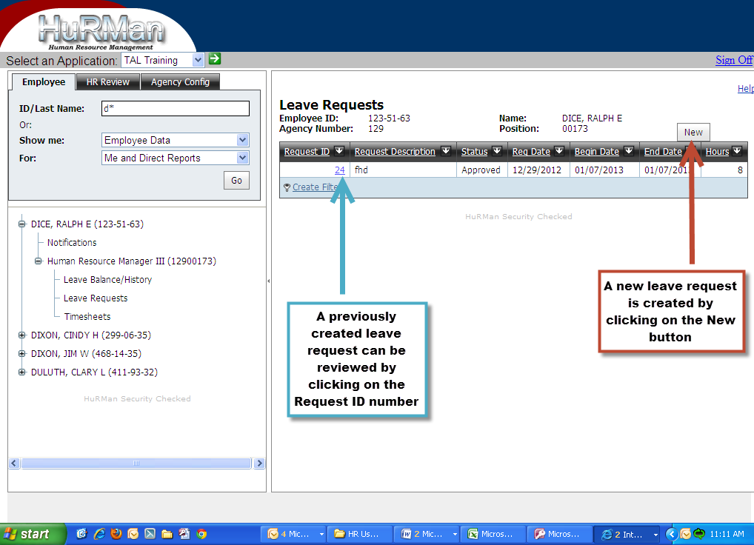

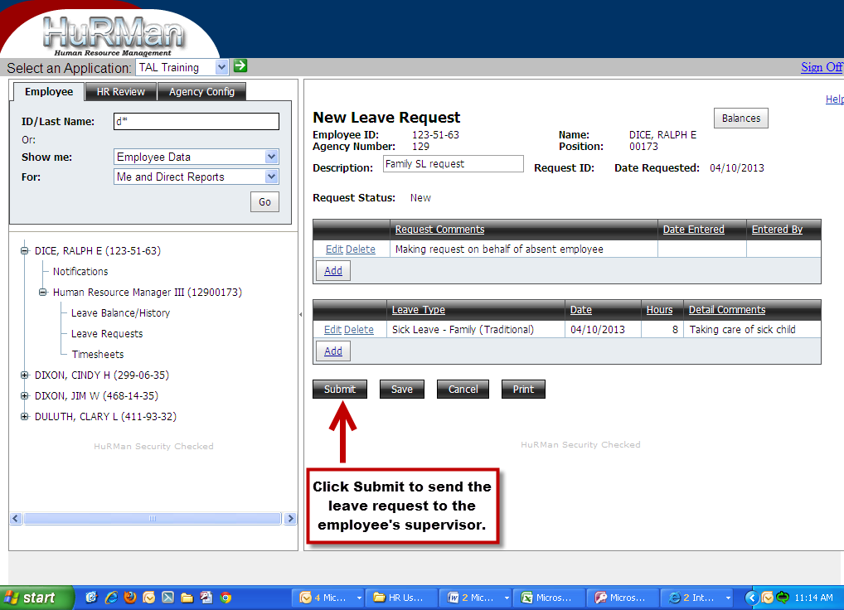

An HR User can open a leave request made by an employee by clicking on the Request ID number. Once the request has been opened, the HR User has the ability to take the same actions that the employee’s supervisor is able to do.

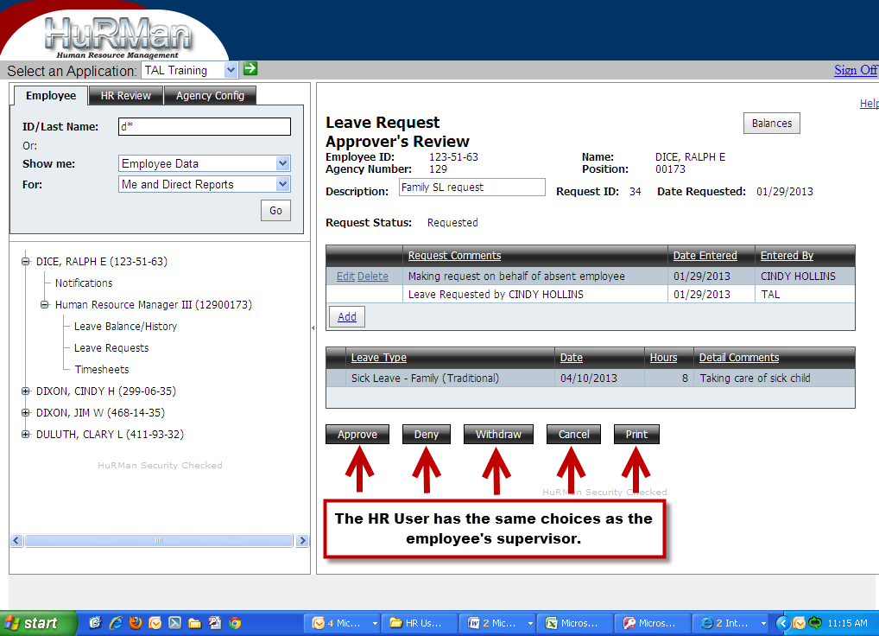

**Notes:**

* *An employee who submitted a request can withdraw it up until the point that the request has been approved/denied.*
* *The employee’s supervisor or the HR User can withdraw the employee’s leave request as long as the days of leave on the leave request have not all passed.  If a leave request containing multiple days of leave is withdrawn, only those days that have not yet passed will be withdrawn.*
* *If an employee who is not required to complete timesheets submits a leave request for Pay Dock or LWOP, TAL will not apply the leave accrual for the associated accrual period (provided that the Pay Dock or LWOP falls within the period for which TAL is giving the accrual and provided that the leave request has been submitted and approved prior to when TAL gives the accrual for the period.). If an accrual has been applied to an employee’s balance for an accrual period, and then a leave request is submitted/approved that contains docking for that same period, TAL will not remove the accrual.  In this case, TAL will write an exception and the HR user must manually adjust the balance to remove the accrual. Also, in cases where the HR User enters Pay Dock or LWOP using the Leave Adjustment screen, TAL will still apply the leave accrual and the HR user would need to manually adjust the leave.*
* *If Comp Earned is entered on a leave request TAL will automatically set an expiration date of 1 year in the future.  The setting of the expiration date happens when the overnight leave process is processing the leave so you won’t see it right away on the leave balance screen.*

## Timesheet Screen

In TAL, timesheets…

1. Can be created, updated and submitted for approval
2. Can be edited and revised up to a certain point (called a “lock”) and after that have a new version created
3. Have the worked hours for positions that are designated to be sent to CIPPS-Payroll summarized and transmitted (the process of summarizing in TAL is referred to “batching”)
4. Can require manual processing by HR rather than automated processing by TAL

**Creating and Accessing Employee Timesheets**

HR Users and Agency Inquirer 1 roles can view an Employee’s Timesheet through the tree view by entering an employee’s name or employee identification number and clicking “go”. To access the employee’s timesheet, expand the tree view further by selecting the (+) symbols located to the left of the employee’s name and then again next to their role title. See screenshot below.

Timesheets for Inactive Positions

* When an employee transfers to another position (and that transfer has been recorded in PMIS and communicated overnight to TAL), the supervisor of the former employee will no longer be able to view the timesheets for the employee.
* If timesheets were not approved prior to when the position became inactive, the HR User must approve the timesheets.
* If the Position Separation Date on the employee’s position screen is prior to the last day on the timesheet, TAL will allow the timesheet to be approved immediately by the HR user.

Running the TAL Query named “Timesheets – Unapproved Timesheets” on a regular basis will provide the HR User with a list of timesheets that may need to be approved.

In this diagram, this wage employee occupies an active wage position for the agency and previously occupied a different wage position in the same agency. The HR User can still access the Inactive position through the tree view, however the employee may access only the current position’s timesheets.

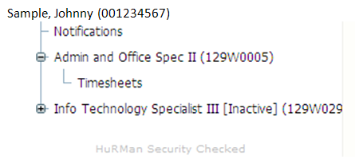

**Employee Timesheet Screen**

Point and click on “Timesheets” located in the tree view directly beneath the employee’s role descriptor, which leads to a screen containing a list of timesheets for the employee. See screenshot below.

Each timesheet is provided a unique identification number, a version number and denotes if the version is current. In addition, all timesheets are highlighted by the start and end date of the work cycle (except in the case of wage employees who are paid on a semi-monthly basis) and current status of the timesheet. The statuses for timesheets are:

|  |  |
| --- | --- |
| Draft | The timesheet has been started |
| Submitted | The timesheet has been submitted and is ready for supervisor’s approval |
| Approved | The timesheet has been approved and is ready for any additional TAL processing |
| Complete | The approved timesheet has been processed for leave and payroll purposes. Status will change to Complete on the night of the lock date associated with the timesheet. If a timesheet with a Complete status is opened for revision, a new version of the timesheet will be created. Any changes made to the new version of the timesheet that impact leave or additional pay must be handled by the HR user manually. |

Finally, the list provides a status date for when each timesheet was last updated. This allows managers/supervisors and privileged users to identify the timesheets that need review and the relevant background information for that timesheet. In the upper right corner of the Employee Timesheet Listing screen, a direct link to a new timesheet is available by selecting the box labeled “New.” When the HR User selects the New button, a list of all timesheets that have not already been completed for 6 months in the past and 2 months in the future will be displayed. Employees will only see a list of timesheets that have not been completed for 2 months in the past and 2 months in the future.

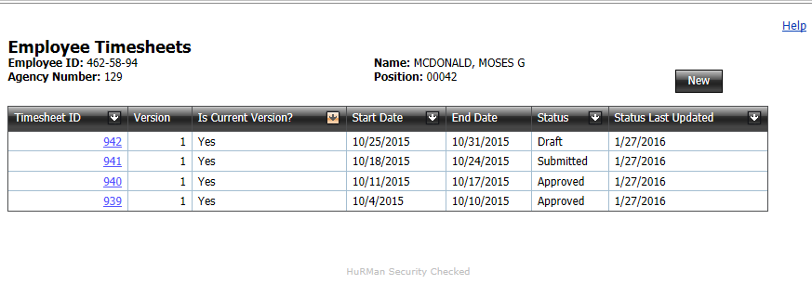

**Reviewing Employee Timesheets**

Use the mouse to point and click to select the Timesheet ID that requires review. This screen includes a Table of Timesheet Comments (see below) outlining the various actions taken by privileged users and supervisors. If the employee responds to the comment notifications, these comments will also be included in the Table of Timesheet Comments.

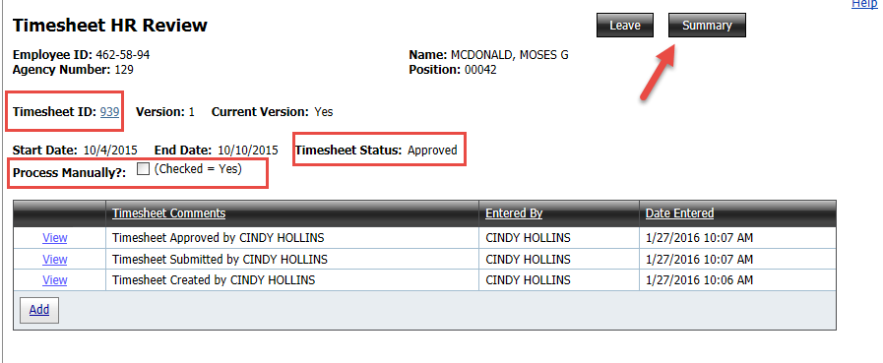

This section of the screen also contains the following identifying information:

* Timesheet ID Number
* Timesheet Status
* Summary (which provides a total of the timesheet’s recorded hours)
* Marker for Processing the Timesheet Manually

A complete view of the time entries is visible on this screen. See below (but note that in this screenshot, HR was advised by the employee that he forgot an entry for 3/15/2013).

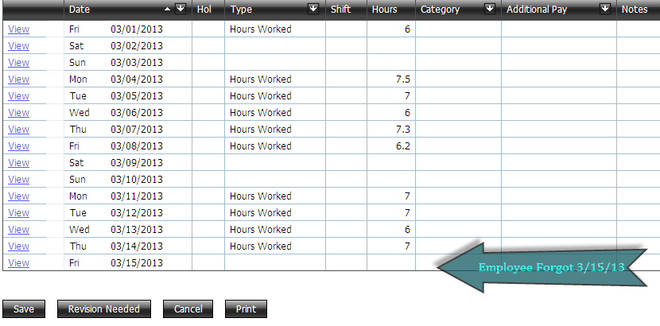

**Pay Dock and LWOP**

If a timesheet contains either PayDock or LWOP hours for dates that the current accrual period covers, TAL will not apply leave accruals for that accrual period.  TAL does not change the Leave Accrual switch on the TAL Setup tab to “Off”, nor is it necessary to do so. If an accrual has been applied to an employee’s balance for an accrual period, and then afterwards a timesheet or leave request is submitted/approved that contains docking for that same pay cycle, TAL will not remove the accrual.  An exception will be written and the HR user must manually adjust the balance to remove the accrual.

An exception is written on approval of a salaried employee's timesheet which contains Pay Dock or LWOP on a timesheet. The employee ID and timesheet ID can then be retrieved from the exception report.  Hours in deficit from a Pay Dock or LWOP must be manually reported to the agency’s Payroll Officer or Payroll Representative at the Payroll Services Bureau with a request to exclude the docked hours.

**Comp Earned**

TAL does NOT calculate and add Compensatory (Comp) Leave Earned for situations when an employee’s total combined work hours, leave and/or holiday hours exceed forty (40) hours in an established work cycle.  If an employee is eligible for Comp Leave Earned, a new entry must be made on the timesheet by selecting Comp Leave Earned in the Type dropdown and entering the number of hours earned.

Note:  If Comp Leave Earned is added to a timesheet and the Total Hours Worked is less than the OT Basis, but the Total Hours Worked + Paid Leave is greater than the OT Basis, salaried non-exempt employees could be overcompensated.  To avoid this, the timesheet can be marked as Process Manually, and the Comp Leave Earned added to the employee’s Leave Balance Screen manually by the HR User. See Appendix A for more information regarding Process Manually and Appendix G for examples containing Comp Leave Earned and Holiday Pay

If Comp Earned is entered on a timesheet, TAL will automatically set an expiration date of 1 year in the future.  The setting of the expiration date happens when the overnight leave process is processing the leave so you won’t see it right away on the leave balance screen.

**Calculating Compensation for Additional Hours Worked on Timesheets**

The chart below applies only to Salaried Non-Exempt Employees.

|  |  |
| --- | --- |
| **Timesheet Totals** | **Rate** |
| **Total Hours Worked > OT Basis Hrs** | **On TAL Settings tab:  If OT Treatment Type = Paid, Hours > OT Basis Hrs sent to CIPPS at rate of 1.5%   if OT Treatment Type = Leave, TAL will create OT Leave hours at rate of 1.5% in the Employee Leave Balance screen up to the maximum number of Leave Hours designated on TAL Settings screen. Once the maximum number of Leave Hours defined is reached, TAL will automatically treat the overtime as Pay.** |
| **Total Hours Worked < or = to OT Basis Hrs but Total Hours Worked + Paid Leave > OT Basis Hrs** | **Hours > OT Basis Hrs sent to CIPPS at rate of 1.0%** |

## Approving and/or Adjusting Employee Timesheets (HR only)

The HR User has the ability to approve and modify an employee timesheet. By clicking the “Revision Needed” button. It is important to attempt to make any necessary modifications to a timesheet as soon as possible to avoid manual processing.

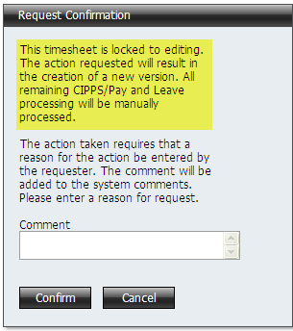

Enter a comment noting the reason for the change to a timesheet and point/click Confirm to proceed.

# Understanding the HR Review Tab and Screens

The HR Review Tab provides a way to query for the TAL system for information as well as create, review and transmit batches of transactions to CIPPS for payment. The HR Review Tab and Tree has the following look:

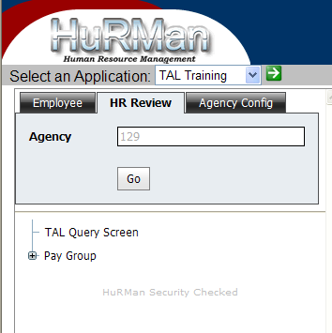

## TAL Query (and other reporting)

By clicking on the TAL Query Screen link in the HR Review tab the user is presented the following screen:

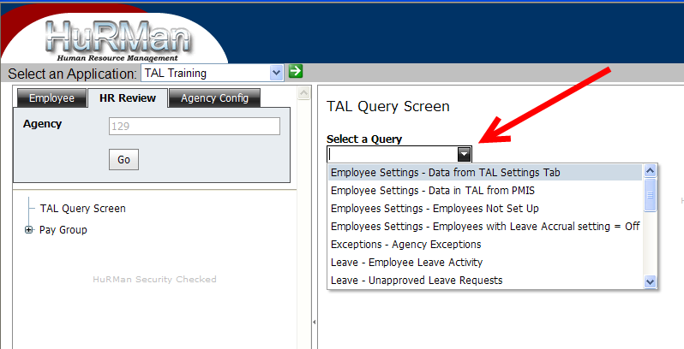

The dropdown labeled “Select a Query” provides a list of different queries that a privileged user can select and run. Some of the queries require the user to enter additional criteria (e.g., a date range).

Following is a list of queries, the user role that can run them and a brief description of the information that they can provide:

| **TAL Query Name** | **HR** | **Agency Inq1** | **Agency Inq 2** | **Payroll** | **This query…** |
| --- | --- | --- | --- | --- | --- |
| Employee Settings - Data from TAL Settings Tab | x | x |  |  | ...provides a quick way to see the settings entered on the TAL Settings Tab of the Position Screen |
| Employee Settings - Data in TAL from PMIS | x | x |  |  | ...provides a quick way to see the PMIS Data that TAL has for all positions currently filled at an agency. |
| Employee Settings - Employees Not Set Up | x | x |  |  | ...identifies those employees who do not have the "Set Up Complete" checkbox checked on the Position Screen. If this checkbox is not checked, then the employee cannot get to the leave balances and timesheets. |
| Employee Settings - Employees with Leave Accrual setting = Off | x | x |  |  | ...identifies salaried employees whose Leave Accrual setting is set to "Off" on the TAL Settings tab of the Position Screen. Employees whose setting is set to "Off" will not receive leave accruals when TAL runs and tries to provide them. |
| Exceptions - Agency Exceptions | x | x |  | x | ...allows a user to see all the exceptions for an agency for a specific timeframe. As certain processes run in TAL (e.g., processes related to giving and taking leave, the generation of batches of transactions that go to CIPPS, etc.) TAL monitors for "exceptions". This query |
| Leave - Employee Leave Activity | x | x |  |  | ...provides a list of all the leave transactions that occurred during a specific timeframe for an agency |
| Leave – Employee Leave Register | x | x |  |  | …provides current leave balance plus list of all the leave transactions for a specified date range for a single employee |
| Leave – Separated Employees w/Reviewable Leave Balances | x | x |  |  | …provides a report of employees that have separated but still show leave balances |
| Leave - Unapproved Leave Requests | x | x |  |  | ...provides a list of unapproved leave requests and the number of days that the approval has been outstanding |
| Leave Liability Reporting - Company Breakdown | x |  |  |  | ...returns company (agency) level leave liability data as of a particular date (entered in order to run the query). Data returned from this query is similar to that of DOA's U0027 report. |
| Leave Liability Reporting - Employee Detail | x |  |  |  | ...returns employee and fund/function level leave liability data as of a particular date (entered in order to run the query). Data returned from this query is similar to that of DOA's U0020 report. |
| Leave Liability Reporting - One Year Estimate | x |  |  |  | ...returns one year estimates of leave liability for current employees as a of particular date (entered in order to run the query) |
| Supervisors - All Alternate Supervisors | x | x |  |  | ...provides a list of supervisor alternates that are set up in TAL for an agency. The list includes those who were alternates during a past period of time, those who are currently set up as alternates and those who are designated as an alternate for a future period of time. |
| Supervisors - Current Alternate Supervisors | x | x |  |  | ...provides a list of supervisor alternates that are set up in TAL for an agency. The list includes only those who are alternates on the date that the query is run. |
| Supervisors - Supervisors and their Direct Reports | x | x |  |  | This query lists supervisors and their direct reports |
| Timekeepers - All | x | x |  |  | ...provides a list of agency timekeepers and the employees for whom they keep time. The list includes those who were timekeepers during a past period of time, those who are currently set up to keep time and those who are designated as timekeepers for a future period of time. |
| Timekeepers - Current | x | x |  |  | ...provides a list of agency timekeepers and the employees for whom they keep time. The list includes only those who are timekeepers on the date that the query is run. |
| Timesheet Monitor | x | x |  | x | … provides a report containing the status of all timesheets that have a start date in a specified date range. Can be filtered by wage, exempt or non-exempt status. Also includes OT hours at Premium and Straight rates from timesheets including those that haven’t been approved yet |
| Timesheets - Details for Timesheets Approved within Date Range | x | x |  | x | ...provides detailed timesheet data from timesheets that were approved within a specified date range |
| Timesheets - Details for Specific Timesheet | x | x |  | x | ...provides specific data for given timesheet. |
| Timesheets - Employee Hours By Date Range and Employee Type | x | x |  | x | ...provides detailed timesheet data from timesheets with entries within the specified date range. This query was created at the request of DARS. |
| Timesheets - Hours Charged by Category | x | x |  |  | ...provides hour charged to a specific category. Hours are only taken from the current version of timesheet and only from approved timesheets. |
| Timesheets – Timesheet Detail by TAL (Batch) ID | x | x |  | x | …provides details of timesheets that are included in a batch |
| Timesheets - Unapproved Timesheets | x | x |  |  | ...lists employees who have created timesheets and those timesheets have not been approved. The query identifies the number of days since the timesheet end date. The query also provides contact info (phone and email) for the employee and his/her supervisor. |
| Wage Hour Tracking Verification | x | x |  |  | …provides information on wage employees and hours on a wage year basis (which is the period from 5/1 of one year to 4/30 of the following year) |

Notes:

1. TAL also provides the ability to print timesheet and leave requests. This capability is provided on the Timesheet and Leave Request screens.
2. Additional TAL data is being targeted to be available in the DHRM Data Warehouse. As DHRM and agencies identify reports/queries or downloads that are better suited to be provided out of the DHRM Data Warehouse, efforts will be undertaken to design, develop and provide those reports through the Data Warehouse.

## Pay Groups

TAL automates the collection of hours worked from approved timesheets, creates batches of transactions of summarized employee hours to be paid and transmits the batches of transactions to CIPPS Payroll. The HR Users and Payroll Users at agencies have the following key responsibilities in TAL related to this process:

1. Initiate the process that creates the batches of transactions
2. Review the created batches
3. Withdraw the created batches from transmission to CIPPS Payroll OR designate them as Ready to Transmit to CIPPS Payroll

TAL enables these users to perform the above steps by accessing the “Pay Group” option under the “HR Review” tab. Although other types of privileged users will have view access to the PayGroups, it will be used mostly by the HR and/or Payroll Users.

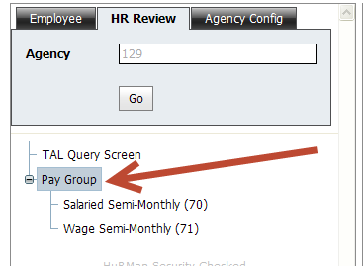

Before describing the steps to take in TAL to perform the above responsibilities, it is important to first understand the processes and steps involved from the creation of a timesheet to the payment of employees by CIPPS Payroll for Hours Worked.

Note: Appendix H – How Timesheet Data is Sent to CIPPS contains additional information on data from timesheets that is sent to CIPPS, as well as an overview of the steps involved in a CIPPS batch creation.

The following diagram depicts those processes and steps:

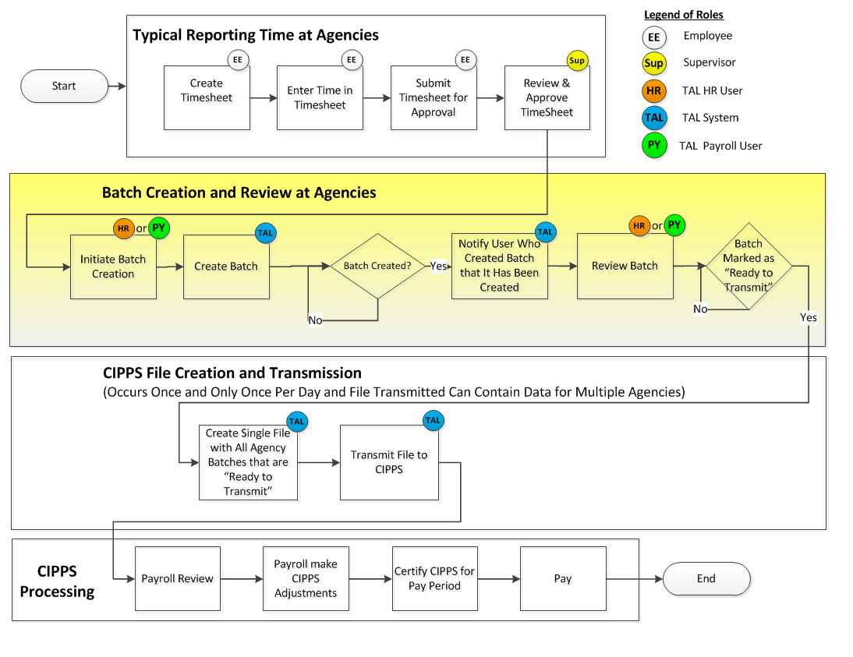

### 4.2.1 Creating, Reviewing, and Transmitting a Batch of CIPPS Transactions

The batch creation and review process performed by HR Users or Payroll Users is performed using the links under the “Pay Group” option in the treeview.

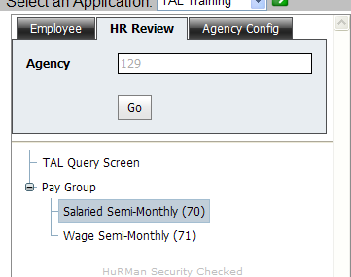

When the Pay Group option in the treeview is expanded, the specific pay groups that have been set up for an agency are displayed under it. For example, in the screenshot above, two pay groups (“Salaried Semi-Monthly (70)” and “Wage Semi-Monthly (71)” ) are displayed. When a specific pay group in the treeview is clicked, the following Pay Group screen is shown:

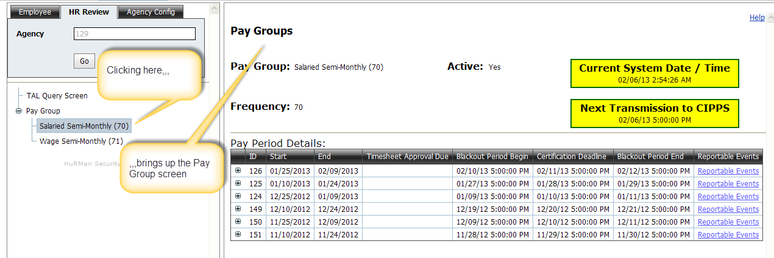

Following is a description of the fields on the Pay Group screen:

|  |  |
| --- | --- |
| **Grid / Field** | **Definition and Key Notes** |
| **Pay Group** | Shows the name of the specific Pay Group being displayed. This name will correspond to one of the pay groups set up for the agency on the Agency Config tab in TAL. |
| **Active** | Indicates whether the specific pay group being displayed is actively being used (values are Yes and No). |

|  |  |
| --- | --- |
| **Frequency** | A two digit number that corresponds to CIPPS Pay Frequency number. The Frequency Number determines how often employees in that frequency are paid in CIPPS Payroll: |
| **Name** | The possible options are listed in a “drop down” box. |
| **Current System Date/ Time** | Current Date and Time when the screen is first displayed |
| **Next Transmission to CIPPS** | The date and time that the TAL system will next attempt to send a file of agency transactions to CIPPS Payroll. If an agency intends for hours worked to make it into a CIPPS Payroll and be included in figures that the agency certifies to pay, then agency must create and mark as ready to transmit batches that contain those hours before the blackout period for a pay group begins. |
| **Pay Period Grid –** ID | Every pay period that an agency has set up in TAL has a unique number assigned to it. This number is called the Pay Period ID. |
| **Pay Period Grid –** Start | The start date of a specific pay period. |
| **Pay Period Grid –** End | The end date of a specific pay period. |
| **Pay Period Grid –** Timesheet Due | The date and time that timesheets are due. Note: This field will be empty except in the case of wage employees who are paid on a semi-monthly basis. |
| **Pay Period Grid –** Blackout Period Begin | When a payroll is being certified in CIPPS Payroll for a specific pay period, batches of transactions for that pay period should be withheld from transmission to CIPPS Payroll. This withholding is to avoid overlaying an existing, certified payroll with new amounts to pay that have not been certified. To properly withhold transmission of batches, TAL has a “blackout period” that starts before the certification deadline and extends after it. The Blackout Period Begin is the start date/time for the blackout period. |
| **Pay Period Grid -** Certification Deadline | The date and time that a particular pay period will be certified in CIPPS Payroll |
| **Pay Period Grid –** Blackout Period End | Refer to Blackout Period Begin above. |
| **Pay Period Grid –** Reportable Events | A link that, when clicked, displays key events that HR will want to be aware occurred during a pay period that possible affect employee pay. Refer to the section titled “Agency Exceptions and Reportable Events” for more information. |

By expanding a particular pay period on the Pay Group screen, HR and Payroll Users are able to create new batches and view batches of transactions that they previously created. The Create Batch button will typically be displayed under the current Pay Period (refer to the **Create Batch button** description in the last table within this subsection for more information on the display of this button). It is used to create a new batch of CIPPS transactions. It is possible to have multiple batches for the same Pay Period.

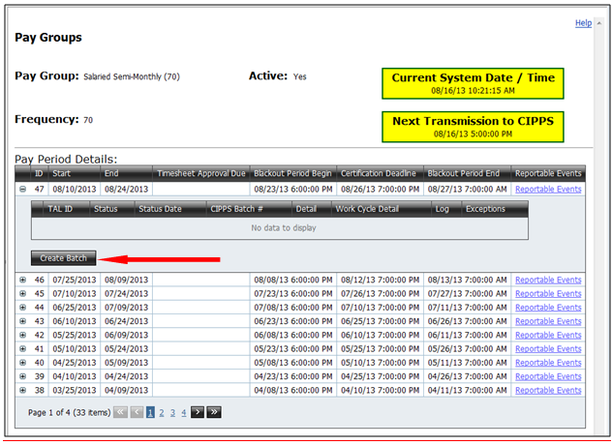

Once the batch is created, a row will be displayed in the Pay Period which contains the status along with links to additional information on the batch. If TAL found information to send to CIPPS, then the initial status on the batch will be set to “Pending Review”. If TAL did not find information to send to CIPPS, then the status will be set to “TAL Withdrawn”. For a batch that shows “Pending Review” the HR or Payroll User responsible for the batches should review the information in the batch. If this user is satisfied with the file, he/she should change the status to “Ready to Transmit” by selecting the Edit link, then selecting “Ready to Transmit” from the Status dropdown, followed by Save.

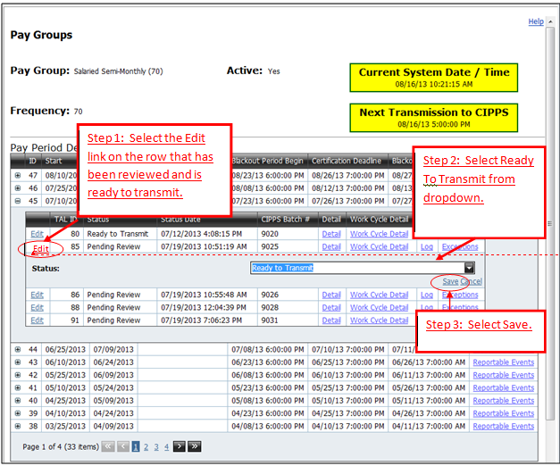

If, after reviewing the batch, the user does not want to send the transactions to CIPPS, the user should change the status in Step 2 of the screenshot above to “Withdrawn”.

The expansion of a particular pay period could look as follows:

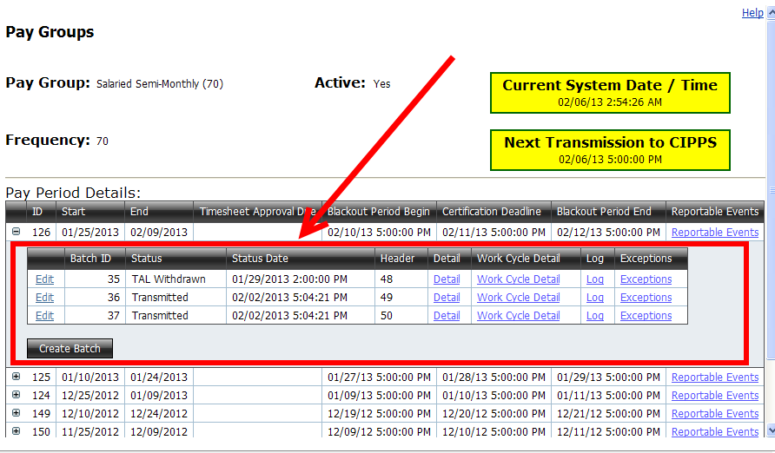

Following is description of the fields highlighted in the screenshot above:

|  |  |
| --- | --- |
| **Field** | **Definition and Key Notes** |
| Edit link | The Edit link provides a way to update the status of a batch that has been created. When clicked the link provides a means for an HR or Payroll User to change the status (see Status below) associated with a batch. |
| Batch ID | TAL assigns a unique number to every batch of transactions that it creates. This Batch ID is that number. This batch ID is **not** the CIPPS Batch Number that CIPPS uses to process batches of transactions. |
| **Status** | The status associated with a batch of transactions that TAL has created.  Valid status values and their meanings are:   1. In Process – While TAL creates a batch of transactions, it assigns this status to the batch. 2. Pending Review – This status is assigned by TAL after it creates a batch of transactions (provided that at least one transaction was created in the batch). 3. Ready to Transmit – Only a TAL User in the HR User or a Payroll User can assign this status to a batch. If a batch has this status when the TAL to CIPPS Interface runs, then that batch is included in the file transmitted to CIPPS (unless the pay period is in a blackout period). 4. Transmitted (Interface) – TAL assigns this status to a batch once it has included a batch in the file interfaced to CIPPS. 5. Withdrawn – This status indicates that the batch was removed by a TAL user from inclusion in the file that is transmitted to CIPPS. Only a TAL user in the HR User or Payroll role can assign this status to a batch. If this status is set inadvertently, then contact the TAL Support Team to address. 6. TAL Withdrawn – This status indicates that no transactions were created when TAL attempted to create a batch of transactions. Since no transactions were created, TAL withdraws this “non-batch” of transactions from inclusion in the file sent to CIPPS Payroll.   The following indicates who and what statuses a batch can change from and to: |
| **Status Date** | The date and time associated with the Status that is displayed |
| **Header** | This is the CIPPS Batch Number associated with a set of transactions that TAL creates |
| **Detail link** | When clicked this link displays the transactions as they will look when included in the file that goes to CIPPS. A sample display is:  C:\DOCUME~1\vjg62759\LOCALS~1\Temp\SNAGHTML75f294.PNG    The arrow in the above screenshot points to the data that is in an actual transaction. The meaning of the numbers that are in each position of the entry that the arrows points are identified in Appendix D. |
| **Work Cycle Detail link** | When clicked this link displays a further breakdown of transactions by work cycle. |
| **Log link** | This link is more for technical troubleshooting if there is a problem in the way that batches are created. |
| **Exceptions link** | Sometimes when batches are created, TAL detects situations (e.g., a salaried exempt employee reported fewer hours than they are required – see section entitled “Agency Exceptions and Reportable Events”) and generates exceptions for HR/Payroll to review. The Exceptions link shows the exceptions that TAL found for a particular batch. |
| **Create Batch button** | When clicked initiates a TAL process to look for approved timesheets from which to create a batch of transactions.  This button only appears under one pay period. The period it appears under is the pay period that has a Certification Deadline that is closest, but greater than the current system datetime. |

Notes:

1. A batch of transactions is a sum of hours by employee that TAL creates. These hours are pulled from approved timesheets. It is possible to include hours from earlier periods than those in the pay period for which a batch is created. This scenario can happen if timesheets are not created and approved in a timely manner.
2. When creating transactions, TAL examines the work cycle that is associated with an employee to determine overtime hours.
3. Agencies should emphasize the timely submission and approval of timesheets to avoid the need to create more than one batch for a pay period. However, TAL does allow an agency to create and transmit more than one batch for pay period.
4. **TAL does not transmit batches to CIPPS on Saturday or Sunday or full-day state holidays**. On partial-day holidays TAL may send files - the TAL Team will send guidance on partial-day holidays as those days near.
5. On days that it does transmit to CIPPS, TAL will do so at 5PM unless otherwise noted in the “Next Transmission Date to CIPPS” box (shown below). Agencies should make sure that batches they want sent on a day that TAL transmits are marked as “Ready to Transmit” by the Next Transmission to CIPPS Date time.

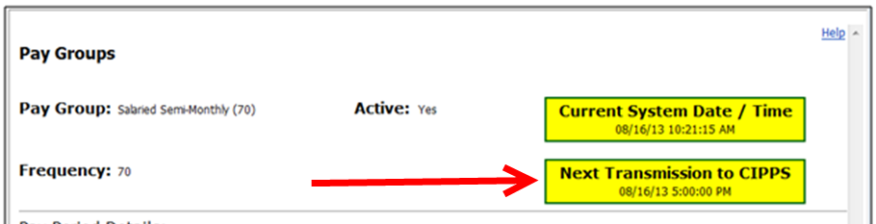

1. An Example of a Checklist for Creating, Reviewing and Transmitting TAL batches to CIPPS is provided in Appendix C.

.

## Agency Exceptions and Reportable Events

The TAL system attempts to capture and track information that is important to HR and Payroll. Much of this information is consolidated into two areas: Agency Exceptions and Reportable Events. There are different ways to get to each of these as the following screenshots show:

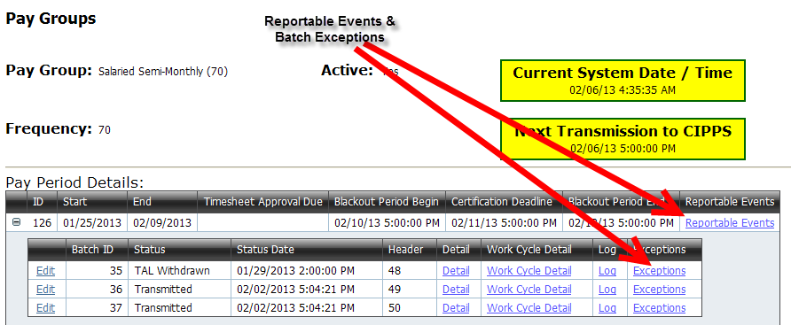

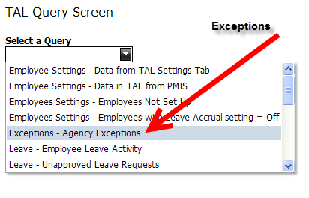

**Agency Exceptions**

* TAL has processes that run to perform special functions – such as:
  + creating batches of transactions for review and transmission to CIPPS
  + pulling data from PMIS to refresh the data in TAL
  + processing leave requests to update employee balances
  + processing approved timesheets
* When TAL runs the above processes and detects something that needs HR attention, it writes a message to a special log it maintains. These special messages are referred to as “exceptions”.
* To see agency exceptions for your agency, use the TAL Query Screen feature and select the ‘Agency Exceptions’ query (or to see Exceptions associated with the creation of a batch, click on the Exceptions link associated with the batch)
* It is recommended that HR Users monitor the TAL System for exceptions as these exceptions generally require HR action.
* The list of possible exceptions and actions to take to address are listed in Table 4.1.

#### How to Find and Resolve the Exceptions

1. From the TAL Query Screen, select Exceptions - Agency Exceptions from the dropdown to view exceptions for the agency within a specified date range.

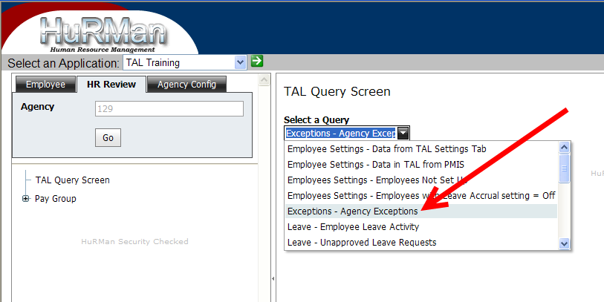

1. Enter the desired date range. Note that the maximum date range is 31 days

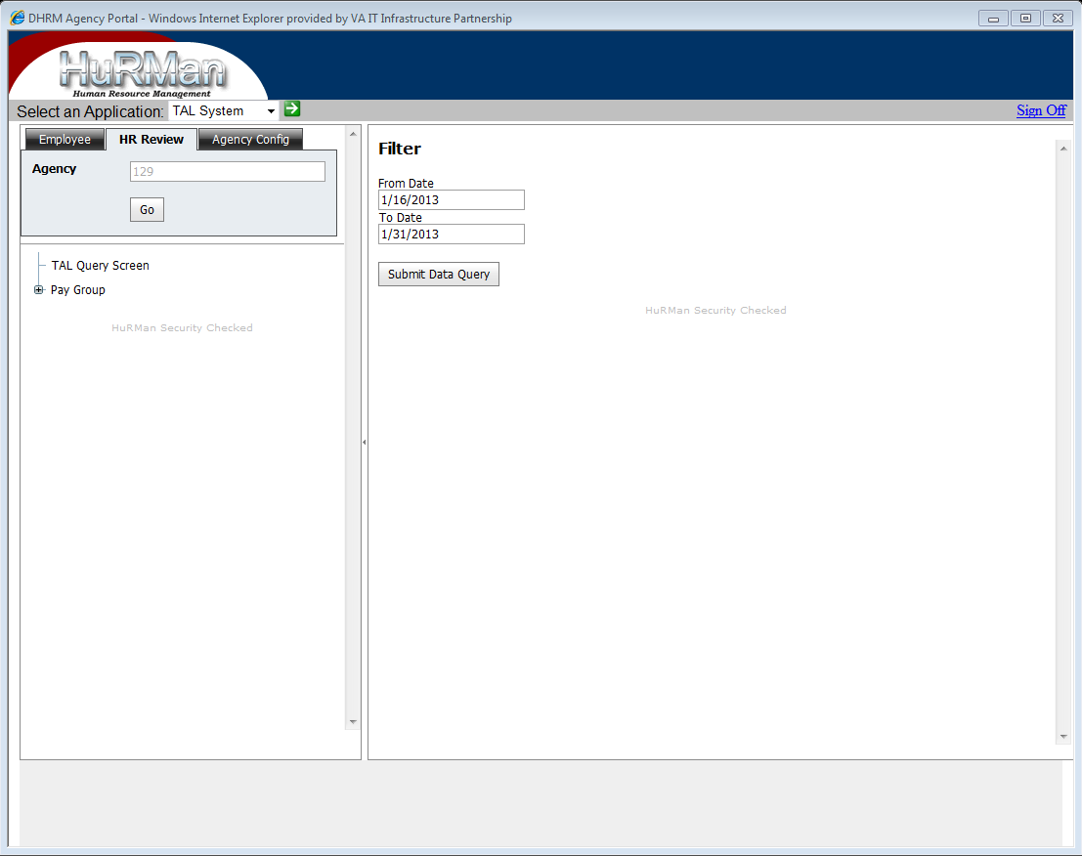

1. Data can be viewed on the screen, or can be exported to Excel by selecting the Export to XLSX button (If running MS Excel version 2003 or older then export to XLS.) It may be beneficial to keep a master spreadsheet of exceptions each time the report is run, and include details of when and how the exception was handled.

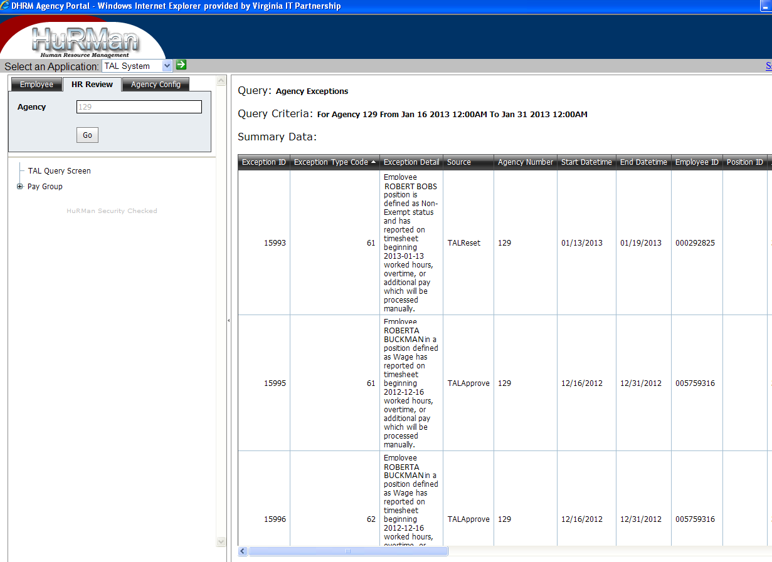

1. Review the data and determine the status of transactions and determine the next steps to be performed by the HR User. See Table 4.1 for additional information on exceptions and suggested action to be taken by the HR User.

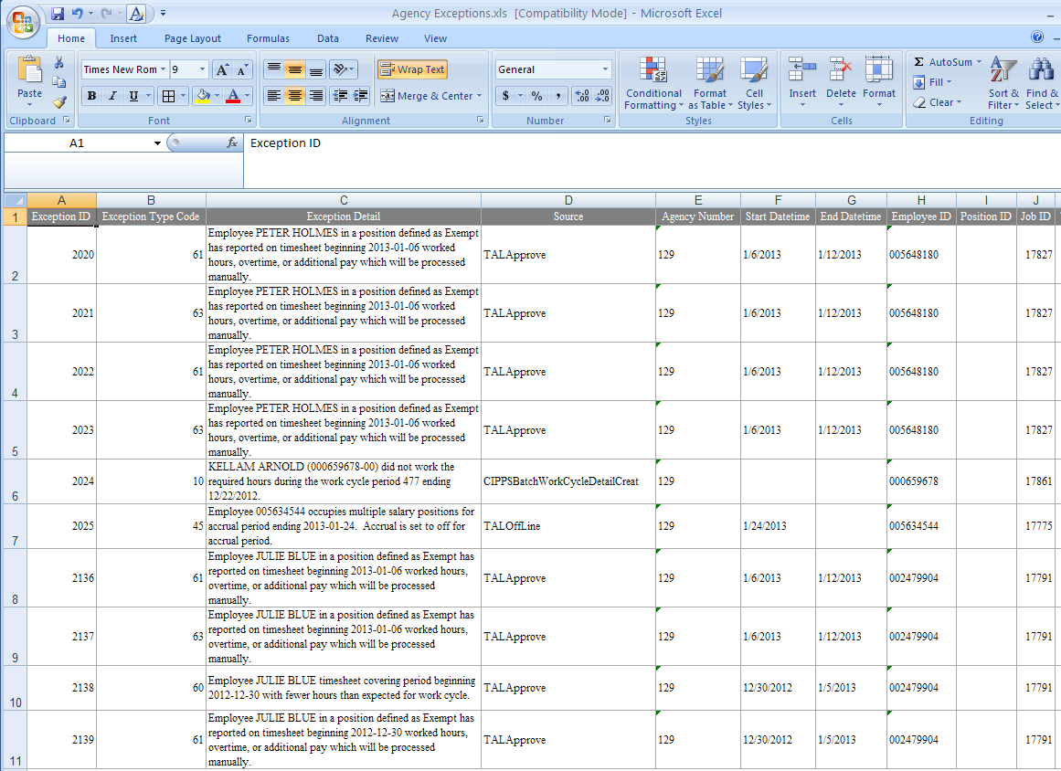

#### Fields of interest

|  |  |
| --- | --- |
| Exception Type Code | Type code associated with exception. This field may be useful when processing a type of work for multiple employees. For example, making leave adjustments. |
| Exception Name | Descriptive name given to exception. |
| Exception Detail | Detailed description of the exception in the context of the source of the exception. |
| Source | The TAL routine that generated the exception. (i.e. "TALOffline" which is the overnight processing of leave, or "TALApprove" when exception is written on timesheet approval. |
| TimesheetID | If the exception is related to a timesheet, then a Timesheet Id associated with the Exception |
| Version | Version number of the timesheet. (If a timesheet that is locked is opened for revision, the version number will be incremented so there could be multiple versions with the same Timesheet ID.) |

Below is a table of the TAL Exceptions, along with a description and suggested action for each.

Table 4.1 – Exceptions

|  |  |  |  |  |  |  |  |
| --- | --- | --- | --- | --- | --- | --- | --- |
| **Exception Type Code** | **Exception Detail** | **Explanation/Conditions** | **Exception Name** | **Wage** | **Salary Exempt** | **Salary Non Exempt** | **Action Required** |
| 1 | ***WARNING*** This PositionNumber [Position ID] has no corresponding SupervisorsPositionNumber. | There is no supervisor position number associated with the position in PMIS | PMISIntNoSupervisor | Yes | Yes | Yes | PMIS Data should be corrected to have a supervisor position number associated with the position. |
| 2 | ***WARNING*** This PositionNumber [Position Number] is set up more than once in TAL as vacant. Request DHRM to update so that at most there is only one record. | The vacant position is set up more than once in TAL. | PMISIntMultVacantPositions | Yes | Yes | Yes | Request DHRM to update so that there is only one record. |
| 3 | ***WARNING*** Position Number [Position Number] is set up more than once for your agency. Although sharing the same position number, these instances do not appear to be the same position. Contact DHRM for guidance. | The position number is set up more than once for your agency for positions that are not the same. | PMISIntPositionNotUnique | Yes | Yes | Yes | Contact DHRM for guidance on resolving. |
| 4 | ***WARNING*** EID:[EmployeeID] Position Number: [Position Number] OvertimeExemptionCode value will be changed from [x1] to [x2] | Either the EmployeePercentTime and/or the OT ExemptionCode values have changed in PMIS. This exception is an informational message with both old and new values displayed. | PMISIntChange%TimeOTExemptCd | Yes | Yes | Yes | Determine if there are any timesheets that have been approved but not processed that will be impacted by this change. |
| 20 | Timesheet ID [TimesheetID] for EmployeeIDNumber [EmployeeID] has been set to PROCESS MANUALLY. This change was triggered by a change to configuration information on the employee's Position Screen. | TAL detects a Position change for an already approved timesheet. The message identifies the employee and the timesheet that needs to be processed manually.  Occurs if: 1. Timesheet is the current version and in “Draft”, “Submitted”, or “Approved” status AND there is a change to any one of the following on the employee’s position:  • Pay Group • Work Cycle  • Overtime Exemption Code OR 2. Timesheet is the current version AND in “Approved” status AND there is a change to any one of the following on the employee’s position: • Employee Percent Time • Employee Time Status • Holiday Calendar • Overtime Treatment Type • Timesheet Is Sent To CIPPS flag | PositionChangeAffectTimesheet | Yes | Yes | Yes | Timesheet has to be processed manually. Open the timesheet and click on the link for TimesheetID to see the previous and current settings from the Employee Position screen. Verify what has changed and the impact on overtime calculation, docking, hours and additional pay sent to CIPPS, and recorded leave. If necessary, HR may have to generate a special pay request outside of TAL, and/or create leave transactions for leave used. Also determine if a new timesheet is required. (i.e. The work cycle has changed.) |
| 40 | There is an insuffient [Leave Type] balance of x hours for a transaction dated yyyy-mm-dd on leave request [Leave RequestID] for employee [EmployeeID]. | Leave usage on leave request is in excess of balance for the date requested. The leave request does not get processed.  TAL attempted to process an approved leave request for an employee with insufficient leave hours available. | InsufficientLeaveBalance | N/A | Yes | N/A | Determine the amount of leave in deficit. (This will be noted in the exception.) Determine if leave type requested, which is in deficit, is appropriate type. Open the timesheet and make the appropriate change to the new version. (Including reporting of pay dock if necessary.) Since this new version of the timesheet will be set to process manually the appropriate leave adjustments must be made on the leave adjustment screen. |
| 41 | Employee [employeeID] has seperated from this position. [n] hours of [LeaveType] effective yyyy-mm-dd on leave request [Leave RequestID] were not processed. | Leave can't be processed from an approved leave request when employee position is in-active.  Occurs when TAL attempts to process an approved leave request for an employee whose position was changed to in-active. | LeaveRequestForVacatedPosition | N/A | Yes | N/A | Leave request should not be processed. Determine if a leave adjustment is necessary and, if necessary, make the adjustment on the leave adjustment screen. |
| 42 | Employee [EmployeeID] is required to enter a timesheet. [x] hours of [Leave Type] effective yyyy-mm-dd on leave request [Request ID] were not processed. | Leave can't be processed from an approved leave request when the employee is required to submit a timesheet.   Occurs when the employee position is set to timesheets not required, the leave is requested, and then the position is changed so the timesheets are required. When the effective date is reached for the previously requested leave, the exception will be written | LeaveRequest-TimesheetRequired | N/A | Yes | Yes | Leave request should not be processed. No action is necessary as the leave should be entered on the timesheet and processed automatically from the timesheet. |
| 43 | Based on the current leave balance, when leave is processed in the next overnight TAL leave process job there will be an insufficient [Leave Type] balance of [n] hours for a transaction dated [yyy-mm-dd] on leave request [Leave RequestID] for employee [employeeID] | TAL determines that an approved leave request has leave requested for the current day for which it appears that the employee does not have sufficient leave balance. (This could happen if the leave was requested ahead of time, at which time the leave is not validated, and the employee decides not to use the leave but doesn't withdraw the request.) | PotentialInsufficientLeaveBal | N/A | Yes | N/A | Determine if the employee leave balance should be adjusted or if the leave request should be withdrawn prior to the next run of overnight leave processing. |
| 45 | Employee [employeeID]  occupies multiple salary positions for accrual period ending yyyy-mm-dd. Accrual is set to off for accrual period. | Accrual can only be 'On' for one salary position. TAL is detecting multiple salary positions and sets the leave accrual to 'Off' for this employee’s accrual period.  Occurs during leave accrual process when an employee has multiple salary positions and the Leave Accrual flag on the TAL Setup tab for both positions is set to On | AccrualOff-MultiplePostions | N/A | Yes | Yes | Ensure that employee has multiple active salary positions. Apply the accrual manually on the Leave Adjustment Screen. Enter accrual as a "Corrected - Increase" action with a comment. |
| 46 | Employee [employeeID] has reported an unpaid leave of absence on a leave request in the accrual period ending yyyy-mm-dd which had the accrual switch on at the time of the accrual. | Unpaid leave in a prior accrual period was reported on a timesheet after the accrual was credited.  Occurs when: 1) An employee not required to submit timesheets submitted a leave request for time off without pay in the past during a period of time in which leave accrual has already been applied.  OR 2) An employee required to submit timesheets submitted a timesheet containing a transaction for a period of time in which leave accrual has already been applied | PotentialAccrualGivenInError | N/A | Yes | Yes | Determine if the unpaid leave of absence reported is correct and the accrual should not have been given. If this is the case reduce the amount of leave on the leave adjustment screen using the correction-reduction. |
| 47 | There is an insuffient [Type of Leave] balance of [xx] hours for a transaction dated yyyy-mm-dd on leave request [Leave RequestID] for employee [EmployeeID]. | TAL system error occurs while attempting to credit the accrual.  Occurs when there are insufficient hours for requested leave. | ErrorWritingAccrual | N/A | Yes | Yes | Contact ITECH helpdesk. |
| 48 | There was a problem writing a leave year end Lost transaction for [Type of Leave] for [xx] hours with an effective date of yyyy-mm-dd for employee [EmployeeID]. Error message: Adjustment requested will result in a negative balance between the effective date and the current date for leave type: [Type of Leave]. | A TAL system error occurs when writing a leave "Leave Year Reset","Lost", or "Credited" transaction during the leave year end processing. The exception message gives additional information including a system error description. | LeaveYearEndProcessingError | N/A | Yes | Yes | Contact ITECH helpdesk. |
| 60 | Employee [name] timesheet covering period beginning zzz with fewer hours than expected for work cycle. | The exception will occur on approval of a salary employee's timesheet which contains less hours than expected.   Occurs on Approval of a timesheet for a salaried employee which contains less hours (paid leave hours + hours worked) than the standard hours required. | HoursReportedLessThanStandard | N/A | Yes | Yes | Determine if this is a pay-dock situation. The employee ID and timesheet ID can be retrieved from the exception report. If it is, the timesheet can be corrected to contain a Pay Docking transaction but the hours in deficit must be manually reported to CIPPS. |
| 61 | Employee [name] in a position defined as [Non-Exempt or Exempt] has reported on timesheet beginning yyyy-mm-dd worked hours, overtime, or additional pay which will be processed manually. | The exception will occur if the process manually flag gets changed to Yes or if the SendToCIPPS flag is set to no on the employee position screen and the additional pay was expected to go through CIPPS. (Associated with a CIPPS shift code in TAL.)  Occurs on Approval of a timesheet that contains Shift or Additional Pay AND meets one of the following criteria: 1. Process Manually flag is set to Yes  OR 2. A non-exempt employee with Send To CIPPS configuration is set to No OR 3. An exempt employee with Send To CIPPS configuration set to Yes or No | AdditionalPayNotSentToCIPPS | N/A | Yes | Yes | Additional pay will be calculated manually and paid as special pay. The additional pay can be determined either by opening the timesheet or by running the Timesheet Detail by Timesheet ID query. (NOTE: If this exception was sent because the Send To CIPPS flag is "N" and timesheet is not locked, the timesheet can be opened for revision, change the Send to CIPPS flag to "Y" on the employee position screen in TAL, and then Submit and Approve the timesheet again.) |
| 62 | Employee [name] in a position defined as Wage has reported on timesheet beginning yyyy-mm-dd worked hours, overtime, or additional pay which will be processed manually. | TAL detects that wage employee hours should be sent to CIPPS for processing but either the timesheet is set to process manually or the SendTOCIPPS flag is set to "N". The exception message indicates that the hours will be processed manually.  Occurs on Approval of a timesheet for a wage employee with Hours Worked > 0 AND (either Send To CIPPS=No OR Process Manually = Yes) | Hours worked not sen~~dt~~ to CIPPS. | Yes | N/A | N/A | Determine the number of hours which should be paid, the amount of overtime, and any additional pay. Send manually to payroll. The note for AdditionalPayNotSentToCiPPS may apply here as well. |
| 63 | Employee [name] in a position defined as [Exempt or Non-Exempt] has reported on timesheet beginning yyyy-mm-dd worked hours, overtime, or additional pay which will be processed manually. | TAL detects that overtime hours should be sent to CIPPS for processing but either the timesheet is set to process manually. or the SendTOCIPPS flag is set to "N", or the employee is exempt but authorized for OT. The exception message indicates that the hours will be processed manually.  Occurs on Approval of a timesheet that meets the criteria: 1. Non-Exempt with Overtime hours on timesheet AND (SendToCIPPS=No or Process Manually=Yes) OR 2. Exempt AND Eligible for Overtime AND Overtime hours on timesheet | OvertimeNotSentToCIPPS | N/A | Yes | Yes | Verify that the employee should be paid the overtime. If the employee is set up on the employee position screen to earn OT Leave, convert the OT up to the maximum and enter as a leave adjustment. If there is any remaining OT to be paid a separate manual request must be sent to payroll. |
| 64 | Employee [name] position is defined as [Non-Exempt or Exempt] status and has reported on timesheet beginning yyyy-mm-dd leave hours which will be processed manually. | An employee has leave hours on a timesheet which will not be processed through a TAL offline leave process.   Occurs on Approval of a Timesheet that contains leave hours and is marked as Process Manually | LeaveProcessingRequired |  | Yes | Yes | Using the Leave Balance Adjustment option,create leave balance adjustments for the unprocessed timesheet leave. |
| 65 | Timesheet for employee [name] covering period mm/dd/yy to mm/dd/yy was approved with unpaid leave. | This exception is an informational message that indicates that an employee's approved timesheet contains hours of unpaid leave.  Occurs on Approval of a timesheet that contains a type of Unpaid Leave | UnpaidLeaveReported | N/A | Yes | Yes | The leave accrual process will look for unpaid leave on the timesheet and turn the accrual off for that period. Pay docking is a manual process. The number of hours to be docked can be determined either by opening the timesheet or by running the Timesheet Detail by Timesheet ID query. |
| 66 | Timesheet for employee [name] covering period yyyy-mm-dd to yyyy-mm-dd was approved with errors. | TAL allows some types of errors in the timesheet approval process, provided that the timesheet is flagged as process manually.  Occurs on Approval of a timesheet with the Process Manually flag set to Yes and there are errors on an approved timesheet. | TimesheetApprovedWithErrors | Yes | Yes | Yes | Timesheet has to be processed manually. Errors can be viewed by opening the timesheet and clicking on the errors link to the right of the page. (Note: A timesheet cannot be approved with errors unless the timesheet is set to process manually.) |
| 67 | Additional pay for employee [name] in a position defined as [Non-Exempt, Exempt, or Wage] has been reported on timesheet beginning yyyy-mm-dd. | TAL detects a specific type of AdditionalPay on the approved timesheet that was set up on the employee configuration to have an exception written when the pay type is used. (Usually this is a special pay situation.)  Occurs on Approval of a timesheet that contains a type of Additional Pay that is configured as Treat as An Exception on the TAL Settings tab for the employee. | AdditionalPayAsException | Yes | Yes | Yes | Determine what additional pay was reported on the timesheet. Go into the timesheet or run the query "Timesheet Detail by TimesheetID' to determine type of additional pay and hours that may apply. (There is a column in the report labeled "Other Pay As Exception" where a value of "checked" indicates the row in exception.) TAL detects a specific type AdditionalPay on the approved timesheet that was set up on the employee configuration to have an exception written when it the pay type is used. (Usually this is a special pay situation. Take appropriate action. |

**Reportable Events**

* TAL can detect and report the following the events that have been recorded in the TAL system.
  + An employee filled or left a position
  + A leave request (for an employee who is not required to complete a timesheet) has hours for LWOP, STD, LTD Working, Workers Comp or Pay Docking
  + A timesheet (for an employee who is required to complete a timesheet) has hours for LWOP, STD, LTD Working, Workers Comp or Pay Docking
  + A timesheet has not been created or approved yet by someone who is required to complete a timesheet
  + A timesheet has an entry for something listed as “Other”
* These events are reported the dates within a particular pay period and for employees associated with that pay period.
* To see Reportable Events, go to the HR Review tab. Click Go. Expand the Pay Groups option in the treeview. Click on a specific Pay Group. On the Pay Group screen that appears, click on the Reportable Events link for a pay period.

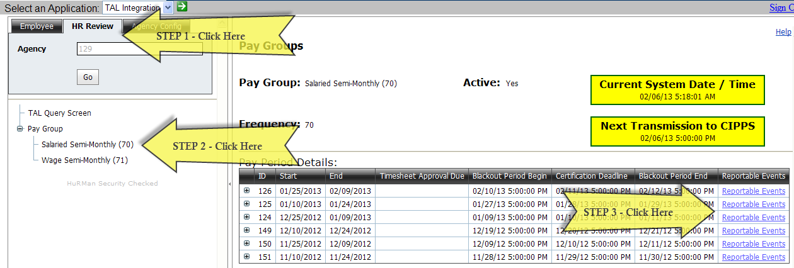

* A sample of layout of what a user can see when the Reportable Events link on the Pay Group screen is clicked is:

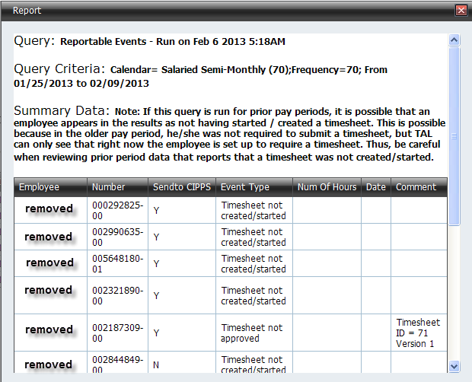

* It is recommended that HR and Payroll Users review the reportable events for a pay period to determine what may need to be reported to payroll

1. Click on the “Request Access” link at <http://web1.dhrm.virginia.gov/itech/> to get the latest copy of the Access Request form.
2. Click on the “Request Access” link at <http://web1.dhrm.virginia.gov/itech/> to get the latest copy of the Access Request form.