Appendices to the Training Materials for

Privileged User Training for the Time, Attendance & Leave (TAL) System

Date 1/19/2016

Table of Contents

Appendix A – Handling “Process Manual” Timesheets (HR only) 3

Appendix B - Where To Go For Help With TAL Questions 14

Appendix C – Example of Recurring Checklist for Creating, Reviewing and Transmitting TAL batches to CIPPS 15

Appendix D – Format of Batch Detail Lines Included in CIPPS File 18

Appendix E – Importance of the Timesheet Required Setting 20

Appendix F – Tracking Wage Employee Hours in TAL 22

Appendix G - Examples of Timesheets containing Holiday Hours and Comp Earned 28

Appendix H – How Timesheet Data is Sent to CIPPS 35

Appendix I - Understanding how TAL processes end of leave year losses, reset and credits 44

Appendix J – Processing Timesheets, Leave Requests, and Adjusting Leave Balances for Separated Employees (including those who transfer from one agency to another) 50

Appendix K – Preparing for Leave Liability Reporting 57

# Appendix A – Handling “Process Manual” Timesheets (HR only)

At times there are situations in which TAL will not be able to automatically process a timesheet. By “process a timesheet” what is meant is the applying of the leave on the timesheet to an employee’s balances and/or the summarizing of the hours an employee worked for transmission to CIPPS Payroll. If TAL does not do this processing, then HR (and possibly Payroll) must. This manual processing will result in additional work for HR.

There are certain things that HR can do (e.g., having timesheets submitted in timely manner) to avoid unnecessarily creating timesheets that would require manual processing. At other times there will be particularly complex or unique occurrence(s) on a timesheet that require that the expertise of HR personnel be applied (e.g., when a 28 day employee must transition to a 7 day timesheet).

In some cases HR can designate a timesheet for manual processing and in other cases TAL will automatically mark a timesheet for manual processing.

Timesheets that are set to be manually processed are so designated by a check in the checkbox shown in the following screenshot:

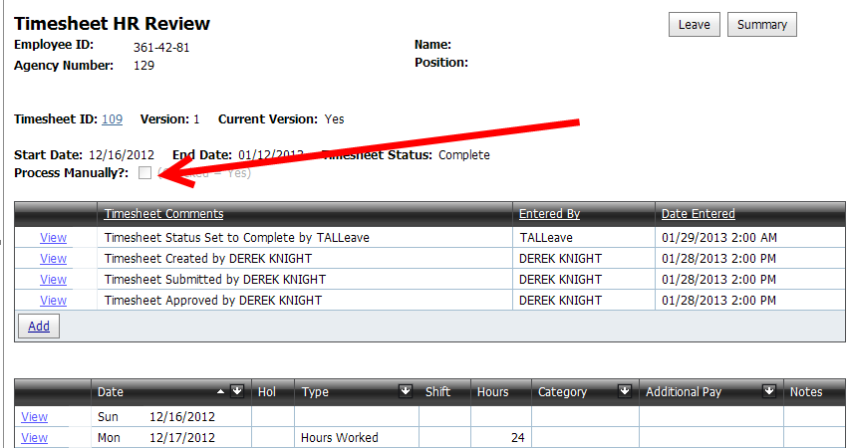

**How the “Process Manually” flag Is Set**

The Process Manually flag can be set to “Yes” on a timesheet by any of the following options:

**Option1)** HR User changes flag to “Yes” on the timesheet.

The HR user can set this flag when turning off the TAL automated processing is desired because the timesheet is atypical.

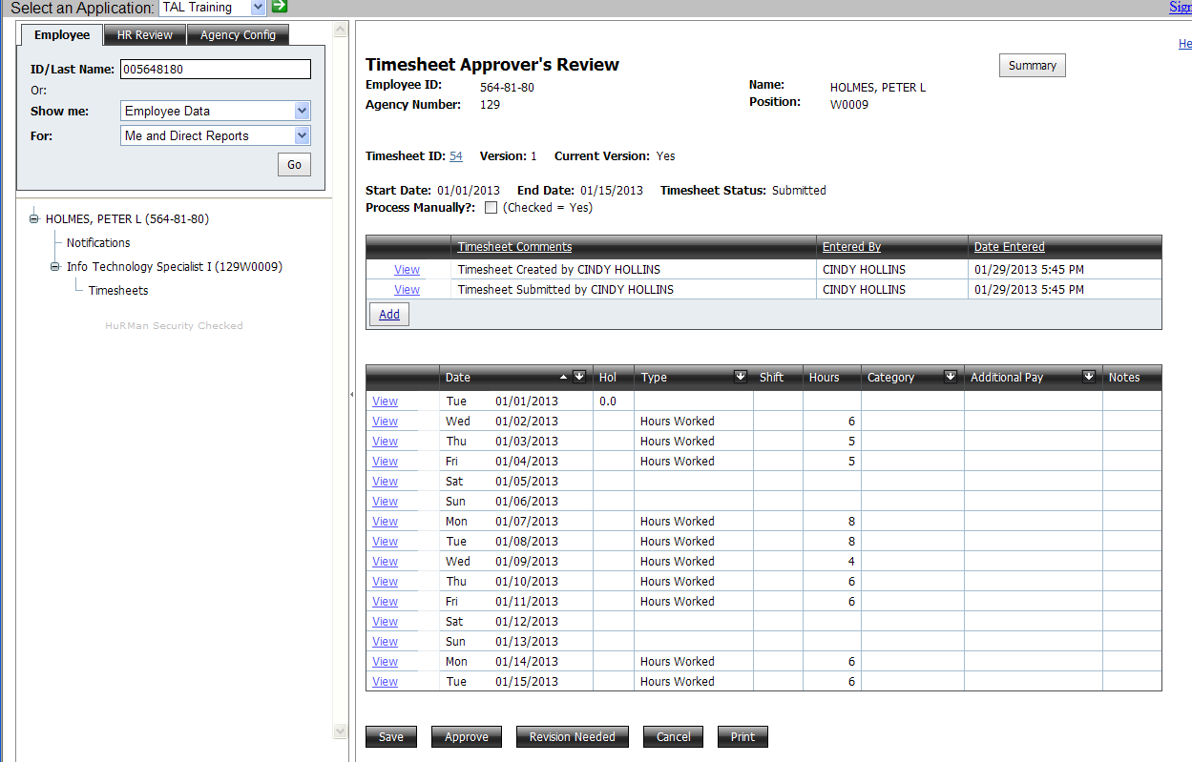

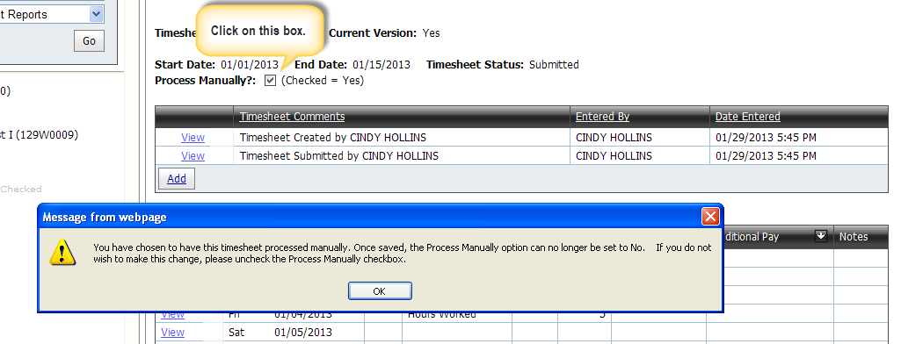

The process manually flag is changed to “Yes” by checking the box as in the diagram above. Note that a warning will be displayed that once the box has been checked and the timesheet saved, the box cannot be unchecked. In the figure below you can see that the box is now disabled.

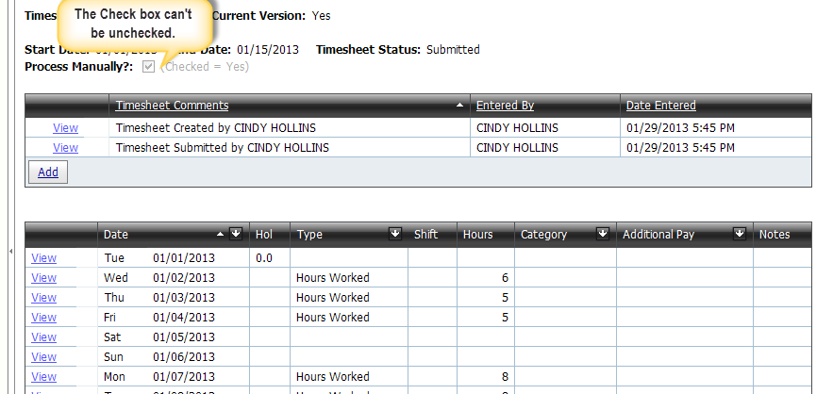

The Process Manually checkbox, which is editable only by the HR User, can be set to “Yes” under the conditions below:

* When it is currently set to “No” (Box is unchecked)
* When a timesheet is in Draft, Submitted, or Approved status - **Note**: If the timesheet is locked changing the process manually flag to “Yes” will create a new version of the timesheet.

**Note:** If the HR User sets the Process Manually flag to ”Yes”, a meaningful comment should be added as to why the flag was set. This comment will be useful when processing the timesheet and in future research.

**Option 2)** A change is made to the configuration of the employee’s position information

Configuration changes to the employee position may potentially impact the timesheet and require HR User action. Examples of configuration changes that will result in the system setting the process manually flag to “Yes” are:

* When the timesheet is the current version and in “Draft”, “Submitted”, or “Approved” status AND there is a change to any one of the following on the employee’s position:
  + Pay Group
  + Work Cycle
  + Overtime Exemption Code
* When the timesheet is the current version AND in “Approved” status AND there is a change to any one of the following on the employee’s position:
  + Employee Percent Time
  + Employee Time Status
  + Holiday Calendar
  + Overtime Treatment Type
  + Timesheet Is Sent To CIPPS flag

**Note:** Changes to the above fields on the employee configuration should be minimized.

**Option3)** The HR User revises a locked timesheet

Once the timesheet is locked, no modifications except for adding comments can be made to the current version of the timesheet. If additional changes are needed, the HR user must open the timesheet for editing by selecting the Revision Needed button. A new version of the timesheet will be created, (version number incremented by 1), and the original version will be marked “Complete”. The Timesheet ID will remain the same. All versions after the original are marked as process manually.

To determine if a specific timesheet is locked, the “Timesheet Detail for TimesheetID” query in the TAL Query screen can be run. When prompted, enter the timesheet ID and look for the “Is Timesheet Locked” field. It will be set to either “Yes” or “No”.

The lock is applied when the first of two events happen. The events are:

* The timesheet is included in a CIPPS batch (Many of the timesheets will not be included in the CIPPS batch, in which case the lock will be applied with the second event.)
* The blackout start date for the pay period in which the timesheet was approved, and which is associated with the employee position, has been reached.

**How to Find Timesheets Marked as “Process Manually”**

1. To determine which timesheets must be processed manually, run the “Exceptions - Agency Exceptions” query from the TAL Query screen. This report will display various types of exceptions including exceptions related to timesheets designated to be processed manually. Look for references to “processed manually” in the Exception Detail column and find the TimesheetId associated with each one.



1. Next, obtain the Timesheet Detail for the timesheets which must be processed manually. There are two options for retrieving the timesheet detail:
   1. Open the employee’s timesheet and review what is on it.

* Determine whether there is anything that must be reported to payroll or any leave which must be processed
  1. A more detail method of obtaining timesheet details is to run the query “Timesheet Detail For Specific Timesheets” from the TAL Query Screen. This query which will show additional details of the timesheet which may be helpful in determining what transactions must be manually processed.

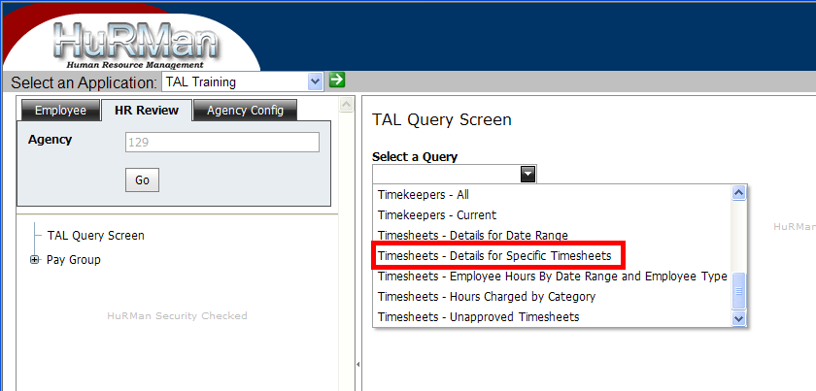

* + 1. When prompted, enter the TimesheetID displayed on the “Exception - Agency Exception” query. If the version number of the timesheet is > 1, then enter the version number as well. If Version is left blank, it will display data for all versions of the timesheet that exist. If there are multiple versions of the timesheet, it may be helpful to view all versions so that a comparison can be done. 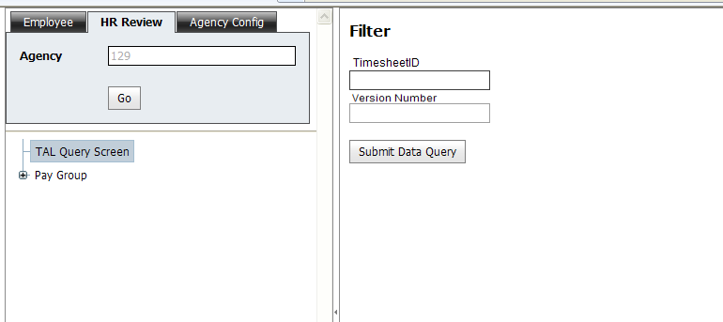
    2. Data can be viewed on the screen, or can be exported to Excel for easier viewing by selecting the Export to XLSX button. (If running MS Excel version 2003 or older then export to XLS.)

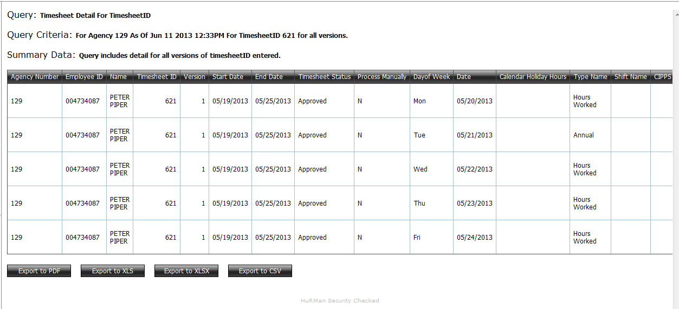

* + 1. There will be a row for each transaction on the timesheet. Determine the status of transactions and determine the next steps from the query. Those transactions that have already been processed will have a ProcessState of C (for Complete), and those that have not yet been processed with have either an E (Exception) or R (Ready to be processed). These are the transactions to focus on.

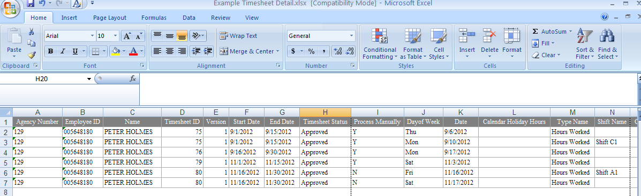

* + 1. Fields of interest that may be helpful in determining any additional steps are listed below. Note that the ProcessState may be set to Complete on some transactions on a timesheet but not all transactions. In that case, only those that have not been completed (set to R or E) will need to be processed manually.
* Date – date of transaction on timesheet
* Calendar Holiday Hours – Holiday hour (informational only)
* Type Name – Type of hours selected on timesheet (i.e. “Hours Worked”, “Annual Leave” “Holiday”)
* Shift Name
* CIPPS Shift Code Shift – If the employee selected a Shift on timesheet and a CIPPS Shift Code has been assigned, the hours may need to be reported to CIPPS.
* Hours – Hours reported on timesheet
* Category Name – Category name selected on timesheet
* Additional Pay Name – Additional Pay option selected by the employee on the timesheet
* CIPPS Shift Code Other – If the employee selected an Additional Pay option and a CIPPS Shift Code has been assigned, the hours may need to be reported to CIPPS. (i.e. “Dispensing Meds”)
* Other Pay As Exception – If the employee selected an Additional Pay option and the other pay selected was set up by the agency configure to create an exception
* Is Timesheet Locked – The timesheet can’t be modified after a lock and leave would normally be processed after the lock.
* Error Warnings Exist – There is at least one error or warning associated with this timesheet.
* CIPPS Batch ID – If the timesheet has already been a CIPPS batch, the Batch ID associated with the timesheet will be displayed. Otherwise, it will be blank. Note that If the process manually flag was set to Yes prior to when the CIPPS batch was created, then this field will also be blank.
* Processing State – This is flag is set when the timesheet is approved. The status can be:
  + Empty – Timesheet has not been approved yet
  + Exception (E) – An exception was noted in the approval process.
  + Ready (R) – The transaction is ready to be processed by either the CIPPS Batch process and/or the automated leave processing.
  + Complete (C) - The status is changed to complete after if there is no more processing necessary. (Exceptions remain in Exception status.)
  + ProcessingStateDatetime – if already processed, date and time that process was completed
  1. Once you have reviewed the timesheet detail and determined what actions need to be performed, you must manually complete those actions. If an employee’s workcycle spans multiple timesheets, keep in mind that you may need to look at the timesheet for the prior workcycle to determine overtime hours.

**How to Process Timesheets that Have Multiple Versions**

Once the timesheet is locked, no modifications except for adding comments can be made to the current version of the timesheet. If additional changes are needed, the HR User must open the timesheet for editing by selecting the Revision Needed **button**. A new version of the timesheet will be created, (version number incremented by 1), and the original version will be marked “Complete”. The Timesheet ID will remain the same. All versions after the original are flagged as process manually and must be handled as such.

To determine if a timesheet is locked, run the “Employee Detail for Specific Timesheets” query in the TAL Query screen (HR Review tab) and enter the ID number of the timesheet when prompted. Next, look at the “Is Timesheet Locked” field. The value will be se to either “Yes” or “No”.

If a locked timesheet is opened for revision, all subsequent versions of the timesheet should follow the standard process - namely the timesheet is edited, submitted and then approved. In some cases, the HR User may edit, submit and approve on behalf of the employee and supervisor. A notification would be sent to the employee and supervisor indicating that the HR user performed these functions.

**Examples of Modifying Timesheets**

Example 1: Non Exempt employee submitted a timesheet with 24 hours worked as Category ABC, 8 hours of Annual leave, and 8 hours worked designated as Category DEF. Timesheet was approved. Employee then realized that only 16 of the hours should have been designated as Category DEF and 16 as Category DEF. Since these categories are used for reporting, they should be accurate and need to be changed.

In this scenario, it would be best to correct the timesheet prior to when the timesheet is locked to ensure that the leave is automatically processed by TAL if possible. However, since that is not always an option, below are the suggestions for correcting the timesheet depending on the timesheet status.

First determine whether or not the timesheet is locked by running the “Timesheet – Details for Specific Timesheets” query from the TAL Query Screen, entering the Timesheet ID, and then checking the “Is Timesheet Locked” field. Next, take the appropriate action based on the status.

Timesheet is Locked: The HR User should select the Revision Needed button on the timesheet. When prompted, a comment must be added for the reason the timesheet is being opened. This will create a Timesheet with the Status of Draft – the Timesheet ID is the same as the original Timesheet ID, but the Version number will be incremented to 2. (By default, only the current version, which is 2 in this case will be displayed in the employee’s Timesheet grid. To view Version 1, the “Is current version” filter in the grid can be set to “No”.) Version 2 of the timesheet must then be updated, submitted and approved. Because the timesheet is marked as Process Manually, TAL will not perform any additional leave nor pay processing. The HR User must determine if the leave was processed by TAL, and if not, will need to process it manually.

Timesheet is Not Locked: The HR User should select the Revision Needed button on the timesheet. Since the timesheet is not locked, a new version will not be created. The employee can then modify the current timesheet. The supervisor will need to approve the new timesheet. Leave will be automatically processed by TAL.

Example 2: Wage employee submitted a timesheet for a period of time that contains 55 hours worked. Supervisor approved the timesheet. HR User created the CIPPS batch, payroll was certified and checks were cut. Employee then realized that the hours worked should have been 62 instead of 55 and is requesting payment for the additional hours.

In this example, the timesheet will always be locked because it was already included in a CIPPS Batch. The HR User should select the Revision Needed button on the timesheet. When prompted, add a comment for the reason the timesheet is being opened. This will create a Timesheet with the Status of Draft - Timesheet ID is the same as the original Timesheet ID, but the Version number will be incremented to 2. The employee will get a notification that the timesheet was opened for Revision and can make the necessary modifications, then submit. The timesheet must then be approved by the supervisor or the HR User. Another option would be for the HR user to make the modifications, submit and approve the new version. Since the timesheet is flagged as Process Manually, (CIPPS already processed hours on the original timesheet), any changes in hours to be paid must be handled manually outside of TAL.

Example 3: Non exempt employee is planning to take 8 hours of unpaid time on a Friday (Pay Dock). Employee submitted a timesheet that contained the following:

* Monday: 8 hours worked
* Tuesday: 8 hours worked
* Wednesday: 8 hours worked
* Thursday: 8 hours worked

Timesheet was approved by the supervisor.

a) The HR User should run the “Exception - Agency Exception” query prior to creating the CIPPS Batch which will display the exception below:



b) To obtain additional information on the timesheet (whether it is locked or not, how many hours are reported, etc), the HR User can next run the “Timesheet – Details for Specific Timesheets” query from the TAL Query Screen, and enter the Timesheet ID from the above query. The query contains the detailed transactions from the timesheet shown below:



c) From the data above, it can be determined that only 32 hours of work were reported, the employee is Non-Exempt and that the timesheet is not locked. There is no leave nor overtime or CIPPS Code hours so this timesheet does not have any transactions to be automatically processed.

d) The HR User should select the Revision Needed button to open the timesheet for edit. A transaction should then be added for Friday with a Type of Pay Docking for 8 hours. The timesheet must then be re-submitted and re-approved. (This HR user can perform all of these steps, or can have the employee and supervisor submit and approve).

e) The next time the HR User runs the “Exception - Agency Exceptions” query, an additional exception for “Unpaid Leave Requested” will appear for the timesheet.

f) If additional details are needed, the “Timesheet – Details for Specific Timesheets” query can be run again. In this particular example, a transaction for 8 hours of Pay Docking will be created in the employee’s leave balance, however, the pay docking must be handled manually.

# Appendix B - Where To Go For Help With TAL Questions

On TAL screens: Use “Help” buttons.

On-Boarding Questions DHRM TAL On-Boarding Coordinator

PMIS Data Issues DHRM TAL On-Boarding Coordinator

CIPPS Suffices Agency Payroll

Pay Groups Agency Payroll

Establishing Batching Schedules Agency HR and Payroll

Work Cycles Agency HR should have established work cycle information.

Work Schedules Check with Agency Supervisors.

TAL Access Issues* [TAL@dhrm.virginia.gov](mailto:TAL@dhrm.virginia.gov)

TAL Configurations* [TAL@dhrm.virginia.gov](mailto:TAL@dhrm.virginia.gov)

E-Direct Access Issues [support@dhrm.virginia.gov](mailto:support@dhrm.virginia.gov)

HuRMan Access Issues [ihelp@dhrm.virginia.gov](mailto:ihelp@dhrm.virginia.gov)

Timekeeping/Leave issues Agency HR, DHRM HR Management Consultant

Training DHRM TAL On-Boarding Coordinator

KC Assistance [TAL@dhrm.virginia.gov](mailto:TAL@dhrm.virginia.gov)

*Please be sure to include a detailed description of the problem that you are experiencing, steps to reproduce and screenshots when contacting the TAL Help Desk.

# Appendix C – Example of Recurring Checklist for Creating, Reviewing and Transmitting TAL batches to CIPPS

Perform every day to two days

|  |  |  |
| --- | --- | --- |
|  | **To Do** | **Comment** |
| |  | | --- | |  | | Run the TAL Query named Agency Exceptions and review/address any exceptions. |  |

As the pay period blackout start draws near for each of your pay groups (this may be done for several days leading up to the blackout start)

|  |  |  |
| --- | --- | --- |
|  | **To Do** | **Comment** |
| |  | | --- | |  | | Check to see that timesheets are being submitted in a timely fashion by going to the individual Pay Groups and clicking the Reportable Events for the specific pay period of interest. If timesheets are not being created, submitted or reviewed in a timely manner, then address this issue. |  |

When it is time to run batches… (approximately 2-3 business days prior to blackout start date)

|  | **To Do** | **Comment** |
| --- | --- | --- |
| |  | | --- | |  | | Determine what timesheets may not have been created, submitted or approved and either 1) contact the appropriate employees to address before creating the batch or 2) note the employees for follow-up. | Note: This same step will be performed as a step as the blackout start draws near. |
| |  | | --- | |  | | Run the TAL Query “Timesheet Detail by Date Range” and review to verify that hours look appropriate |  |
| |  | | --- | |  | | Create and review the batches for each pay group. |  |
| |  | | --- | |  | | If batches look satisfactory, mark them as “Ready to Transmit” (and make sure to click the “Save” button). Only those batches which have a status of “Ready to Transmit” prior to 5:00 PM on the Blackout Period Begin Date* will be included in the payroll run. | Note: For batches marked as “TAL Withdrawn” these batches do not need to and cannot be marked as “Ready to Transmit”. |
| |  | | --- | |  | | For batches that are transmitted, contact DOA PSB representative the day after the batch is transmitted to verify batch appears in CIPPS. | Note: Compare batch totals of TAL and CIPPS as part of verification. |

*The Blackout Period Begin Date and Blackout Period End Date refer to the period of time during which TAL will not transmit a batch of transactions to CIPPS. During this period, payroll certification takes place and TAL does not transmit to avoid overlaying an already certified payroll. If the status of a batch is changed to “Ready To Transmit” during this period of time, TAL will not send that batch to CIPPS until after the blackout period has ended.

Agencies should be mindful of the blackout periods and mark the appropriate batches as “Ready to Transmit” prior to the beginning of those periods.

Following is a calendar that shows dates (yellow highlighted cells) that an agency might consider creating a batch if their blackout dates and approvals fell on the dates listed below.

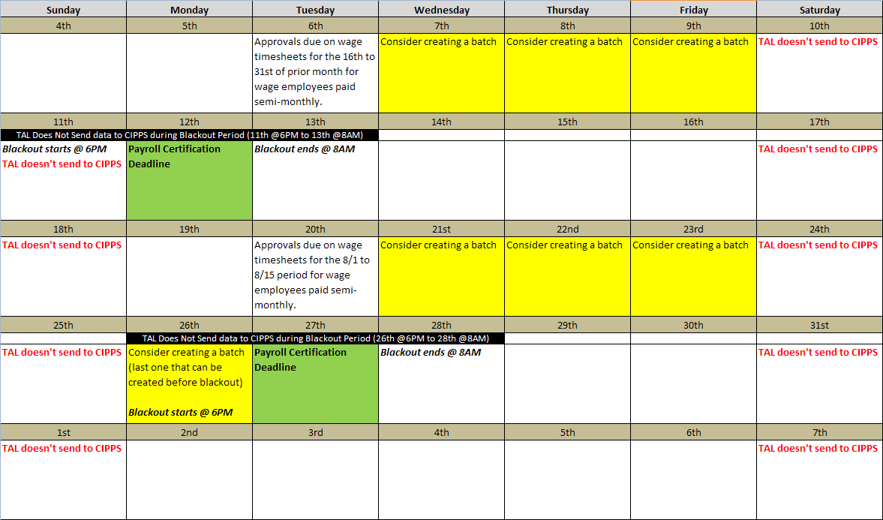

**Important:** The above calendar is only for conceptual purposes and should not be used as definitive guidance for when your agency should create batches. An agency could use the above to develop a calendar specific to its needs.

# Appendix D – Format of Batch Detail Lines Included in CIPPS File

Each batch included in the file transmitted to CIPPS has detail records associated with it. DOA has defined the following layout those detail transactions:[1]

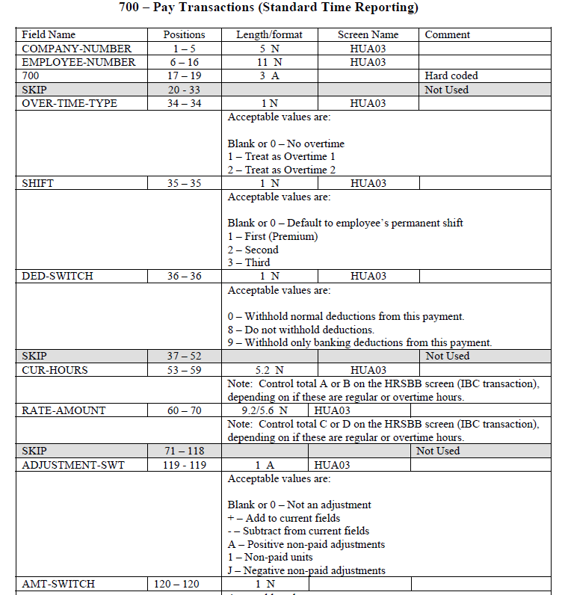

Using the above structure, a sample detail record for a batch could have the following look:

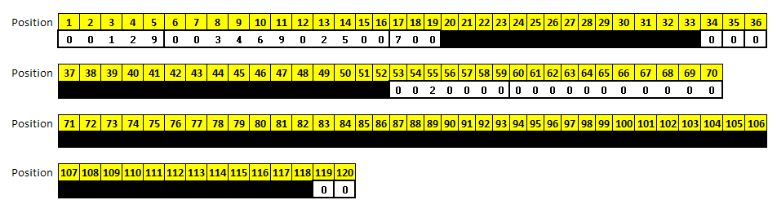

Notes:

|  |  |  |
| --- | --- | --- |
| **Field Name** | **Positions** | **Note** |
| COMPANY-NUMBER | 1-5 | Three digit agency code left padded with zeros. |
| EMPLOEE-NUMBER | 6-16 | Job.EmployeeIDNumber + Job.CIPPSSuffixNo |
| 700 | 17-19 | Hard code '700' |
| SKIP | 20-33 | All Blanks |
| OVER-TIME-TYPE | 34-34 | Will have a value if transaction is to pay overtime |
| SHIFT | 35-35 | Will have a value if transaction to pay for hours worked that are associated with a supplement / shift that has a CIPPS Shift code associated with it. |
| DED-SWITCH | 36-36 | Zero |
| SKIP | 37-52 | All Blanks |
| CUR-HOURS | 53-59 | Sum of hours – zero filled on the left. |
| RATE-AMOUNT | 60-70 | All zeros |
| SKIP | 71-118 | All Blanks |
| ADJUSTMENT-SWT | 119-119 | Blank |
| AMT_SWITCH | 120-120 | Blank |

# Appendix E – Importance of the Timesheet Required Setting

Every position in TAL has a Timesheet Required setting. This setting can be either “Yes” or “No” and designates whether an employee filling a position must complete a timesheet. This setting (see area circled in red) is located on the TAL Settings tab of the Employee Position Information Screen.

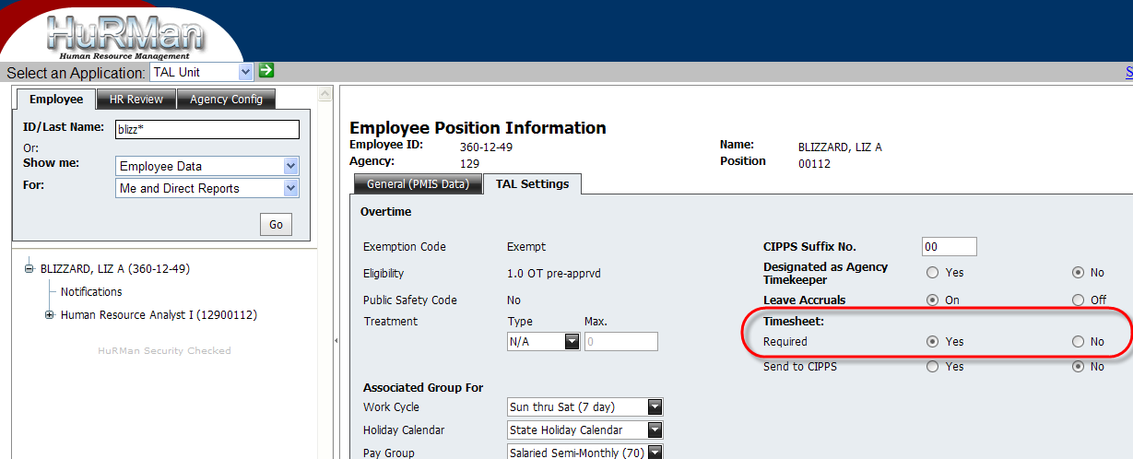

**Importance of Setting**

The “Timesheet Required” setting is **critical** toTAL’s processing of leave. By “processing leave”,

If it is set to “Yes” for a position, then the employee filling the position will have his/her leave balances adjusted based on information on submitted / approved **timesheets**. An employee should still complete a leave request in TAL, but the leave request does not affect his/her leave balances.

If it is set to “No” for a position, then the employee filling the position will have his/her leave balances adjusted based on information on submitted / approved **leave requests**.

Note:

1. It is not an employee’s exempt / non-exempt status that determines how his/her leave is processed. Rather as noted above, it is whether an employee must complete a timesheet.
2. TAL *requires* all non-exempt employees to complete a timesheet. TAL *allows* an exempt employee to complete a timesheet if the Timesheet Required setting is set to “Yes”.
3. TAL HR Users should be very careful about switching an employee’s Timesheet Required setting between “Yes” and “No” once an employee has had set up completed in TAL. Changing this setting after an employee already has leave requests and / or timesheets affects how an employee’s leave is processed. Following are specific notes:
   1. If the setting for an employee is changed from “Yes” to “No”, then TAL will adjust leave balances based on submitted/approved leave requests with certain exceptions: TAL will not process any leave requests for past dates that were approved prior to the change in the Timesheet Required setting to “No”. TAL will process leave from leave requests (regardless of the date of the leave) that are approved after the Timesheet Required setting is set to “No”.
   2. If the setting for an employee is changed from “No” to “Yes”, then TAL will continue to process leave only from those requests that were approved prior to when the setting was changed. TAL will no longer adjust leave balances from leave requests that are approved after the setting is changed. All leave on timesheets will be processed by TAL.

# 

# Appendix F – Tracking Wage Employee Hours in TAL

TAL provides a means to track the number of hours that a wage employee works in the twelve month period (“wage hour year”) from 5/1 to 4/30 (for more on wage employee hour limitations refer [here](http://www.dhrm.virginia.gov/hrpolicy/documents/FAQsWorkHoursLimitationsforWageEmployees.pdf)). Wage hour totals can be viewed in one of two places in TAL:

* 1. In the TAL Settings tab on the Employee Position Information screen
  2. From the TAL Query named “Wage Hour Tracking Verification” in the HR Review tab

Additionally, as TAL detects that an employee’s hours for a wage hour year exceed certain thresholds (e.g., 1000 hours or 1400 hours), TAL can send notifications of this event to employees, supervisors and others.

The following sections describe screen, query and notifications mentioned above in greater detail.

**Wage Hours on the Employee Position Information Screen**

On the Employee Position Information screen, a section titled Wage Hours Tracking is displayed on the TAL Settings tab for wage positions only.

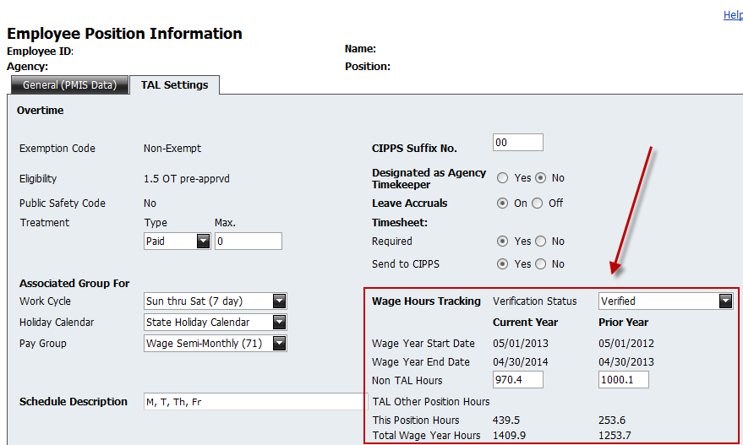

The fields highlighted by the red box above have the following meaning:

|  |  |
| --- | --- |
| **Field** | **Description** |
| Verification Status | The status of the Non-TAL Hours that show on the screen (see below for an explanation of “Non-TAL Hours”.  Possible Status values are:   * Verified – the agency has confirmed the values in the “Non-TAL Hours” field. * Verification in Progress – the agency is currently in the process of reviewing / confirming the amount of “Non-TAL Hours” * Verification Not Started – the agency has not reviewed/confirmed the amount of the “Non-TAL Hours”. TAL will not allow the setup of an employee to be completed when this is the status showing on the screen. |
| Wage Year Start Date | 5/1 of a particular wage hour year |
| Wage Year End Date | 4/30 of a particular wage hour year (12 months after the wage year start) |
| Non-TAL Hours | Hours for a wage year that TAL does not have on a TAL timesheet; e.g., if your agency went live with TAL on 9/25, then TAL would not have hours for wage employees from 5/1 to the start of the employee’s first TAL Timesheet (likely 10/1). These hours need to be entered into TAL in the appropriate non-TAL field. If you would prefer to provide a spreadsheet of non-TAL hours uploaded into TAL for your agency, send that request to [TAL@dhrm.virginia.gov](mailto:TAL@dhrm.virginia.gov).  Also if your agency, after adopting TAL had an employee complete a paper timesheet that was not entered into TAL, HR Users should add these hours into the non TAL hours field.  The “Verification Status” field (see above) applies to the status of the Non-TAL Hours.  Only TAL HR Users can update the “Non-TAL Hours” fields |
| TAL Other Position Hours | If an employee at your agency had more than one wage position at your agency, the hours from approved timesheets from the other position(s) for the wage year would display here. |
| This Position Hours | TAL shows the hours worked from approved TAL Timesheets for the currently displayed wage position. If multiple versions of a timesheet exist, only hours from the last approved timesheet will be included. |
| Total Wage Hours | The sum of Non-TAL Hours + TAL Other Position Hours + This Position Hours. |

**TAL Query for “Wage Hour Tracking Verification”**

The TAL Query named Wage Hour Tracking Verification will provide information on wage employees and hours on a wage year basis (which is the period from 5/1 of one year to 4/30 of the following year).

To run this query, run the “Wage Hour Tracking Verification” from the TAL Query Screen.

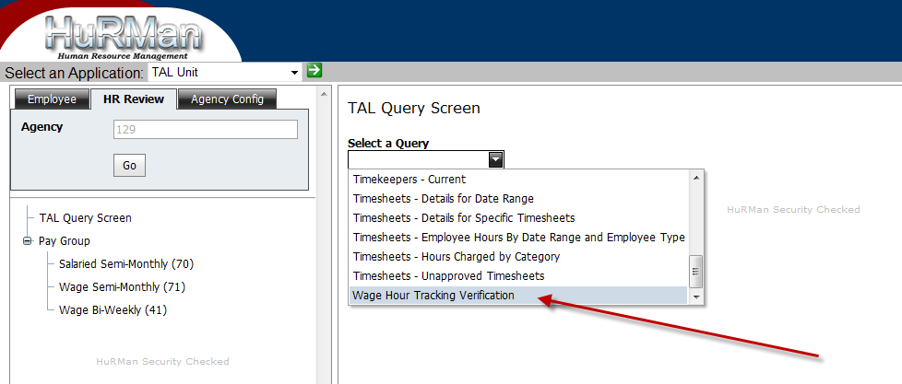

When prompted, enter a wage year (Ex 2014):

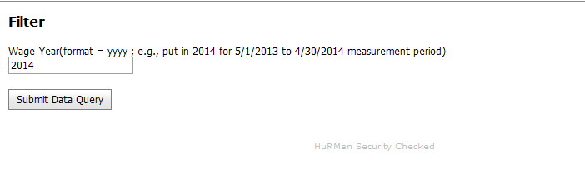

To determine the proper wage year to enter use the year in which the wage hour year ends. For example, if interested in the period from 5/1/2013 to 4/30/2014, enter “2014” (i.e., the year in which the wage hour year ends).

The query will contain the following columns:

| **Column** | **Description** (if not self explanatory) |
| --- | --- |
| Employee First and Last Name |  |
| Employee ID Number |  |
| Wage Year | This will show the wage year entered to run the query |
| Period Start and Period End dates | Shows the 5/1 to 4/30 start and end dates that correspond to the wage year entered to run the query |
| Non TAL Hours Verification Status | The Verification Status shown for the employee that shows on the Employee Position Information screen |
| Non TAL Wage Hours | This figure is the same that shows on the Employee Position Information screen |
| Position Wage Hours | This figure is the same that shows on the Employee Position Information screen |
| Other Position Wage Hours | This figure is the same that shows on the Employee Position Information screen |
| Total Wage Hours | This figure is the same that shows on the Employee Position Information screen |
| Pending Wage Hours (hours on timesheets that have not yet been submitted nor approved) |  |
| Employee Position |  |
| Separated Date |  |
| Position Role Name |  |
| Employee Email |  |
| Employee Phone |  |
| Supervisor First and Last Name |  |
| Supervisor Position, Email and Phone |  |

The query will have the following look: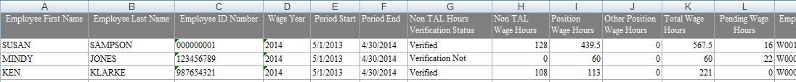

**Notifications**

TAL can be configured to send notifications when an employee’s wage hours reach a certain threshold (number of hours).

An example of a notification sent when an employee exceeds 1000 hours is below:

FYI: Wage employee (Employee Name) has exceeded 1000 hours for wage year 2014 covering the period 05/01/2013 to 04/30/2014~~3~~.

To see when, how, and to whom TAL will send these wage related notifications, refer to the following Notifications Configurations screen for your agency:

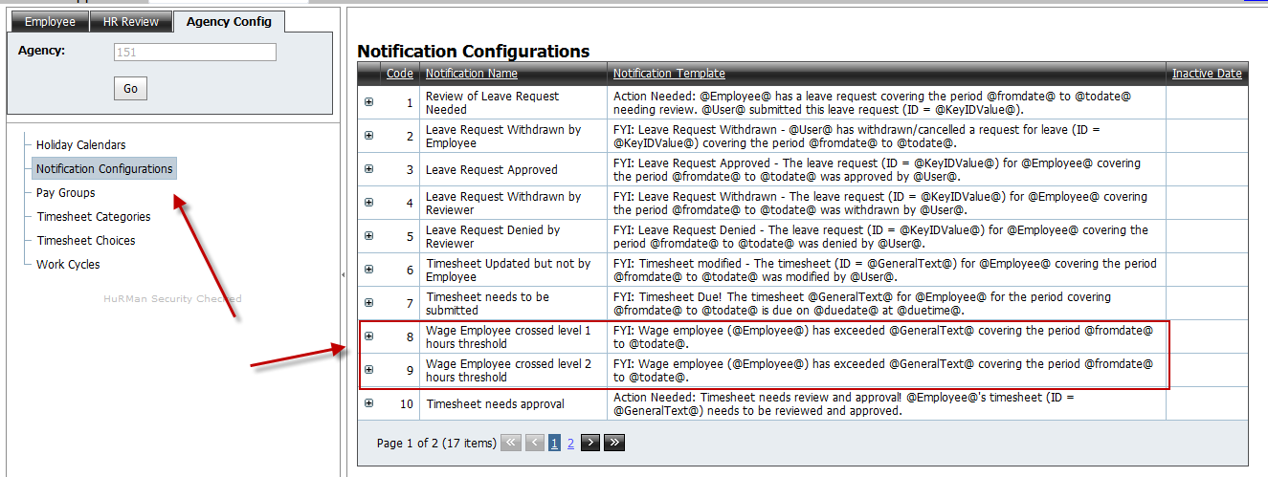

In the red box above “level 1” will initially be set to 1000 hours and “level 2” will be set to 1400 hours.

Agencies can request the TAL Team to make changes to the hours associated with these levels as well as who (employee, supervisor, HR User) receives the notifications and how (just in TAL or e-mail as well) they are sent. Additionally, notifications can be configured to be sent only once when the number of Total Wage Hours meets or exceeds a threshold, or can be sent every time a change occurs where the number of Total Wage Hours is greater than a threshold.

**Agency Considerations for Getting Non-TAL Hours into TAL**

As an agency adopts TAL, the agency HR Team should determine the wage employees for whom non-TAL hours need to be entered into TAL.

Agencies have two options for entering the data into TAL:

1. The TAL Team can import the data from a spreadsheet. Please send spreadsheets to [TAL@dhrm.virignia.gov](mailto:TAL@dhrm.virignia.gov) , indicate your agency number and include the following fields:

* Employee First Name
* Employee Last Name
* Employee ID Number
* Employee Position
* Non TAL Wage Hours (can only be to one decimal place – 10.2 is acceptable but 10.25 is not)

The wage year will be assumed as the current wage year and the upload process will automatically mark the Verification Status as “Verified”.

**OR**

1. Agency HR Users can key the hours on the Employee Position Information screen for each wage employee.

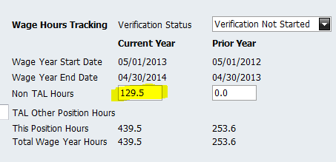

Once the Non-TAL hours have been entered and verified, change the Verification Status field on the Employee Position screen to “Verified”.

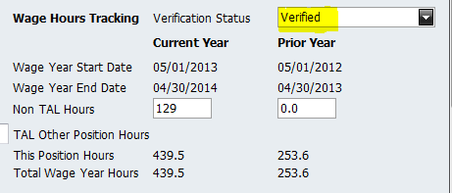

Select “Save”.

# Appendix G - Examples of Timesheets containing Holiday Hours and Comp Earned

|  |  |  |  |  |  |  |  |  |  |  |  |  |  |
| --- | --- | --- | --- | --- | --- | --- | --- | --- | --- | --- | --- | --- | --- |
| **Timesheet Entries** | | | | | | | | | | | | | |
| **Day** | | | **Scenario 1** | | | **Scenario 2** | **Scenario 3** | | **Scenario 4** | | **Scenario 5** | **Scenario 6** | |
| Sunday | | |  | | |  |  | |  | |  |  | |
| Monday | | | 8 - Holiday | | | 8 - Holiday | 5 - Holiday | | 8 - Hours Worked | | 8 - Holiday | 5 - Holiday | |
| Monday | | |  | | | 3 - Hours Worked | 3 - Hours Worked | | 8 - Comp Earned | | 3 - Hours Worked | 3 - Hours Worked | |
| Monday | | |  | | |  | 3 - Comp Earned | |  | |  | 3 - Comp Earned | |
| Tuesday | | | 8 - Hours Worked | | | 8 - Hours Worked | 8 - Hours Worked | | 8 - Hours Worked | | 8 - Hours Worked | 8 - Hours Worked | |
| Wednesday | | | 8 - Hours Worked | | | 8 - Hours Worked | 8 - Hours Worked | | 8 - Hours Worked | | 8 - Hours Worked | 8 - Hours Worked | |
| Thursday | | | 8 - Hours Worked | | | 8 - Hours Worked | 8 - Hours Worked | | 8 - Hours Worked | | 8 - Hours Worked | 8 - Hours Worked | |
| Friday | | | 8 - Hours Worked | | | 5 - Hours Worked | 8 - Hours Worked | | 8 - Hours Worked | | 8 - Hours Worked | 5 - Hours Worked | |
| Friday | | |  | | |  |  | |  | |  | 3 - Comp Used | |
| Saturday | | |  | | |  |  | |  | |  |  | |
|  | | |  | | |  |  | |  | |  |  | |
| **Assumptions:** | |  | | The scenarios assume a non-exempt employee who has a 40 hour work cycle with five 8 hour work days during a 7 day Sun-Sat period | | | | | | | | |
| **Scenarios Described:** | | | | | | | | **What's sent to CIPPS from TAL** | | **What Employee Receives** | | |
| 1 | Employee takes the holiday and works the remainder of the week as he/she is scheduled | | | | | | | Nothing | | Paid 40 straight | | |
| 2 | Employee works a portion of the holiday but schedule adjusts on Friday so that no comp time is earned | | | | | | | Nothing | | Paid 40 straight | | |
| 3 | Employee works part of the holiday and requests comp earned for it | | | | | | | Nothing | | Paid 40 straight Comp Earned 3hrs | | |
| 4 | Employee works the entire holiday and requests comp earned for it | | | | | | | Nothing | | Paid 40 straight Comp Earned 8 hrs | | |
| 5 | Employee works part of the holiday and is paid the hours worked as straight time in addition to the holiday time | | | | | | | 3 Hrs at Straight Time is sent to CIPPS | | Paid 43 straight | | |
| 6 | Employee works part of the holiday, takes holiday leave for hours not worked on holiday, pay for hours worked on holiday, comp earned for holiday time which was due but not taken, and then uses that comp time later in the week. | | | | | | | Nothing | | Paid 40 straight Leave will be written as emp leave transactions but balance effect will be no change. | | |
|  |  |  | |  |  | | |  | |  | | |

Scenario 1 – Standard work week with a holiday

Employee takes the holiday and works the remainder of the week as scheduled

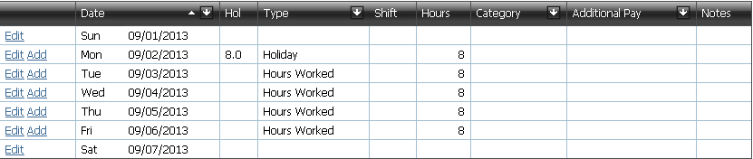

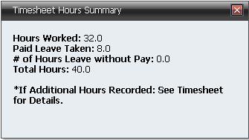

Paid 40 hours straight time

Nothing is sent to CIPPS

Scenario 2 – Schedule Adjust for hours worked on holiday

Employee works a portion of the holiday but schedule adjusts on Friday so that no comp time is earned

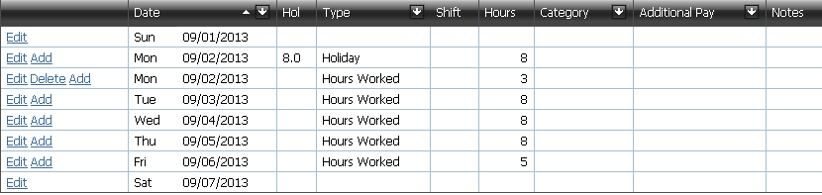

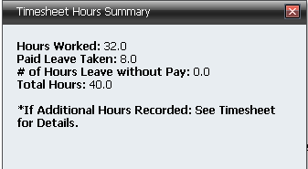

Paid 40 hours straight time

Nothing is sent to CIPPS

Scenario 3 – Comp Earned as compensation for holiday hours worked

Employee works part of the holiday and requests comp earned for it

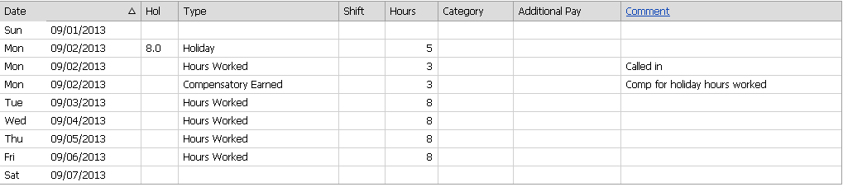

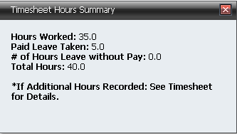

Paid 40 hours straight time; Comp Earned 3 hours

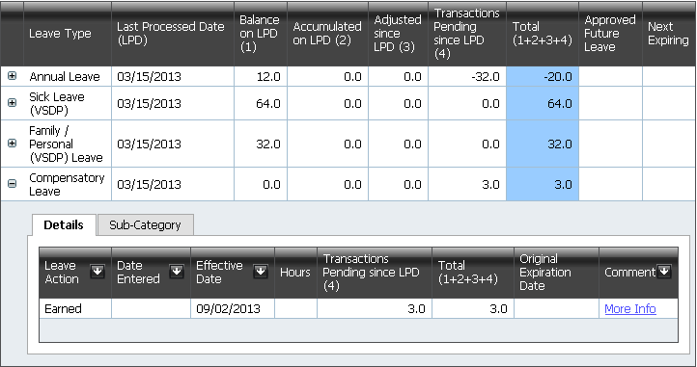

Scenario 4 - Comp earned as compensation for holiday hours worked - no holiday leave taken

Employee works the entire holiday and requests comp earned for it

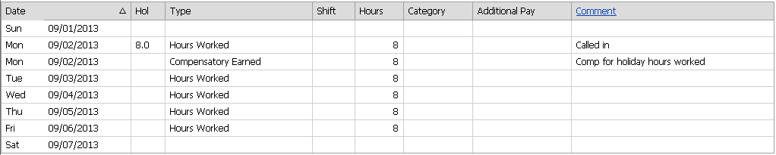

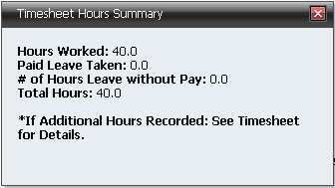

Paid 40 hours straight time; Comp Earned 8 hours

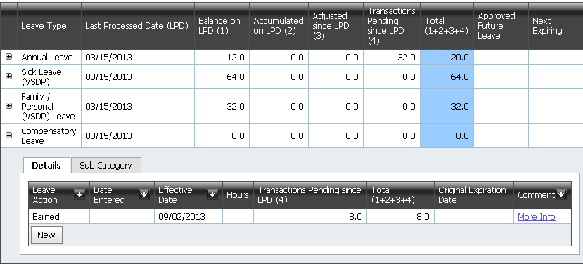

Scenario 5 - Hours worked on holiday paid in addition to holiday pay

Employee works part of the holiday and is paid the hours worked as straight time in addition to the holiday time

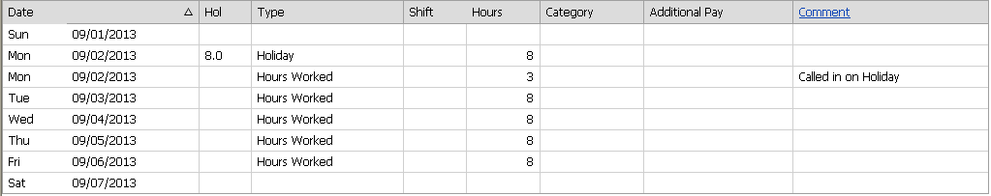

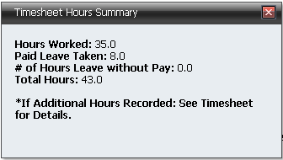

Paid 43 hours straight time

3 Hours stratight time sent to CIPPS

Scenario 6 - Comp earned as compensation for holiday hours worked. Comp taken at end of week.

Employee works part of the holiday, takes holiday leave for hours not worked on holiday, pay for hours worked on holiday, comp earned for holiday time which was due but not taken, and then uses that comp time later in the week.

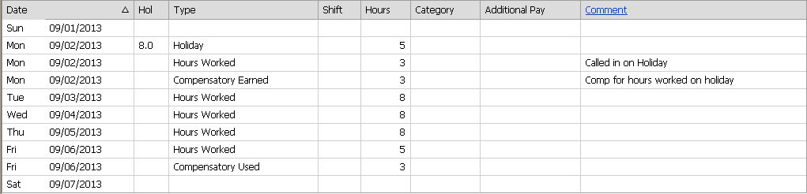

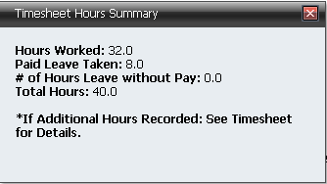

Paid 40 hours straight time

Nothing sent to CIPPS

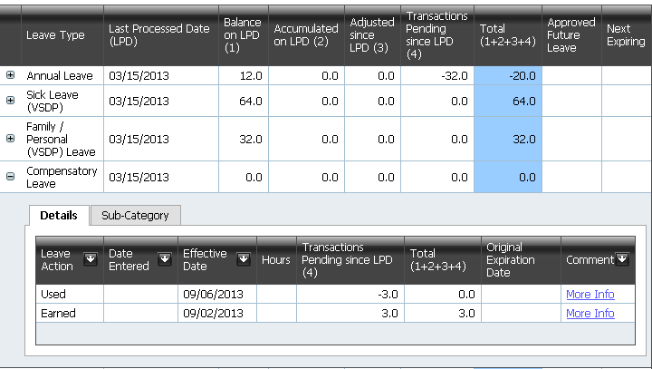

# Appendix H – How Timesheet Data is Sent to CIPPS

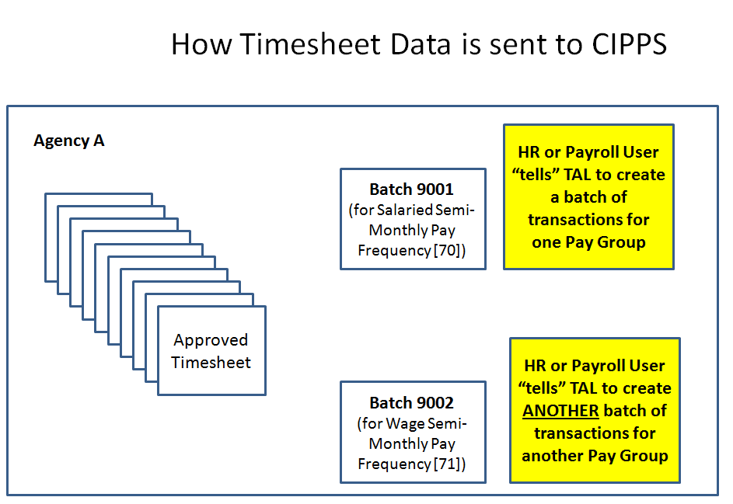

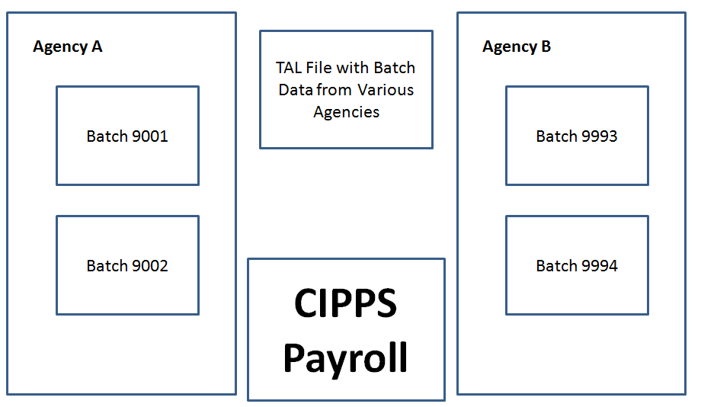

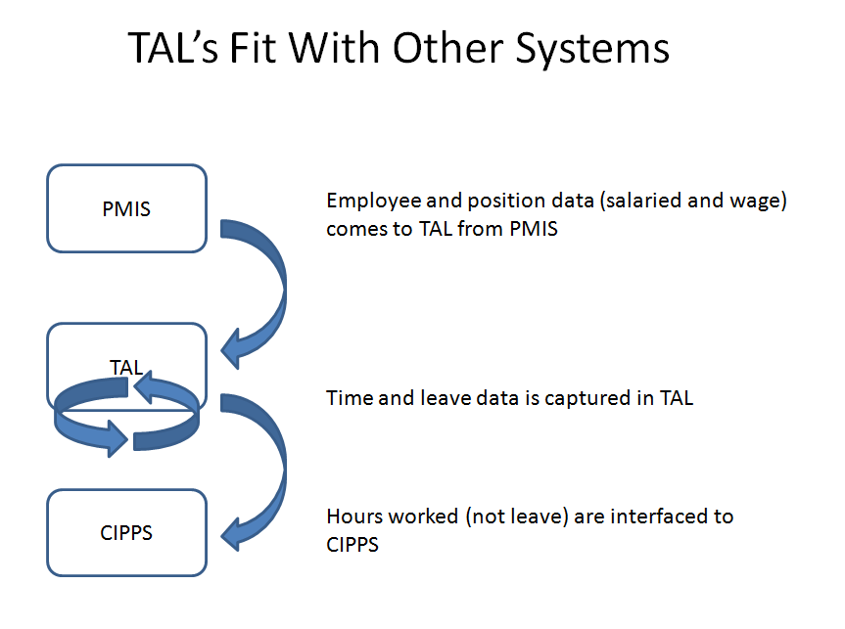

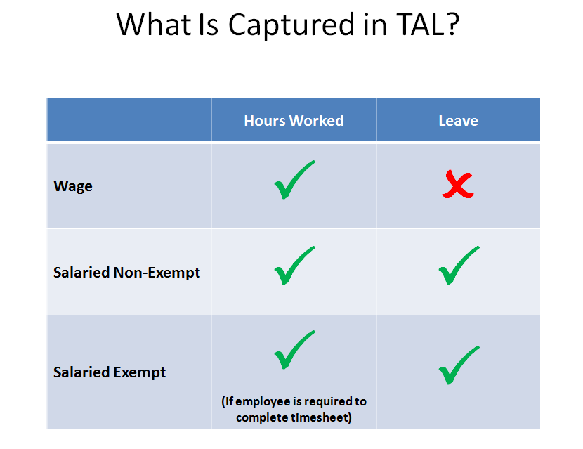

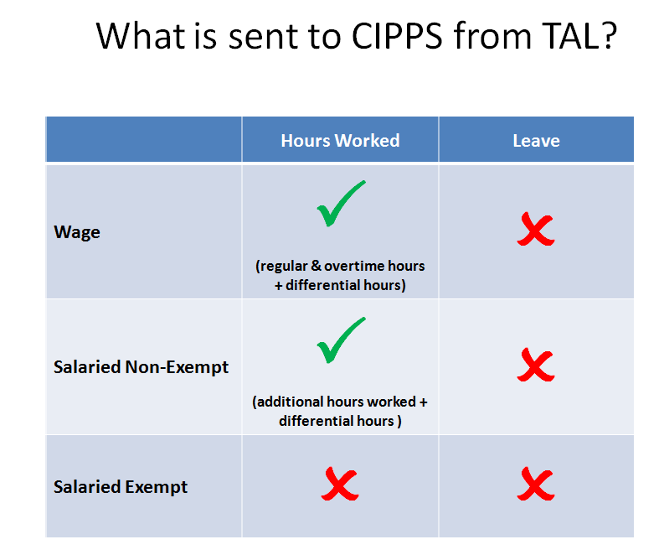

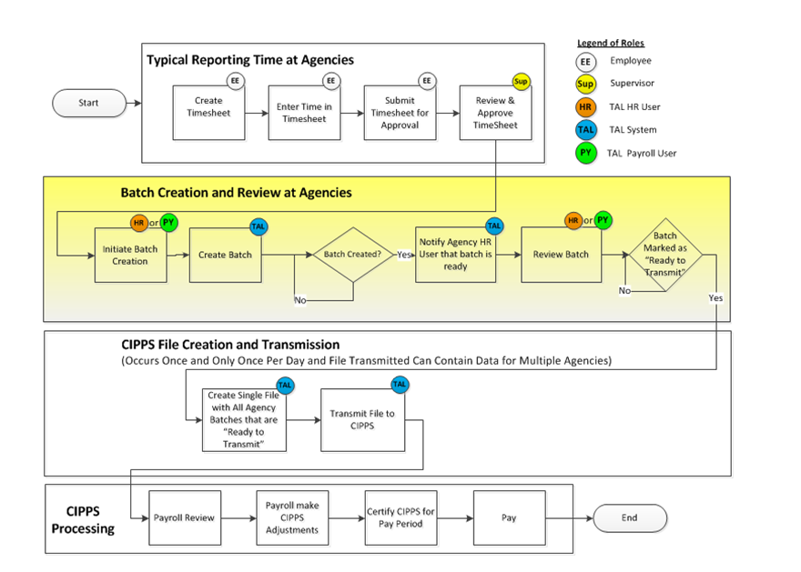

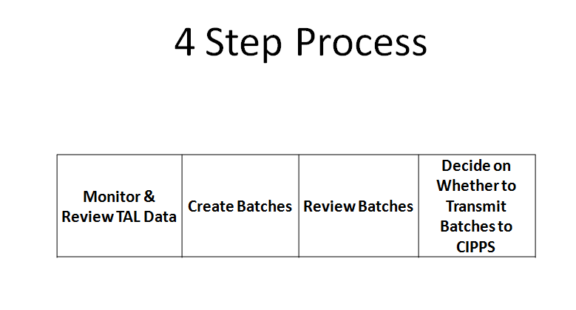

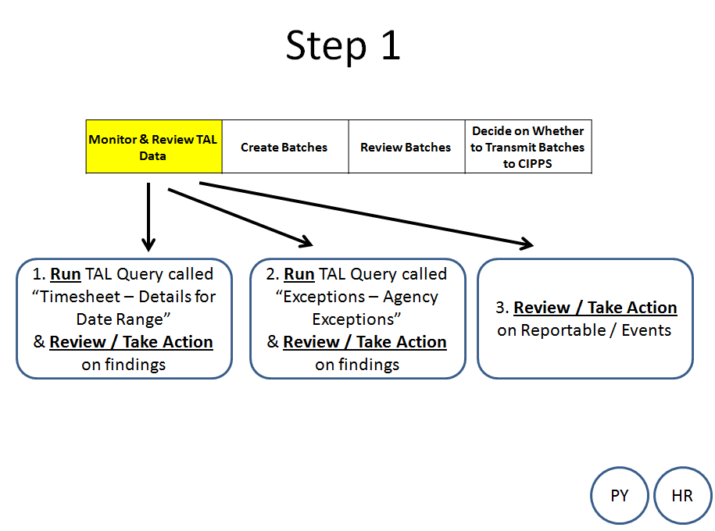

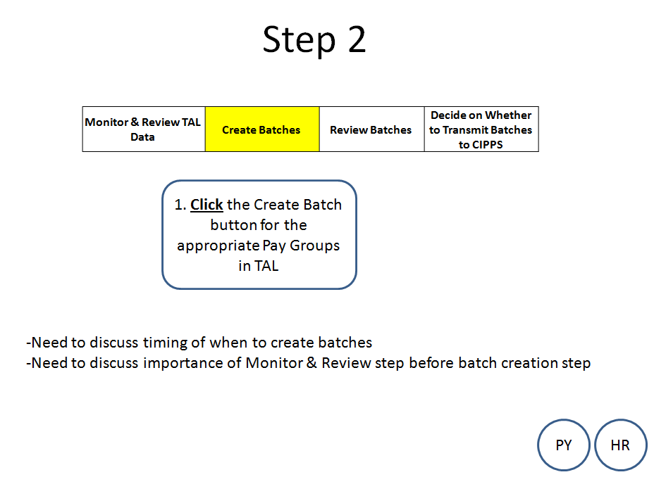

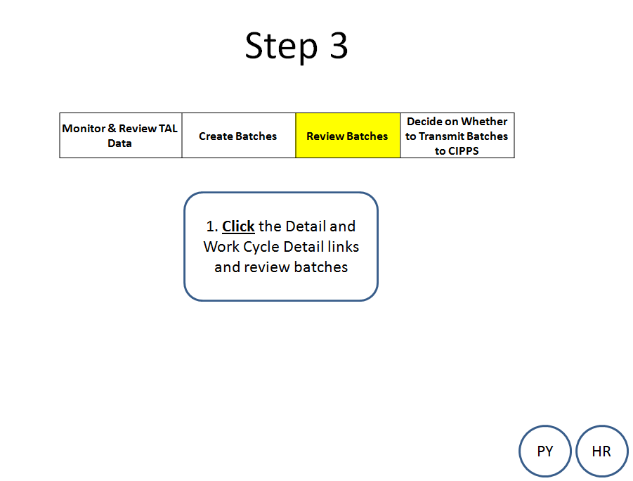

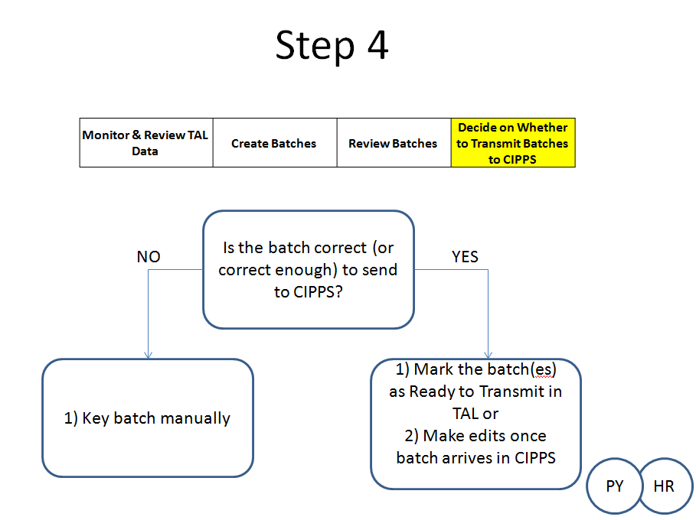

# Appendix I - Understanding how TAL processes end of leave year losses, reset and credits

As we cross into a new leave year, TAL will reduce employee leave balances in accordance with carryover limits and will reset appropriate balances to zero. In doing this, TAL will create “Lost”, “Credited” and “Leave Year Reset” transactions that will display on the employee’s Leave Balance screen. The following section provides examples of these transactions.

**“Lost” Transaction**

In the example below, the employee’s annual leave balance is reduced from 474 to his carryover limit of 432 hours. TAL shows a “Lost” transaction.



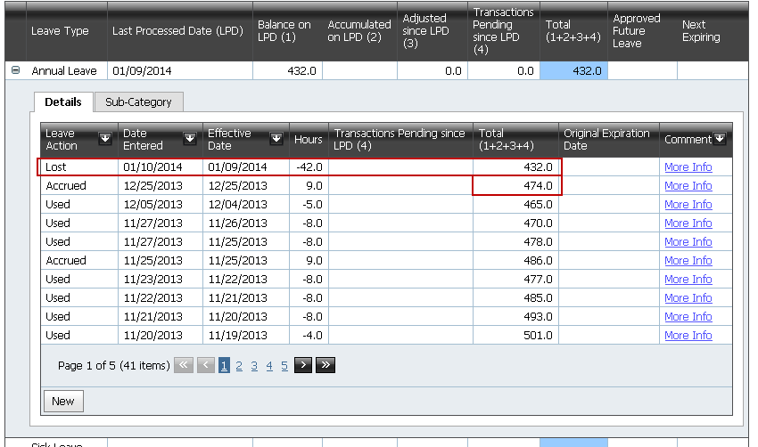

**“Credited” Transaction**

For an employee on the VSDP program, he/she will see a “Credited” transaction on 1/10 for any new Sick or Family Personal Leave allotments. The following screen shows an example of what TAL displays when an employee crosses the leave year and loses 46 hours of VSDP Sick Leave and then receives a new allotment.

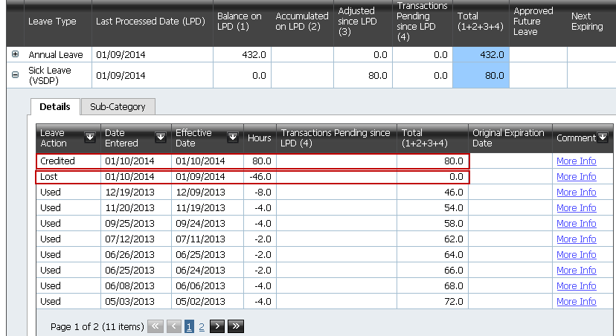

**“Leave Year Reset” Transactions**

For leave which is tracked by accumulation, TAL writes a “Leave Year Reset” transaction. TAL writes this transaction on 1/10 and resets the accumulator to 0. The following screenshot shows an example of this for School Assistance and Volunteer Service Leave. You will note in the screenshot that the employee did not appear to have used any of this leave during the prior leave year. Had the employee used this type of leave it would still have been reset to zero.

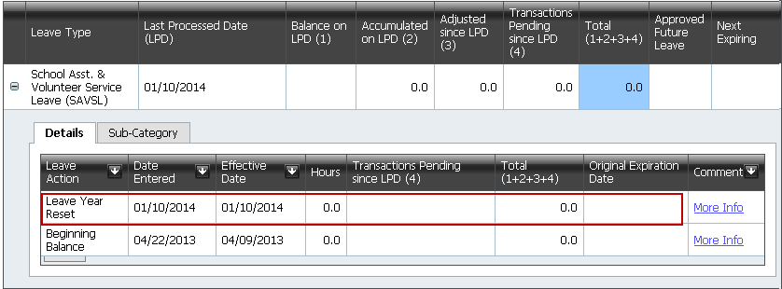

**What happens when an employee submits leave for the prior leave year after Jan. 9th?**

There will be cases where an employee doesn’t submit his/her use of leave for a prior leave year until the new leave year. This could very likely happen in the case of a timesheet that starts in one leave year and finishes in another or in the case of an employee who returns from a vacation after 1/9 and submits leave for the prior year.

Let’s look at two examples. First, let’s take the case of an employee whose annual leave balance screen displays as follows:





Let’s then assume that, in the new leave year, the employee records that she used one more hour of annual leave in the prior leave year. TAL has already noted a loss of 42 hours (see above), but it takes that into account and reduces the amount of leave lost through a new transaction called “Lost Adjustment Decrease” as shown here:  
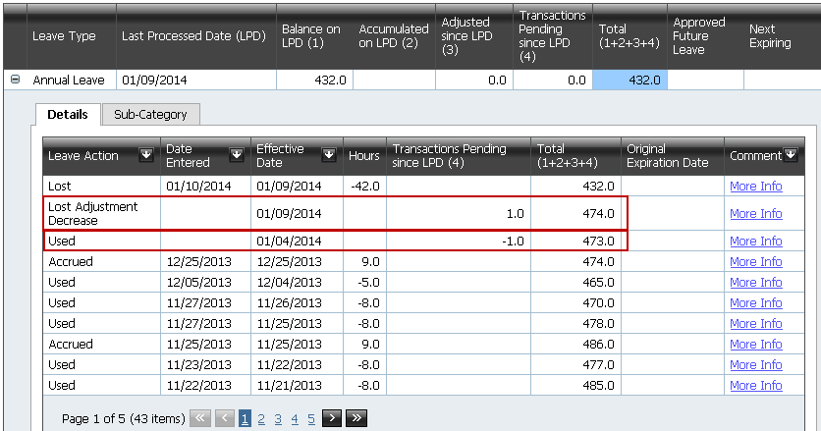

Note: In the screenshot above, the highlighted transactions show without a value in the “Date Entered” column. This occurs because the transaction is pending TAL processing. Once TAL processes the transaction (and that processing depends on whether an employee is required to complete a timesheet), TAL will display a value in the “Date Entered” column for the transaction.

Let’s consider a second example: In the new leave year, an employee (who is not required to submit a timesheet) submits and has approved a leave request of 1 hour of School Assistance and Volunteer Service Leave for 12/16 of the prior leave year. TAL will display that as follows: 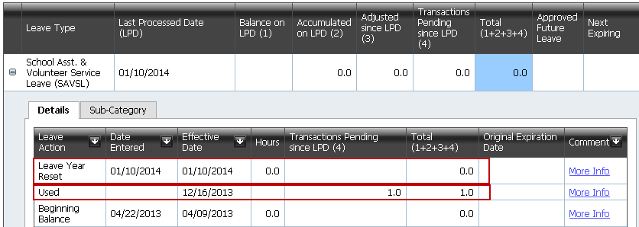

Note that the Leave Year Reset transaction does not show an amount in the “Hours” column, but it still sets the Total column back to zero. It may have been expected that the Leave Year Reset transaction would show a -1 in the Hours column to “zero out” / reset the leave category, but TAL instead just shows 0.0 in the field and this is sufficient to reset the leave total in the new year to 0.

**Additional Considerations**

1. When several transactions with dates prior to the new leave year are added from one or more leave requests, or timesheets, a leave “Lost Adjustment Decrease” will be written for each new transaction. In this example 3 new transactions are written and 3 new “Lost Adjustment Decrease” transactions are written.

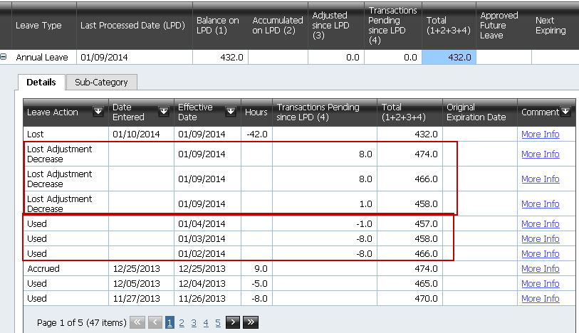

1. Also note that if the employee is required to complete a timesheet, the Last Processed Date (LPD) for leave balances will be the end date of the most recently processed timesheet. In the display below, the last timesheet was processed on 12/28/13. The accumulated leave balance for CWRL has a 1/10/14 LPD because that is when TAL resets that balance.

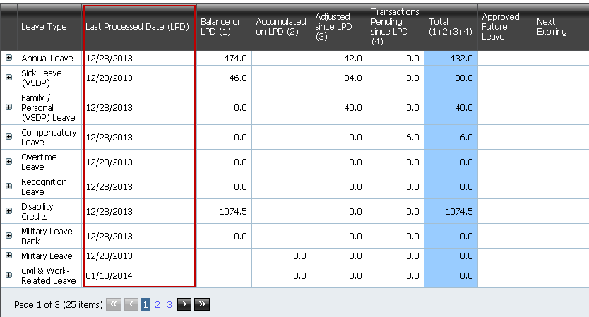

1. For an employee who no longer fills an active, classified position in TAL, TAL will:
   * apply carryover limits to the employee’s annual leave balance
   * reduce VSDP balances to zero (if employee was in VSDP program)
   * reset all accumulators to zero
2. There is no leave year end processing for At Wills.
3. If an employee receives an extension for annual leave, HR will need to make that extension in TAL on the Leave Adjustment screen. The extension should be made after the TAL Year End Leave process runs on 1/10.

# Appendix J – Processing Timesheets, Leave Requests, and Adjusting Leave Balances for Separated Employees (including those who transfer from one agency to another)

When a salaried employee separates from an agency, agency HR must review leave requests, approve timesheets, and adjust the employee’s leave balances in TAL to reflect leave pay outs or losses as soon as possible. The employee’s leave balances will not be accessible after 30 days from the separation date. It is particularly important that the balances for separated employees be adjusted to ensure that an agency’s leave liability reports will reflect correct figures.

**Reviewing and Approving Timesheets**

When an employee separates from an agency (including a transfer to another agency), it is important to verify that all existing timesheets have been approved. Once the employee separates from a position, neither the supervisor nor the employee will be able to view leave requests and timesheets under the inactive position. If there are any timesheets that have not yet been approved, the HR user should review the hours with the supervisor, update the timesheet if necessary and then approve the timesheets. Any leave hours on approved timesheets will be deducted from the employee’s balance when TAL processes the timesheet.

**Reviewing Leave Requests**

When an employee separates from an agency, the HR user must verify that all leave requests for leave used have been approved. Any existing leave requests for future dates under the inactive position will not be processed by TAL. Just like with timesheets, neither the supervisor nor the employee can view leave requests under the inactive position.

**Updating Employee Leave Balances in TAL**

Agency HR should follow policies for paying employees for various types of leave balances (e.g., annual leave, compensatory leave, overtime leave, recognition leave, traditional sick leave and disability credits). This process involves reflecting pay outs in PMIS as well as communicating with the appropriate payroll representatives to have balances paid out. Appropriate leave pay-outs must be reported to Payroll manually; TAL does not send this information to CIPPS. When an agency pays out or otherwise needs to “zero out” balances, agency HR needs to record these actions in TAL using leave adjustments.

Use the following matrix to determine the necessary adjustments to make in TAL:

|  |  |
| --- | --- |
| **Separation Scenario** | **Needed Action in TAL** |
| 1 - Employee is separating from your agency and state service | Record in TAL all leave that was actually paid out as well as the loss of any leave that exceeded the amount that policy allows to be paid out. Pay outs for leave depends on the leave balances the employee had at time of separation, but could be for any of the following leave types: annual leave, compensatory leave, overtime leave, recognition leave, traditional sick leave and disability credits. [This removes the leave liability from your agency.] |
| 2 – Employee is separating from your agency and transferring to another state agency. The agency the employee is transferring to does **not** use TAL. | Record in TAL all leave that was paid out (likely just compensatory, overtime, and recognition leave). Be sure to record the balances that transfer to the new agency and inform the agency receiving the employee of the balance transfers. Balances that transfer to the employee’s new agency should be reduced to zero in TAL (using a leave adjustment type of “Correction Reduction” and add a comment that explains the reason for the balance adjustment). [This removes the leave liability from your agency.] |
| 3 – Employee is separating from your agency and transferring to another TAL agency. The agency the employee is transferring to uses TAL. | Record in TAL all leave that was paid out (likely just compensatory, overtime, and recognition leave). TAL will automatically transfer the other balances to the employee’s record in the new agency. [This removes the leave liability from your agency.] |
| 4- The employee is separating from your agency but has not communicated whether he/she is continuing state employment | Refer to Scenario #1 |

Important Note: TAL does not send any hours designated as “Paid Out” to CIPPS for payment. **Such payment authorizations must be documented and sent to Payroll manually.**

**Examples of recording leave adjustments:**

Example 1: Recording a pay out to an employee for comp leave balances

Employee had 4 hours of Comp Earned at the time of separation that were paid out, so an adjustment of 4 hours of Paid Out Compensatory Leave was created in TAL, bringing the balance to zero.

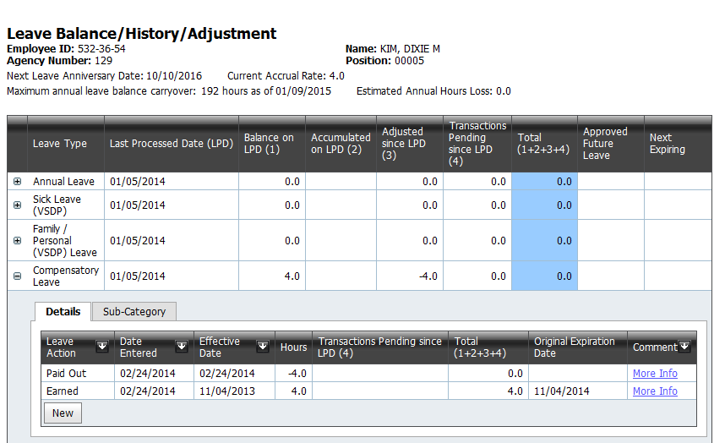

Example 2: Recording a pay out to an employee for annual leave balance

Employee had a balance of 215 hours of Annual Leave at the time of separation. The maximum payout for this employee was 192 hours. An adjustment for 192 hours of Paid Out Leave was created in TAL, leaving a balance of 23 hours. To zero out the balance, a Corrected Reduction adjustment was made for the remaining 23 hours.

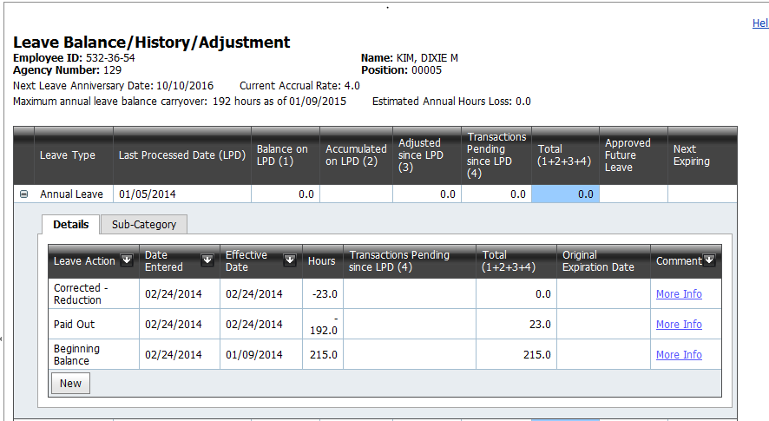

**It is important in the above example to record the hours in two separate transactions** **so that the amount of leave actually paid can be reflected separately from the amount of leave over the payout maximum that is deducted to reconcile the balance. This establishes a clear audit trail.**

Had the example above been for a Sick Leave (Traditional) or Disability Credits (or, starting 6/25/2014, Traditional Sick Leave Bank)all hours would need to be zeroed out even though only 25% up to a maximum of $5,000 value is paid out. Unlike the leave types with maximum payout limits which are expressed in specific numbers of hours, these categories are paid out differently.

**Balances that agency HR should review in TAL when an employee separates**

When an employee separates from an agency, the agency needs to review the following categories on TAL’s Leave Balance screen to determine whether action is needed to zero them out:

| **Category** | **Does this balance affect an agency’s leave liability?** | **Notes** |
| --- | --- | --- |
| Annual Leave | **Yes** |  |
| Sick Leave (VSDP) | No | See Note 1 |
| Sick Leave (Traditional) | **Yes** |  |
| Traditional Sick Leave Bank (eff. 6-25-14) | **Yes** |  |
| Sick Leave (Traditional) - Family | No | See Note 2 |
| Family / Personal (VSDP) Leave | No | See Note 1 |
| Compensatory Leave | **Yes** |  |
| Overtime Leave | **Yes** |  |
| Recognition Leave | **Yes** |  |
| Civil & Work-Related Leave | No | See Note 2 |
| Disability Credits | **Yes** |  |
| School Asst. & Volunteer Service Leave (SAVSL) | No | See Note 2 |
| Military Leave | No | See Note 2 |
| Military Leave Bank | **Yes** |  |
| Bone Marrow/Organ Donation Leave | No | See Note 2 |
| Educational Leave | No | See Note 2 |
| Emergency/Disaster Leave | No | See Note 2 |
| Public Health Emergency Leave | No | See Note 2 |
| Pre-Layoff Leave | No | See Note 2 |
| Pre-Disciplinary Leave | No | See Note 2 |
| Leave Without Pay | No | See Note 2 |
| STD (not Workers Comp) | No | See Note 2 |
| STD (Workers Comp) | No | See Note 2 |
| LTD - Working (not Workers Comp) | No | See Note 2 |
| LTD - Working (Workers Comp) | No | See Note 2 |
| Workers Comp | No | See Note 2 |
| Family Medical Leave Act | No | See Note 2 |
| Pay Docking | No | See Note 2 |

**Note 1:** This leave will automatically be zeroed out at leave year end so Agency HR can zero this out or allow TAL to automatically zero it out.

**Note 2:** No need to zero out this balance since it is just a counter of how much of this category was used. TAL will reset this to zero at leave year end. The hours charged to leave that accumulates will automatically transfer with the employee to the new agency if the new agency is in TAL.

**Note 3:** If an employee is requesting **disability credits** be converted to service credits, use the Paid Out option, and make a note in the comment section about the number of hours of disability credit converted to service credit.

**A TAL Query that Helps Identify Separated Employees with Leave Balances Needing Review**

TAL provides a query that, when run, will identify employees that have separated from the agency and have a non-zero balance in the following categories (all of which affect an agency’s leave liability report):

* Annual Leave
* Comp Leave
* Overtime Leave
* Recognition Leave
* Traditional Sick Leave
* Disability Credits

The name of the TAL Query is *“Leave – Separated Employees w/ Reviewable Leave Balances”.*

# Appendix K – Preparing for Leave Liability Reporting

At the end of each fiscal year, agencies must certify leave liability data.  For those agencies using TAL, TAL will provide queries that make this data available in early July (after fiscal year close) for agency review and use when completing the Leave Liability Attachment as required by the Comptroller’s Directive Compliance Guidelines for State.  In order for TAL to accurately reflect an agency’s leave liability, the data that TAL uses to determine that liability must be correct.

Agency HR personnel should perform the following steps to ensure that TAL has accurate data:

1. Agency HR personnel should ensure that all leave adjustments effective through 6/24 for the following leave categories have been recorded in TAL for their employees by the end of the fiscal year (6/30):
   1. Annual
   2. Sick Leave (Traditional)
   3. Compensatory Leave
   4. Overtime Leave
   5. Recognition Leave
   6. Disability Credits
2. Agency HR personnel should ensure that the following fields of data are accurate in PMIS by end of day on 6/24:

|  |  |  |
| --- | --- | --- |
| **Field in PMIS** | **Source to Use to Review** | **Description** |
| Employee State Begin Date | PME480 | Date when the employee began the current term of continuous state service |
| Prior State Service | PME480 | Number of months of state service completed prior to the present term of continuous employment with the state |
| Employee Percent Time | PME480 | Percentage of time that this employee occupies this position, i.e. 100.00, 50.00, 68.75, etc. |
| StateSalary | PME480 | Salary paid by the Commonwealth of Virginia from funds deposited with the State Treasury |
| Non-State Salary | PME480 | Any compensation awarded to the employee that was not directly provided by the State Treasury |
| Special Rate Compensation | PME480 | VRS-creditable pay that applies to specific positions designed to address unique needs of the agency. |
| VSDP Enrollment Indicator | PME480 | Enrollment status of the employee in the Virginia Sickness Disability Plan (VSDP):  Value "N" means "no", is not enrolled  Value "Y" or "L" means "yes", is enrolled  ("L" is for DHRM internal use) |
| Position Funding | Refer to Note | Contact Shannon Gulasky at [Shannon.gulasksy@doa.virginia.gov](mailto:Shannon.gulasksy@doa.virginia.gov) and request a report that highlights discrepancies between CIPPS and PMIS funding.  Use this report to investigate discrepancies between CIPPS and PMIS and then update PMIS position funding as necessary. |

 Agency HR personnel should ensure that they have recorded leave balance payouts for separated employees in TAL by the end of the fiscal year (6/30).  If an agency has paid out leave balances for separated employees, but TAL does not reflect this payout, then the agency’s leave liability will be overstated on the TAL leave liability reports. To check whether a separated employee has a leave balance in TAL that could be paid, run the **TAL Query named** **“Leave – Separated Employees w/ Reviewable Leave Balances”**.  It may be that the employee has been paid for his / her remaining balance but that TAL still needs to be updated to reflect the payment.

1. <http://www.doa.virginia.gov/Payroll/Forms/Magentic_Media/700_magnetic_media_requirements.pdf>