CoVA Exit Survey
Agency Internal Communication Template

The Commonwealth of Virginia has launched an exit survey for classified employees who are resigning from employment with the Commonwealth of Virginia. The purpose of the exit survey is to obtain a deeper understanding for reasons for employee turnover and to identify opportunities for addressing turnover reasons.

The Commonwealth has engaged a third-party vendor, Mercer I Sirota, to partner with us on this initiative. The vendor will collect exit survey responses and only provide summary results to the Commonwealth. All individual survey responses are confidential.

Mercer | Sirota will send post cards to classified employees who have resigned from employment with the Commonwealth in the month following the resignation. Post cards will be sent to home addresses and will include a website link and passcode for completing the survey. The survey can be completed using a mobile device or computer. If those options are inaccessible, then a paper survey can be requested from Mercer | Sirota. The exit survey should take 5 - 10 minutes to complete.

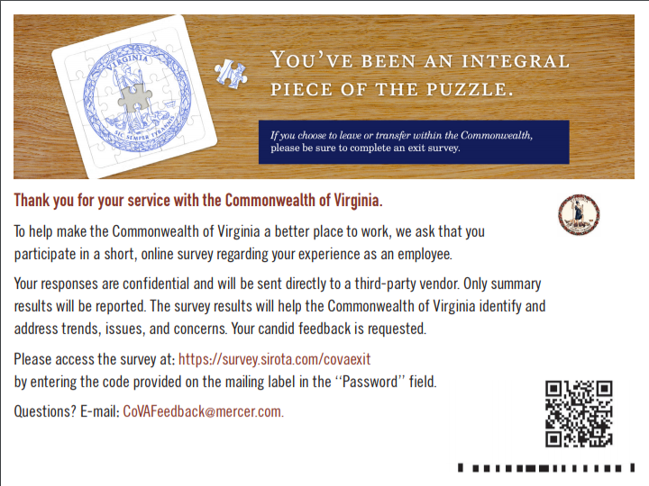
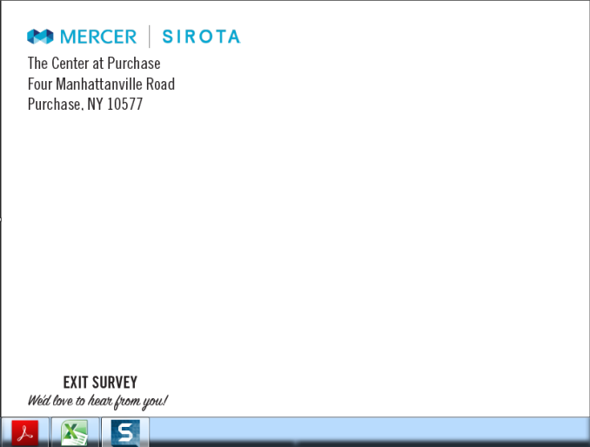
Below is a sample post card. The feedback provided from resigning employees is important and valuable for the Commonwealth to better understand and address challenges that may exist. If you have any questions regarding this process please contact <Agency Name> Human Resources.

Sincerely,

<Agency Director or Commissioner>
Agency Name

