James Monroe Building
101 N. 14th Street
Richmond, Virginia 23219
(804) 225-2136 (office)
(800) 533-1414 (office)
(804) 371-7401 (fax)
eesvcs@dhrm.virginia.gov
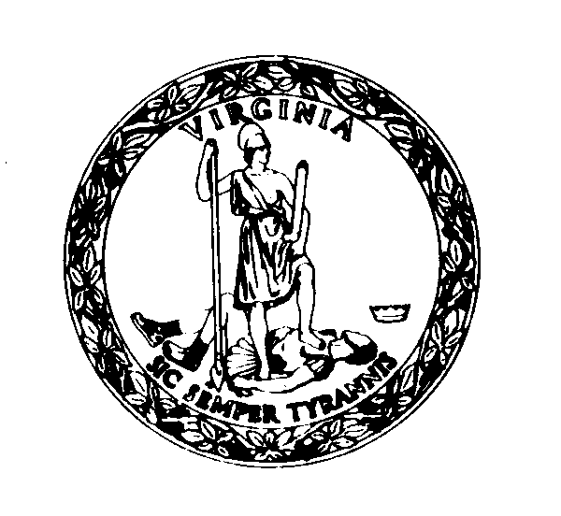

Commonwealth of Virginia

Department of Human Resource Management

Office of Equal Employment & Dispute Resolution

http://www.dhrm.virginia.gov/equal-employment-opportunity

COMPLIANCE REVIEW CERTIFICATION

My signature below indicates that this agency has reviewed the information contained in the DHRM EEO Assessment Tool for fiscal year _________ and shared this information with the agency head and human resource director, including any appropriate corrective action(s) that are recommended and/or have been taken.

Agency/Number: __________________________________________________

Name/Title: ______________________________________________________

Signature: |  | Date:

Initialed as seen: _____ (Agency Head) - Date: _____________________________

Initialed as seen: _____ (HR Director) - Date: _______________________________

