Basics 101: Searches: How to Save a Search

How to Save a Search in the Applicant Tracking System

Applicant Tracking – Posting Saved Search
”More Search Option” criteria can vary from the options (Column options, Department, Workflow State, FLSA) listed in this guide.
1. Underneath MORE SEARCH OPTIONS;
A. Select the appropriate Columns that you would like to add to the search.
B. If you would like to add specific department(s) to the search, select the appropriate Department(s) that you would like to the search. If there are more than one, hold down the control key and select multiple departments.
C. In this example, there is also the option to add Workflow State. Again, multiple workflow states can be selected by holding down the control button and clicking on the desired states.
D. Add Additional options like FLSA.
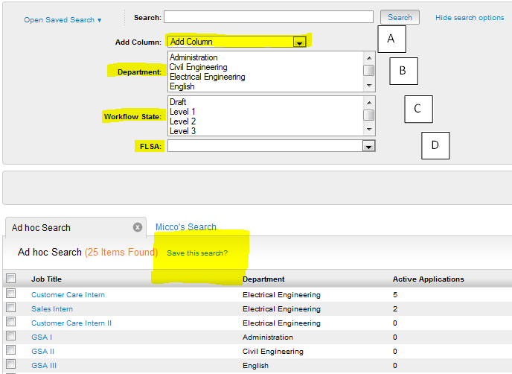
2. SAVE THIS SEARCH?
A. Please click the “Save This Search”
B. Name this “Saved Search” something relevant to this specific search.
C. Define the search as a “Personal” (You), “Group” (Ex: HR), Global (Everyone)” Saved Search.
D. You have the option to make this a “Default” search for the Person, Group, Global (Everyone) by checking the box. NOTE: Global Default will override all others aside from personal default searches that users have created for themselves.
E. Click the Save This Search button.
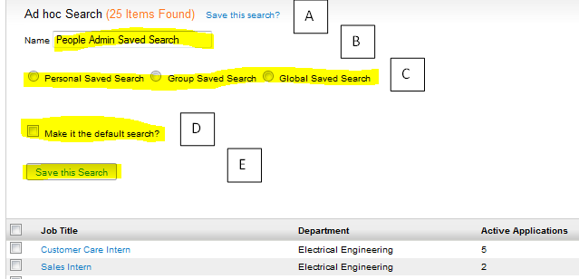
3. SAVED SEARCH will populate as a tab, if set as a “Default” saved search [A] , or it will appear under the “Open Saved Search” blue drop down[B].
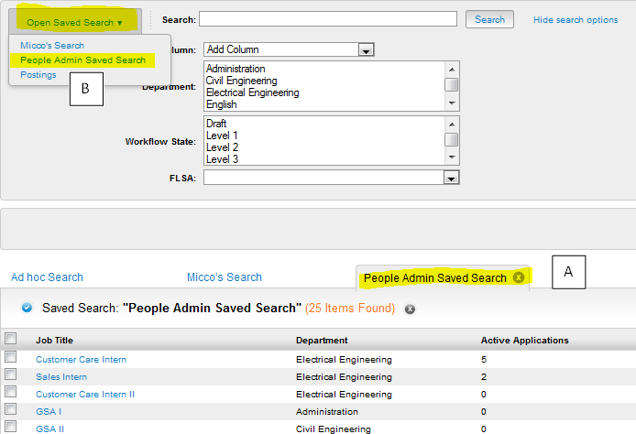

Applicant Tracking – Applicant Saved Search
1. Saved Search also exists on the Applicant tab within each posting.
Underneath MORE SEARCH OPTIONS,
A. Select the appropriate Columns that you would like to add to the search.
B. If you would like to add specific applicant state (Active / Inactive) to the search, select the appropriate state(s) that you would like to the search. If an applicant does not appear, he or she could be in a DRAFT state. Please check the Draft checkbox.
C. In this example, there is also the option to add Workflow State. Again, multiple workflow states can be selected by holding down the control button and clicking on the desired states.
D. Select SAVE THIS SEARCH…then follow the same instructions in Step 2.
