User Guide

Table of Contents
INTRODUCTION Error! Bookmark not defined.
GETTING STARTED Error! Bookmark not defined.
Adding Screening Questions Error! Bookmark not defined.
Documents Needed to Apply Error! Bookmark not defined.
Activating Guest Users Error! Bookmark not defined.
SEARCHING POSTINGS Error! Bookmark not defined.
To search for items on a page Error! Bookmark not defined.
To search for a specific applicant Error! Bookmark not defined.
Reviewing Applicants Error! Bookmark not defined.
Changing the Status of Applicants Error! Bookmark not defined.
Changing the Status of Multiple Applicants Error! Bookmark not defined.
Hiring Proposals Error! Bookmark not defined.
To approve a hiring proposal or move it in the workflow Error! Bookmark not defined.
To print a hiring proposal Error! Bookmark not defined.
Working with Document Types Error! Bookmark not defined.
About Email Templates Error! Bookmark not defined.
Working with Email Templates Error! Bookmark not defined.
Configuring Global Settings for Site Behavior Error! Bookmark not defined.
Configuring Password Requirements Error! Bookmark not defined.
Supplemental Questions in the Admin Area Error! Bookmark not defined.

INTRODUCTION

Welcome to the Department of Human Resource Management Online Employment Application System. The Human Resources department has implemented this system in order to automate many of the tasks of the employment application process.

You will use this system to complete three main tasks:
- Review Requisitions
- Search and Review Applicants
- Communicate electronically with HR Administrators, Hiring Managers, Applicants, and others involved in your hiring process

PeopleAdmin, Inc. has provided these training materials to assist your understanding of this system. If you have any questions, please email askpa@peopleadmin.com

Your Web Browser
PeopleAdmin SelectSuite® supports the following browsers:
- Chrome (self-updating)
- Firefox versions currently supported by the vendor
- Internet Explorer version 9 and later
- Safari versions currently supported by the vendor
When an issue arises with a supported browser version, PeopleAdmin will consider fixing it in an upcoming release. Issues related to browser versions that are no longer supported will not be addressed.
The site also requires you to have Adobe Acrobat Reader installed. This is a free download available at www.Adobe.com.
Security of Applicant Data
To ensure the security of the data provided by applicants, the system will automatically log you out after 60 minutes if it detects no activity. However, anytime you leave your computer we strongly recommend that you save any work in progress and log out of the system by clicking on the logout link located on the bottom left side of your screen.

GETTING STARTED

After entering the URL, the “login screen” for the system will appear and should be similar to the following screen:
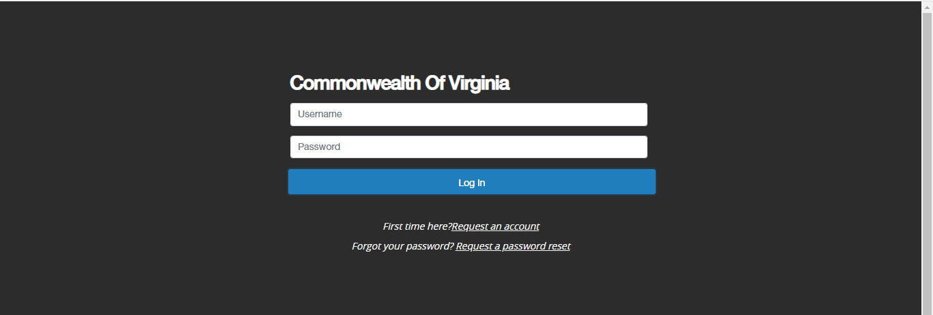

The Welcome Screen appears after you log in, and should appear similar to the following screen:
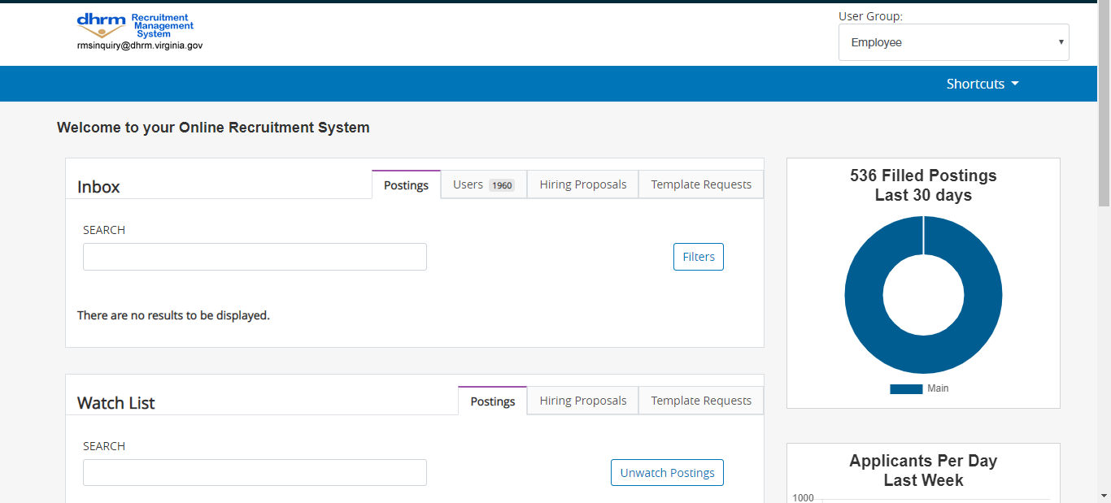
This page is designed to help you keep track of the actions required by you or your department.
Items in your inbox require your attention. Items on your watchlist are things you have designated you’d like to keep an eye on as they move through the approval process.

Postings/Requisitions

You may create a requisition/posting using the system. You will be able to create a posting from scratch (blank form) or from a previous posting.

To create a new posting, click on Postings from the top menu and then click on the Create New Posting button.
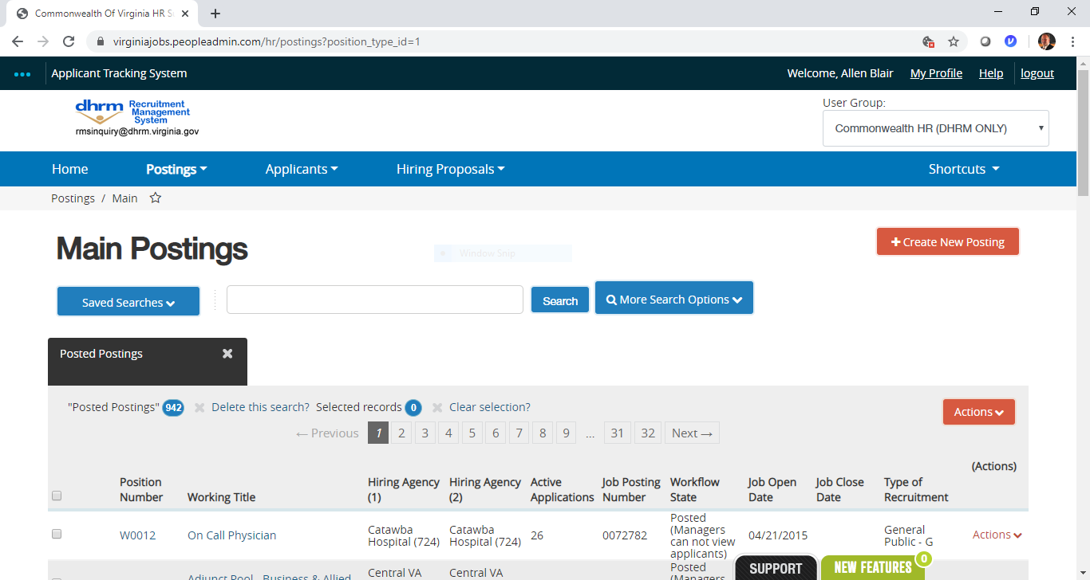

Entering Posting Information

You will then be prompted to create your posting from a position type (scratch) or from a previous posting.

You will then come to the Postings Setting page where you will give the title of the posting and determine the division and department of the posting.

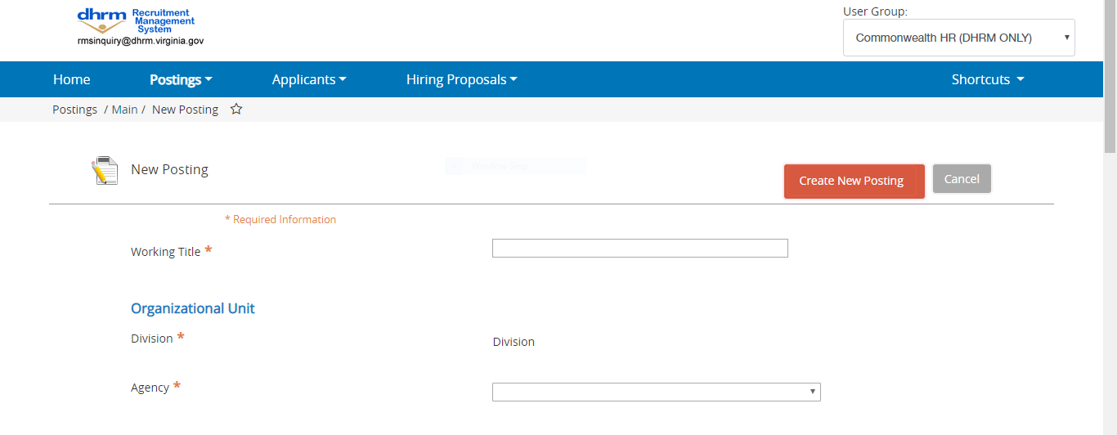
When you have completed filling out that information, click on the Orange Create New Posting button.
You will then come to the Posting Details page, the first page of the Posting. Fill out the fields on the form.
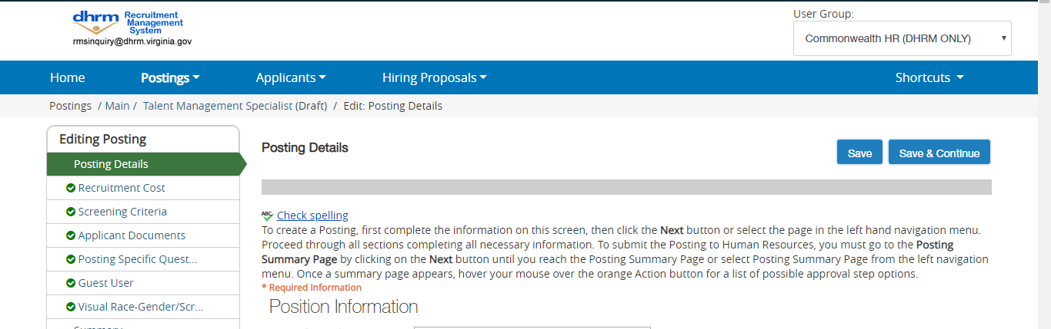

Fields with an Asterisk (*) are required, so if you do not include information in the field, an error message will appear and you will be required to complete it.

TIP: Certain fields you enter on this screen will appear on the applicant site exactly as you enter it on this screen, so please proofread carefully.

Adding Screening Questions

Posting Specific (screening) Questions are individual questions that can be used to qualify/disqualify candidates, or rank applicants based upon a score. You may create those questions in this section.

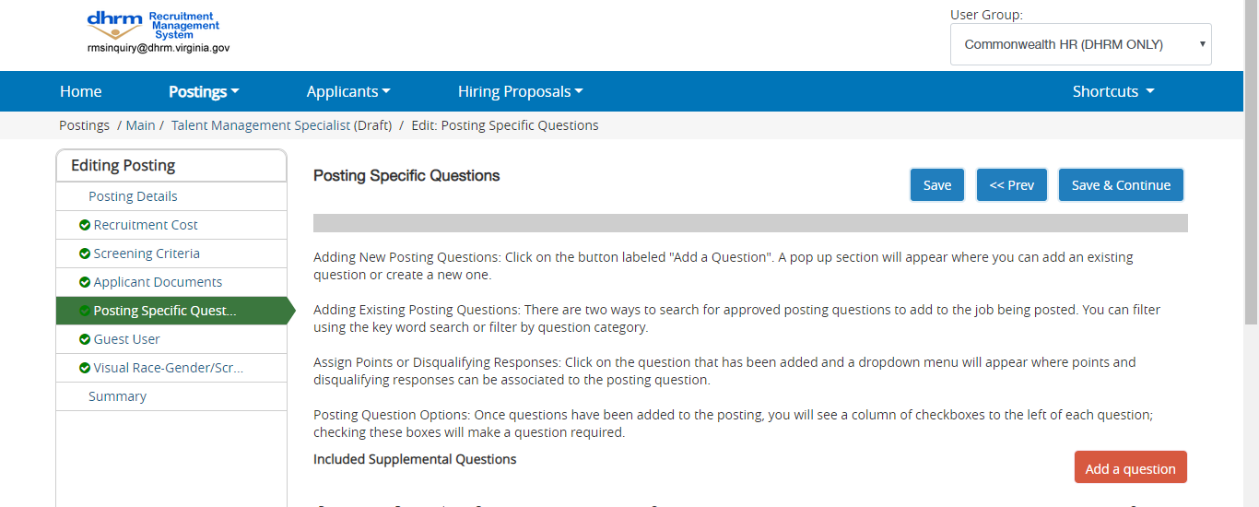

If you are not adding any Screening Questions, click the Next button.

To add a Screening Question to this Requisition, click on the Add a Question button, which returns the following page:
The first step is to search existing questions. You can enter a keyword to search the question text (or leave the field blank). The system will return a list of all questions that have been entered previously by Human Resources or Hiring Managers for other Requisitions. Select one of the questions from the list if it is appropriate for this Requisition.

If you do not find an applicable sample question from the list, you may create a question from scratch by clicking on the Add a Question link at the bottom of the Search Results screen.
Step 1: Please enter question name, status, category and question text Enter the text of the question you wish to ask all candidates who will apply to this Posting. (Only HR will be able to change the status of question, all other user groups will have their question at a “Pending” status awaiting HR’s approval.

Step 2: Please select answer type: select either Open Ended or Predefined Answers – described in the following sections.

Step 3: Enter answer choices or select answer format based upon your selection in step 2.
Adding Closed Ended Questions

Closed Ended questions require a multiple-choice answer. For example:

Do you have experience working in an office environment?
Possible Responses: Yes or No
After selecting the “Closed Ended” radio button, enter the answer choices that candidates can choose from in the boxes labeled “Possible Responses”. In this case, you would enter:
- Yes
- No

Adding Open Ended Questions

Open Ended questions do NOT require a multiple-choice answer. For example:

Describe any work experience relevant to this position.

The next step is to click on the Submit button at the bottom of the screen. This attaches the question to the Requisition, and every applicant who applies to this Requisition will be asked this question.

After you click Submit Question, you should see a screen similar to the following. This screen summarizes the question(s) you have entered. As you enter additional questions, they will be added to this summary screen.

From this screen you may continue to add more questions by clicking the Add a Question button. You may also delete a question you have entered by clicking the x next to the relevant question.

You also have the ability to Require an applicant to provide an answer to the question you added. The applicant will not be allowed to proceed without answering a question with the “Required” status. To require the question, check the required box.

If you wish to make a question a disqualifying question or to assign points to responses, click on the question link.
When you click on the question, you will see the screen above where you can mark a selection disqualifying by checking the box or you can assign points to a particular response. This is often done to help find the most qualified candidates quickly. You do NOT have to use this functionality to use supplemental questions.

When you have finished adding screening questions for this Requisition, click the Next button.

Documents Needed to Apply
On this screen, you will designate the documents that will be necessary for applicants to apply to this posting. You can make this determination on a posting by posting basis. If a document is optional, select the Optional radio button, if it is required, select the Required radio button.

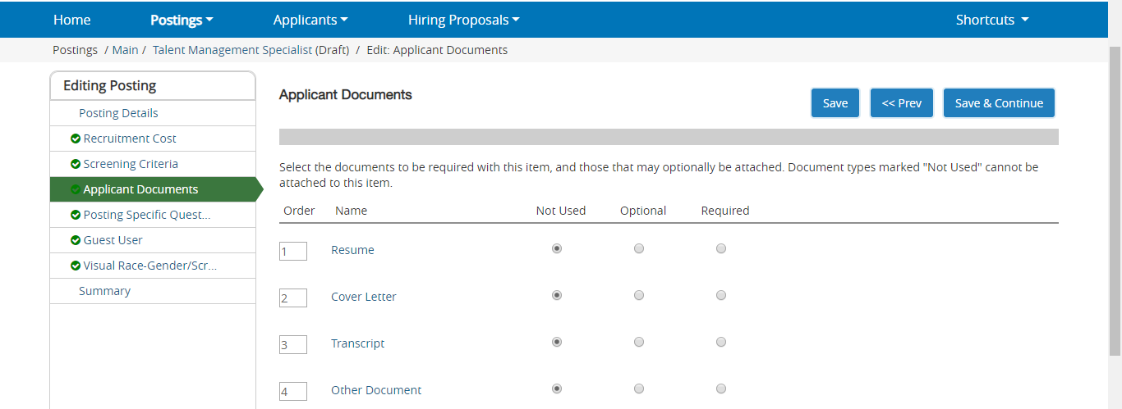

Activating Guest Users
Guest Users are only able to view the applicants to the Requisition(s) to which they are assigned, and are not permitted to take action on any of the applicants. Also, Guest Users are only able to view the Requisition(s) to which they are assigned. When the Requisition is filled, the guest user name and password are automatically deactivated. This feature can be used for individuals who are not users in the PeopleAdmin system.

Click on the Create Guest User, the system will generate a Username and the password will also auto generate. If you want to change the password, update the password and then click on Update Password. You can enter the email addresses of anyone you want to send the guest user credentials to and when finished, you would click on the Update Guest User Receipient List. When done on the Guest User page, click on the orange Next button.
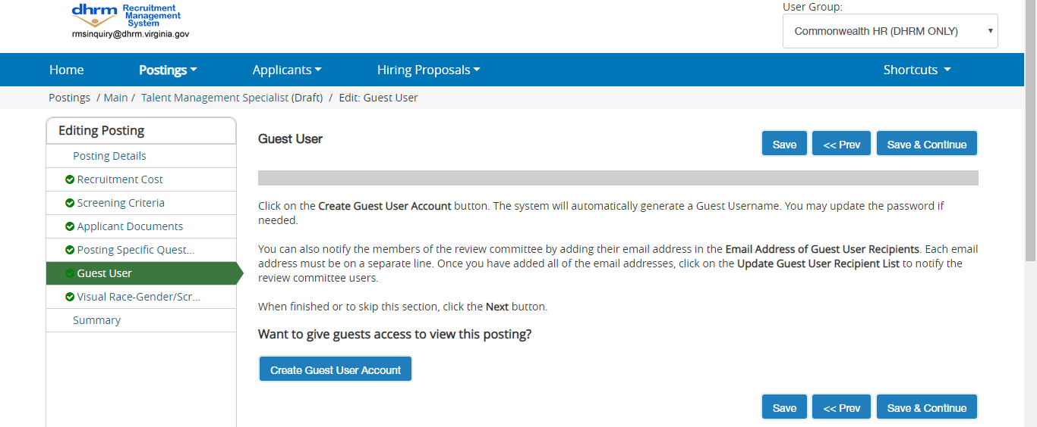

The system will then bring you to a summary page where you can review the posting and and move to the next level approver.

The system will generate an email to the Unit VP and this posting will appear in their inbox for their approval. The posting will continue through the approval process until Human Resources will post the position.

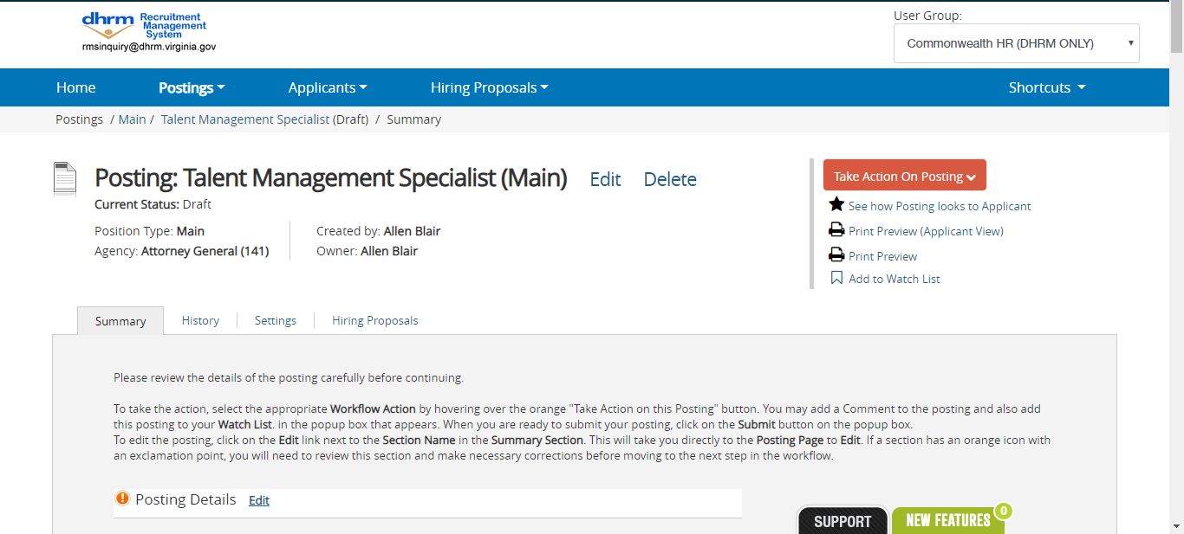

SEARCHING POSTINGS

To search for postings in the system, you will go to the Posting label on the top menu. The system will return your default posting search resutls. You can customize your search results baesd on how you wish to view the posting data. There is a key word search where you can type in a word and search for the posting. Our most common fields are indexed to return in a keyword search. The Add Column feature allows you to add additional fields to your search results.

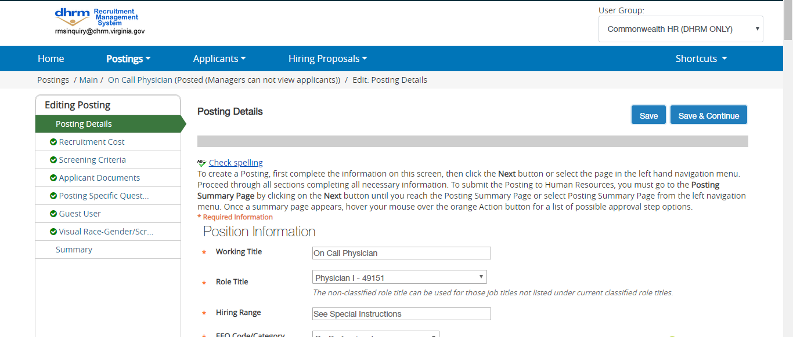

To search for items on a page
- The text search box allows you to search for specific words or names.
- Select More search options to expand the search tools area.
- Use the searching and filtering tools to narrow down the results that the system presents:
  - You can add columns if the information you need is not included on the page.
  - Use advanced filters (if any are available) to narrow down the results.
- Use the column controls to organize and sort the search results:
  - Move a column to the left or to the right using its left and right controls.
  - Delete a column using its delete control if you do not want to display it. If you need to add it back later, use the add columns control to do so.
  - Order the search results by sorting a column in ascending or descending order using its up and down controls.
You can use all these tools in any order.

Search tips
- Text search is not case sensitive.
- Searches normally return items that contain all your search terms. For example, if you enter facilities manager, the search returns items that contain both these words.
- To exclude search results, use the - character. For example, to search for postings that contain the word "director" but not "athletic", enter director !athletic or director -athletic, placing a space before the ! or - character.
- To search for a phrase that contains a dash or a space, enclose the entire phrase in quotation marks: "director - athletic".
- You can't do a search that only specifies what not to return, such as !coordinator.
- You can't do a search for a word or phrase that was selected from a drop-down list, such as the name of a state, but you can use filtering to find the information. The procedure below for viewing applicants who reside in a specific state gives an example of how to do this.

Example: To search for a specific applicant
Applicant is a customizable term. Common synonyms: candidate or job seeker.
- In the APPLICANT TRACKING module, select Applicant Search from the Applicants menu.
- Select More search options to expand the search tools area.
- Use the searching and filtering tools to narrow down the results that the system presents:
  - You can add columns if the information you need is not included on the page.
  - You can select workflow states of interest.
If your organization uses position types, the list of workflow states includes states for each position type, so there may be more than one state with the same name. Your searches may be more effective if you select all instances of the desired workflow state.
- Use the column controls as you would in any other search.
When you search for applicants by name, your search results include all applicants who included the name anywhere in their applications. Sorting the results by applicant name can help you find the person you are searching for.

Example: To view applicants who reside in a specific state
- In the APPLICANT TRACKING module, locate and select the desired posting.
Posting is a customizable term. Common synonyms: announcement, requisition, workforce request, or open position.
- Follow the Applicants link to present a list of people who have applied to this posting.
- Select More search options to open the advanced searching controls.
- From the Add column menu, select (Applicant Detail Parent) Lookup State. This adds a column to the table of applicants, showing the state listed in each person's address.
- Use the ascending or descending order sorting control associated with the new Lookup State column to group applicants by state.

To export search results
- Set up the search or open a saved search.
- From the Actions menu, select Export Results. The search results are saved in .xls format. Depending on your browser, the file may automatically download to your computer's download folder, or you may be prompted to choose whether you want to open or save the file.

To save a search
When you save a search, you have the option to set it as your default search. This is your only opportunity to set it as the default search.
People with administrative access can share saved searches by tagging them as global or group saved searches. Non-administrative users can only save personal searches.
- After you have used the search and filtering controls to present the search results the way you want to see them, select Save this search. The Saved Search area expands.
- Give the search a name that will help you remember its purpose.
- Select one of these:
  - Personal Saved Search – Only you will have access to this search.
  - Group Saved Search – The search will be available to all users within the groups that you specify. Select at least one group from the list that appears when you select the Group Saved Search option. To select more than one group, hold down the Ctrl key while you select the groups.
  - Global Saved Search – The search will be available to all users within your organization.
- If this search presents the information you will normally want to see when you navigate to this page, you may want to select Make this the default search.
- Select Save this search. The search tab refreshes to present the name you have given the search. This tab remains available for the rest of your session. The next time you log in, the search is available from the list of saved searches in that area.
You can delete your personal saved searches when they are no longer useful to you.

To run a saved search
- Access the list of items you need to search.
- From the Open Saved Search menu, select the search you want to run. A new tab presents the search results.

To delete a saved search
- Access the list of items you need to search.
- From the Open Saved Search menu, select the search you want to run. A new tab presents the search results.
- Select the Delete (X) control placed just after the name of the search and the number of search results returned. A message asks you to confirm that you wish to delete the saved search.

Reviewing Applicants
APPLICANT TRACKING: Postings – Select Main from the Posting menu. Locate the posting that you wish to review applicants on and open it to the Applicants tab.
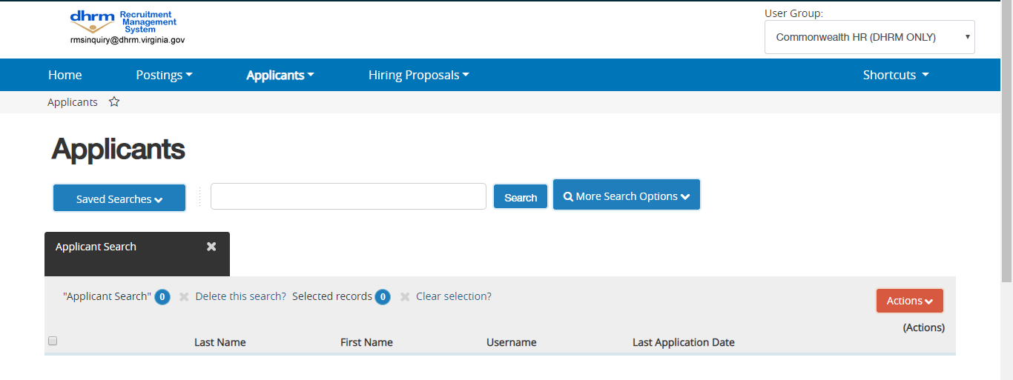

To see who has applied to a posting
- Locate and open the posting.
- Open the Applicants tab to open the list of applicants.

To view an application
- In the search area of the posting's applicants list, add the "Document Conversion Status" column to this search view to see whether any applicants have submitted documents that did not convert properly to PDF.
If an applicant uploads a document that fails to convert to PDF, the application will need to be reactivated so the applicant can provide a new document.
The supplemental questions section indicates whether the applicant passed the qualification group questions, if there were any on the posting.
The certification section of the application shows whether the application was submitted by the applicant or by an HR user on behalf of the applicant.

To view an applicant's documents one at a time
- Locate the applicant of interest from the complete list of applicants on the posting or from a supplemental question statistical detail.
- Select the document of interest.

To view one applicant's application materials together
- If the list of applicants does not include the Combined Documents column, select More Search Options and add it from the Add Column list. The list of applicants refreshes.
- For the applicant of interest, select Generate or View in the Combined Document column, depending on which is available. Generate creates an up-to-date PDF. View presents the PDF of the applicant's most recent application materials in a new tab of your browser.

To view a collection of applicant documents
You can review more than one applicant document at a time. You may choose to view all the documents for an applicant, specific applicant documents for each of a group of applicants, or all applicant documents for a group of applicants.
- On the posting's Applicants tab, check the boxes to select the applicant or applicants of interest.
- Do one of these things:
  - See the selected applicants' materials together: From the Actions menu, select Download Applications as PDF. In the dialog box, select the types of documents you want to view, then select Submit.
  - See the selected applicants' materials separately: From the Actions menu, select Create Document PDF per Applicant.
The system creates a PDF containing all the documents that you request.

Changing the Status of Applicants

While reviewing an application, you can change the status of applicants as you review their credentials, interview them, and make a final decision. To change the status of one applicant, click the “Take Action on Job Application” button.

Changing the Status of Multiple Applicants

To move a group of applicants to a new workflow state
- From the list of all applicants on the posting, check the boxes associated with the applicants of interest.
- From the Actions menu, select Move in Workflow. The Editing Workflow States page opens.
- Do one of these things:
  - Use the Change for all applicants box to select the workflow state for all the applicants you selected, or
  - For each applicant listed on this page, select the new workflow state.
- If required, select the reason that best explains why you are moving the applicants in the workflow. You can select a reason for each applicant even if you moved all of them in the workflow together.
- When you have moved all applicants to the appropriate workflow states, select Save Changes to update them.

Hiring Proposals
When an applicant has gone through the evaluation process and becomes the finanlist/selected candidate, a link to begin the hiring proposal will appear. The Department Head will be able to begin the hiring proposal by selecting the Start Hiring Proposal link.
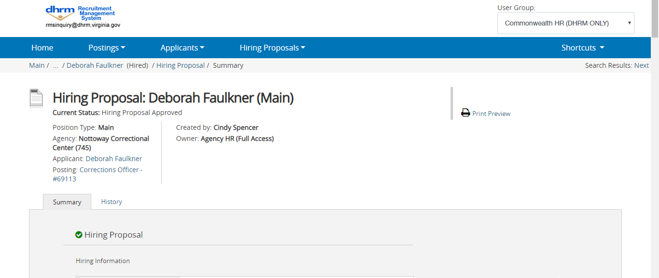

To approve a hiring proposal or move it in the workflow
- From the Hiring Proposals menu, select the appropriate position type.
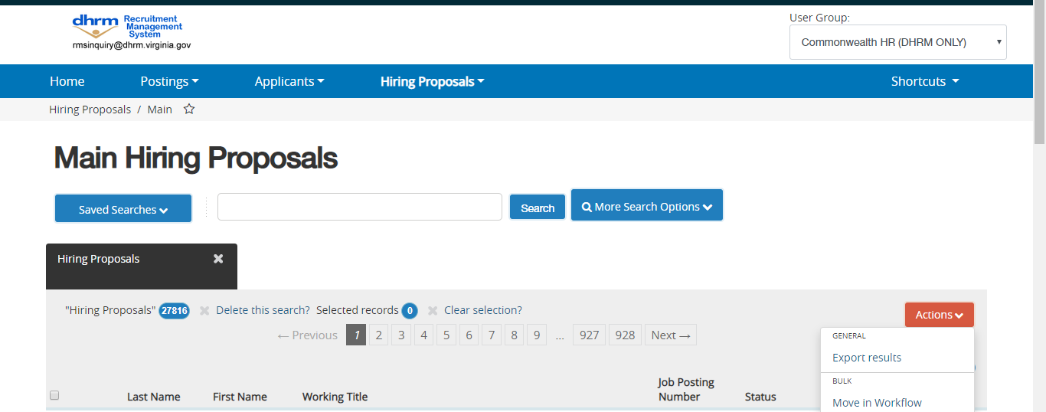
- Locate and open the hiring proposal for the applicant of interest.
- Open the Take Action on Hiring Proposal menu and move it to the appropriate workflow state. A confirmation box opens.
- If required, provide an explanation for moving the applicant to this workflow state.
- Select Submit to move the hiring proposal to the selected workflow state.
Your organization's process determines how the offer is generated and presented to the applicant.

To print a hiring proposal
- Locate the hiring proposal and open it for viewing.
- Select Print Preview. The system presents a printable view.
- Use your browser's Print feature to print the document.
- Use your browser's Back button to return to the main view of the hiring proposal.

When the hiring proposal is finalized, the applicant will be moved to Hired.
At this point, you will want to go to the Posting and move it to filled. This will complete the close out process of your posting in PeopleAdmin.

Admin Module (HR Only)

Working with Document Types
ADMIN: General Setup / Document Types— Create and edit document types. Delete document types that are not used.
Document types allow you to specify and provide guidance concerning the files that people can upload to your applicant portal. Some document types are supplied by internal users; others are supplied by applicants.
Document types do not have histories.
Document types are grouped into categories: Posting documents, position description documents, and hiring proposal documents support your organization's internal processes. Application documents include document types such as résumés, curricula vitae, cover letters, media presentations, and other types of documents that applicants may need to submit as part of the application process.
Document types do not specify what is in a file of that type, and SelectSuite does not validate the uploaded material. The document type simply creates a way to tag and identify the material within SelectSuite, to ensure that it is handled properly.

Terms that might not match what you see
Many elements on your PeopleAdmin site can be renamed to match your organization's terminology, so the buttons, menu tabs, and other elements of your site might not match the terms used in the help.
Posting is a customizable term. Common synonyms: announcement, requisition, workforce request, or open position.
Position description is a customizable term. Common synonym: position.
Applicant is a customizable term. Common synonyms: candidate or job seeker.

To view document types
- Select General Setup / Document Types to open the Document Types page.
- Select the category of document type, then select Filter to open a list of documents (if any) that have been defined in that category. Categories are:
  - Posting – typical document types in this category include organizational charts and budget-related documents.
  - Position description – typical document types in this category include budget- and compensation-related documents and job descriptions.
  - Hiring proposal – typical document types in this category include verification documents.
  - Applicant – typical document types in this category include résumés, cover letters, transcripts, and CVs.
  - Reference letter – This category is for recommendations provided by each applicant's reference providers. You may choose to set up document types that are specific to position types or categories of jobs.
  - Onboarding – typical document types in this category include policy manuals and benefits information.
If no document types have been created in the selected category, the list of document types is empty. You can change to a different category of document type, or create a document type.
- Locate and select the document type of interest. Its summary view opens.
From this view, you can edit the document type or return to the list of document types.

To edit a document type
- Locate and view the document type you need to edit.
- Open its Actions menu and select Edit document type.
- Edit the information for the document type:
  - Name – Use a short, descriptive term. This name will be used wherever users or applicants work with document types – for example, if it is an applicant form, the name will be included on the page where applicants upload résumés and other documents.
  - Description – Provide a short, clear explanation of the document type. The description needs to provide guidance, so that people understand what is expected.
  - Accept URL in Lieu of Uploaded Document – Select this option to allow users and applicants to link to a document instead of uploading it. This allows people to provide access to files that are too large to upload (such as complex charts, video, or music recordings) and to present portfolio offerings such as online photo galleries.
  - Convert to PDF – Check this box to convert documents of this type to PDF, or leave it unchecked to leave the documents in their original format. Convert to PDF is a good choice for text documents such as résumés and cover letters; it enables the hiring manager to view multiple applicant documents as a single PDF file. The system's PDF converter cannot convert graphics, scanned files, or video.
  - Index for Searching (available if this type of document is to be converted to PDF) – Select the check box if you would like the system to make the PDF file searchable. Documents must contain text to be searchable.
  - Maximum Allowable Document Size – Select a maximum allowable size for documents of this type from the drop-down menu.
- After you have defined or updated the information for the document type, select Update Document Type (or Create Document Type, as applicable) to apply your changes and view a summary page.

To create a document type
Create separate document types for text and non-text items.
- Open the appropriate category of document types.
- From the Actions menu, select Create New Document Type.
- Continue as you would to edit a document type.
- After you have defined or updated the information for the document type, select Create Document Type to apply your changes and view a summary page.

To delete a document type
If a document type is in use, you cannot delete it.
- Open the appropriate category of document types.
- From the Actions menu associated with the document type you wish to delete, select Delete Document Type.
- Confirm the deletion.

About Email Templates
Email templates allow the system to send messages to specific people or groups when specific things happen. Examples include:
- When an applicant selects "Email a friend" in a posting, a message about the goes to the email address the applicant provides.
- When a posting is filled, a message goes to the hiring manager.
- When an application to a pool expires, a message goes to the applicant.
- At the appropriate point in the applicant workflow, recommendation request messages go to the people whom the applicant has listed as references.
Email templates use text that you supply, along with variables (such as name, posting number, and posting title) to tailor or personalize the message. After you associate an email template with a system event or site trigger, the system can use it to generate a message when the event or trigger condition happens.
Email templates are associated with specific system events. The email generated from the template goes to the person associated with the system event. For example, when someone requests a new profile and a site administrator approves the profile, the approval event can be configured to generate an email message saying that the profile has been approved and is now active. Since the event affects one profile, the email message automatically goes to the user.
System events and email templates are organized into categories. When you choose an email template to use for a system event, you can only choose from the templates available in the category to which the event belongs.

Working with Email Templates
ADMIN: General Setup / Emails & Templates – Work with email templates by category; specify the email template that each system event uses to generate email messages.
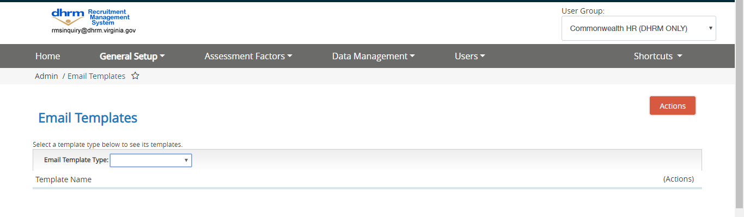
Email templates automate messages that address common points in HR processes when people need to be notified – for example, organizations typically have templates for messages to acknowledge an application, let applicants know they are or are not under consideration, solicit references from reference providers, and so on.
Each system event can be associated with one email template. You use the same email template for more than one system event.
If you need to set up a template for a special-purpose message such as an offer letter, free-text reports may provide the capabilities you need.

- Select General Setup / Emails & Templates to see the main Email Templates page.
- Select the email template type, then select Filter to see a list of email templates of the selected type.
- To see an individual email template, select it to open its summary view.

To find out or change which message is associated with a system event
- Select General Setup / Emails & Templates to go to the Email Templates page.
- From the Actions menu, select Manage System-Wide Email Events or Manage Position Type Specific Emails to see a list of system events. Each event that has an associated message shows the name of a message in the Email Template column.
- You can select the blank line in the drop-down list if you do not want the system to send a message when this event takes place.
If there is no message associated with a system event, its Email Template field is empty.

To create or clear an association between an email template and a system event
- Select Manage System Event Emails to go to the list of system events. If an email template is associated with the system event of interest, it is listed.
- Do one of these things:
  - To associate an email template to a system event, open the list of email templates available for the event. If the list is empty, follow the previous procedure to create an email template for this event. Otherwise, select an email template from the list.
  - To remove an association between an email template and a system event, open the list of email templates available for the event and select the blank line at the top of the list.
- When you have created all needed associations between events and email templates, select Save Changes.

To edit an email template for a system event
- From the main Email Templates page, select the email template type that corresponds to the system context for the system event. Then select Filter to display a list of templates (if there are any) for that category of system event.
- Open the email template you wish to edit.
- Select Edit Template. The Editing Email Template page opens. Fields marked with an asterisk * must be filled in.
- On the email template editing page, provide or edit all the message and addressing information. There is no To line in the template because messages generated from this template always go to the person associated with the event that generates the message – for example, if the message is a password reset confirmation, it automatically goes to the person who requested the password reset.
  - Name – The name you assign to an email template helps you pick it from a list of email templates when you are setting up system behaviors. Email recipients do not see the email name. Templates must have unique names. You can rename the template.
  - From Address – Messages appear to come from the system email address, which is configured in General Setup / Preferences as part of setting up site behavior.
  - CC and BCC (optional) – You can specify a CC address and a BCC address that will receive copies every time a message is generated from the template. The CC address is visible to other recipients; the BCC address is not. If you include more than one email address in either of these fields, use commas to separate them.
  - Subject – The text of the subject line. This field does not accept variables.
  - Body – This is the body of the email. You can use variables to personalize the message.
Do not copy and paste text from word processing applications such as Microsoft® Word®. This brings in code that is not visible in the Word file but can cause your email to display incorrectly when it is sent.
- To place a variable in the message, select the desired variable. It is inserted at the typing cursor.
Do not change variables. They will not work if you change them.
- When you are finished, select Update Email Template to save the template. The system presents the updated list of email templates for the selected category. If you have created a new email template, it is included on the list.

To create an email template based on an existing one
- To create an email template similar to one that already exists, open the Actions menu associated with the appropriate email template and select Clone Template. The Cloning Email Template page opens.
- Name the new email template and select Clone Template. The list of email templates of the selected type now includes the new template.
You can now edit the template.

To create a system event email template from a blank form
If there is no message that is appropriate for a given system event, you can create a new email template.
It is simplest to understand what needs to be in the email template if you start by thinking about when and why the message will be sent. Something happens; who needs to be notified, and what do they need to know about it? When you can answer these questions, you are ready to design the template for effective, informative email messages about the event.
- Identify the system event that will generate the message and make a note of its system context. This is the category of event, and corresponds to the category of email template. The system context determines who receives the email message. For example, "Applicant requests username" is an applicant event, so the system responds by emailing the applicant.
- Decide what information should be in the messages that the email template will generate. For example, the message for the "Applicant Requests Username" event should provide the username and may be personalized with the person's first name.
- If you make any changes on System Events page, select Save Changes. Then select Email Template from the breadcrumb navigation to go back to the Email Templates page.
- From the main Email Templates page, select the email template type that corresponds to the system context for the system event. Then select Filter to display a list of templates (if there are any) for that category of system event. The categories of email templates that you see depend on your permissions and how your site is configured, but may include:
  - Action – for messages about changes that result from personnel actions, such as a change in pay on a position description.
  - Applicant – for messages related to applicant profile changes, such as when a new applicant profile is created.
  - Application – for messages related to specific applications, such as when an applicant is moved to a new candidate workflow state.
  - Employment task – for messages that assign employment tasks to individuals in the course of an employment (onboarding) event.
  - Guest User – for guest profile emails, such as when a guest profile has been activated for a specific posting.
  - Hiring Proposal – for messages about changes related to hiring proposals, such as a hiring proposal being created.
  - Performance - for messages related to performance management tasks and activities.
  - Pool – for pool-related emails, such as when a pool is closed.
  - Position Description – for emails about changes in position descriptions.
  - Posting – for posting emails, such as when a posting is moved to a new workflow state.
  - Reference Provider – for messages related to employment references.
  - User – for messages related to employee profiles, such as when a new profile is approved.
- From the Actions menu, select Create New Template. The Creating Email Template page opens. Fields marked with an asterisk * must not be left blank.
- Continue as for editing an email template. When you are finished, select Create Email Template.
After you create the email template, you can associate it with a system event or site trigger. Email templates are not used unless they are associated with a system event or site trigger.

To delete an email template
Email templates can only be deleted if they are not associated with a system event or a site trigger.
To delete a template, open the Actions menu associated with it,and select Delete Template. You will be prompted to confirm the deletion.

Configuring Global Settings for Site Behavior
ADMIN: General Setup / Preferences – Configure settings for site behavior to meet your organization's requirements.
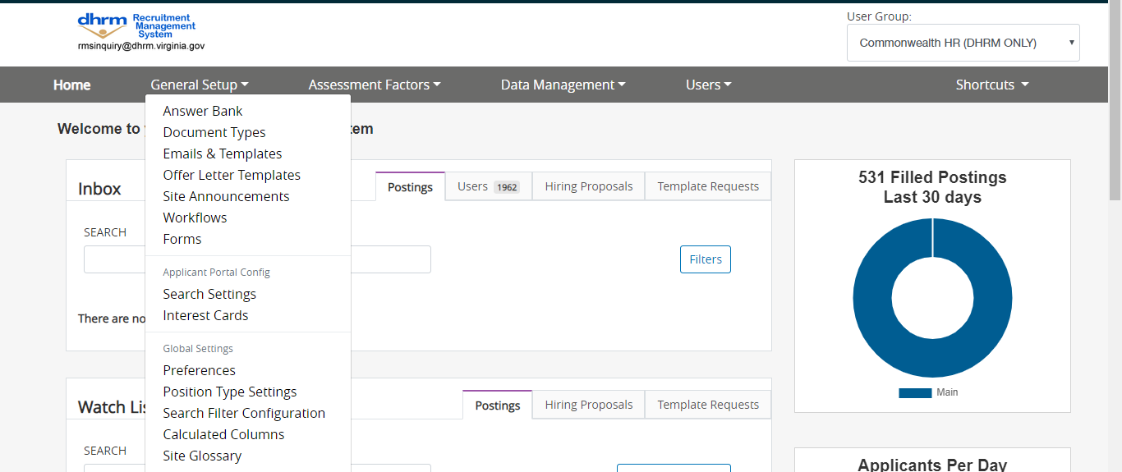
You can configure the basic appearance and behavior of your PeopleAdmin SelectSuite® site and applicant portal:
- Browser title bar text, internal site home page title and logo
- Timeouts and time zone
- System email "From" address and test recipient address
The Preferences page also allows you to configure global settings for your HR process.

Terms that might not match what you see
Many elements on your PeopleAdmin site can be renamed to match your organization's terminology, so the buttons, menu tabs, and other elements of your site might not match the terms used in the help.
Applicant is a customizable term. Common synonyms: candidate or job seeker.

To configure site behavior
Select General Setup / Preferences and change any of these settings that do not currently meet your organization's current needs:
- Display Name (required) – The title that appears on the Home page of the internal site.
- Applicant Portal Title (optional) – The title that appears in the browser's title bar while an applicant is logged in to the applicant portal.
- HR Suite Title (optional) – The title that appears in the browser's title bar while you are logged in to the internal site.
- Employee Portal Title (optional) – The title that appears in the browser's title bar while an employee is logged in to the employee portal.
- Employee Portal Header Color (optional) – HTML color name or hexadecimal color code for the topmost portion of each page of the employee portal. Hexadecimal codes must include the # symbol but are not case-sensitive. Use 3-digit form (for example, #68a or #68A) or 6-digit form (for example, #608ea4 or #608EA4).
- Site Logo (optional) – The image that appears at the left end of the header on each page of your internal site and applicant portal. Typically this is your organization's logo. The image must be no more than 200 pixels wide by 60 pixels high. The file may be a .png, .gif, or.jpg file. Select Browse, locate the appropriate file on your computer or network, and select it.
When you upload a new site logo, the change does not take effect immediately. In some cases you might not see the new image until several hours later.
- Google Analytics key (optional) – Your organization's Google Analytics web property ID. Google Analytics can show you how people found your site, how they explored it, and how you can enhance their visitor experience.
- Time Zone (required) – The time zone your organization uses in defining time stamps in the system. Typically this is the time zone used at your main office or headquarters.
- HR Suite Session Timeout (required) – The number of minutes that a user can be logged on to the internal site without any activity. A user who does not select any control or enter any data for this length of time will be logged out automatically.
- Applicant Portal Session Timeout (required) – The number of minutes that an applicant can be logged on to the applicant portal without any activity. An applicant who does not select any control or enter any data for this length of time will be logged out automatically.
- Employee Portal Session Timeout (required) – The number of minutes that an employee can be logged on to the employee portal without any activity. An employee who does not select any control or enter any data for this length of time will be logged out automatically.
- System Email Address (required) – The address from which automatically generated email messages will appear to be sent; for example, noreply@yourorganization.edu.
- Test Email Recipient Address (optional) – The email address to receive test emails from the system. Use a valid, active email address to which you or the appropriate users have access, so that you can use it to verify that system emails look and behave the way you want them to.

Configuring Password Requirements
ADMIN: General Setup / Password Policy – Set up or change password requirements for your sites.
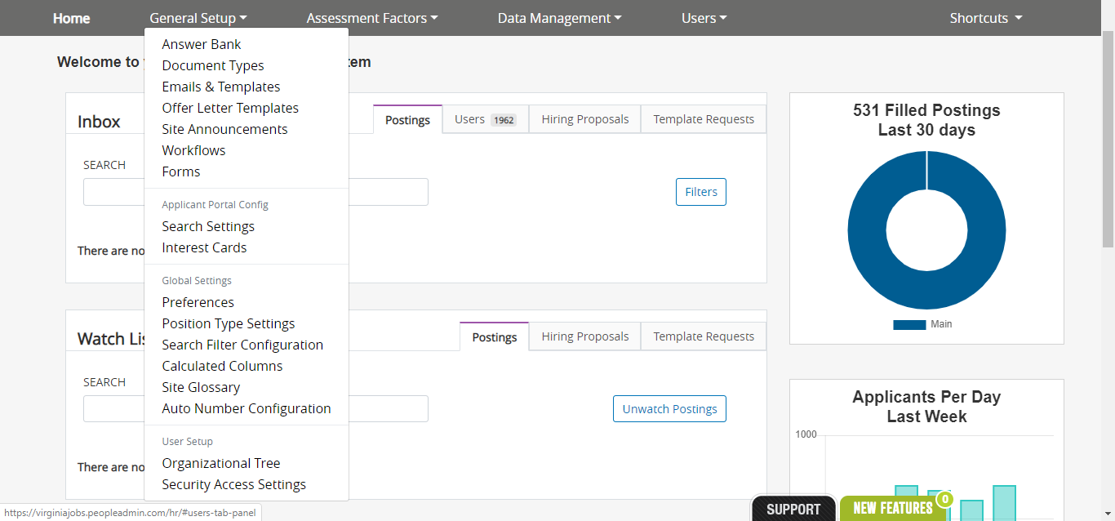
Your organization's password policy establishes the requirements for valid user and applicant passwords. Password requirements are set separately for your internal site and the applicant portal.
For optimum password security, allow people to create passwords they can remember. Requiring very long passwords or setting passwords to expire often can lead people to write down their passwords, potentially defeating your security measures. You can create easy-to-remember, secure passwords by running two words together.
After someone tries to log in using non-valid credentials (typically an incorrect or mis-typed password) three times in a row, the user profile is locked out for five minutes. After three lock-outs in a row, if the next login is unsuccessful, the user profile is disabled.

To define or change password policy settings
The password policy for your PeopleAdmin SelectSuite® site also applies to the Employee Portal.
- Select General Setup / Password Policy. The Password Policies page opens.
- Define or change these settings for your sites:
  - Require Complex Password? – Select this option to require passwords to meet any three of these requirements:
    - Include uppercase letters
    - Include lowercase letters
    - Include numerals
    - Include special characters
Complex passwords improve security by being harder to guess than simple ones.
If the site starts requiring complex passwords after allowing simple ones, users will be required to change their passwords the next time they log in if their passwords do not meet the complexity requirements. If someone tries to set a new password that does not meet the complexity requirements, the change is not accepted and the page presents a message telling the user how to correct the problem.
Example: "P@55word" is a valid complex password because it contains uppercase and lowercase letters, numbers, and a special character.
  - Minimum Length – Enter the smallest number of characters required for a valid password. If you increase the password length requirement, users and applicants whose passwords are too short will be prompted to change their passwords the next time they log in.
  - Password expires in how many days? – Enter the number of days after which people must change their passwords. When your password expires, you are prompted to change it the next time you log in. If your organization chooses not to require periodic password changes, leave this field blank.
- Select Update if you are finished making changes to the password policy settings.

Supplemental Questions in the Admin Area
ADMIN: Assessment Factors / Supplemental Questions – Manage supplemental questions individually, manage categories, or perform bulk operations on supplemental questions.

To edit a supplemental question
You can edit supplemental questions even if they are used on currently open postings. In this situation, you may choose to notify applicants of the change and invite them to answer the updated version of the question.
- Locate and view the supplemental question.
- Select Edit to open the item for editing. If the supplemental question is in use, the editing page presents a message explaining that you will be able to specify how the new version of the question is applied.
- Make any needed changes:
  - Name – This is the label that is presented when a user selects this type of assessment factor on a posting. Applicants never see this.
  - Label (ranking criteria only) – This is the label used on the summary page of a posting.
  - Status – Pending, Inactive, or Active. When you create an assessment factor of any type, its status remains pending until it is approved. This allows people to create new assessment factors while working on postings. You can approve your own assessment factors when you create them from the ADMIN module.
  - Category – Optional. Categories help you organize each type of assessment factor for ease of searching. The categories for each type of assessment factor are independent.
  - Question (supplemental questions only) – The text of the question as you want applicants to see it.
  - Possible Answers – Select Open-ended Answers to give applicants a free-text field for answering the question, or select Predefined answers to set it up as a yes/no or multiple-choice question. If you select Predefined Answers, provide at least two possible answers. When you add a possible answer, another Possible Answer box opens. Leave blank any Possible Answer fields that you do not need.
- After you have defined or updated the information for the item, select Update to apply your changes and view a summary page.

To create a supplemental question

Access the appropriate list of assessment factors.
- From the Actions menu, select Create New. The Creating page opens.
- Enter a name for the item. This is the label that is presented when a user selects this type of assessment factors on a posting. If you are creating a supplemental question, this is the only field that you must complete before saving a draft version of the question. For ranking criteria or assessment criteria, you must also fill in the label and description.
- Continue as for editing.
- After you have defined the information for the item, select Create to apply your changes and view a summary page.
Supplemental questions only: If you select Create New Supplemental Question before you provide the text of the question, a draft is saved but you remain on the Creating page so that you can continue editing. The button label changes to Update Supplemental Question.

To create a supplemental question based on an existing question
You can use a supplemental question as the template for another supplemental question, but at this time you cannot create new ranking criteria or assessment criteria from existing ones.
- Locate the question that you wish to use as a template.
- From the question's Actions menu, select Clone question. The fields are all populated with information from the question you selected.
- Change the name of the question, and continue making changes as you would when editing a question.
- After you have defined or updated the information for the question, select Update Supplemental Question to apply your changes and view a summary page.

To change the status of a supplemental question

Locate and view the item you need to work with.
Select the status change operation from the menu:
  - Approve allows you to activate an item that has never been active.
  - Deactivate allows you to remove an active item without deleting it. You can reactivate it if your organization ever needs it again.
  - Reactivate allows you to activate an item that has been deactivated.
The page presents a message stating that you have successfully changed the status of the item.
If the new item does not become available for use on postings after it is approved, it may need to be associated with the position types where it will be used. Contact PeopleAdmin Customer Care for help with this.

To delete a supplemental question
If the item is in use, you will not be able to delete it.
- Locate and view the item you need to work with.
- Select Delete.
- A confirmation box asks whether you wish to delete the item. Select OK to delete it and return to the list.

To manage categories of supplemental questions
The categories for the three types of assessment factors are independent of each other, but they are set up from the same page.
- Access the appropriate list of assessment factors.
- Select Manage Categories. The Categories page opens.
- Be sure the Category Type shown is the one you want, or select the desired type from the menu.
  - To delete a category, select its Delete (X) control. A confirmation box asks whether you wish to delete the category. If it is in use, you will not be able to delete it.
  - To rename a category, select it. When the text box opens, edit it as needed and select OK to make your change.
  - To add a category, enter a name in the box at the end of the categories list and select Add Category.

